Now may the God of hope
fill you with all
joy and peace in believing,
that you may abound
in hope by the power
of the Holy Spirit.
Romans 15: 13

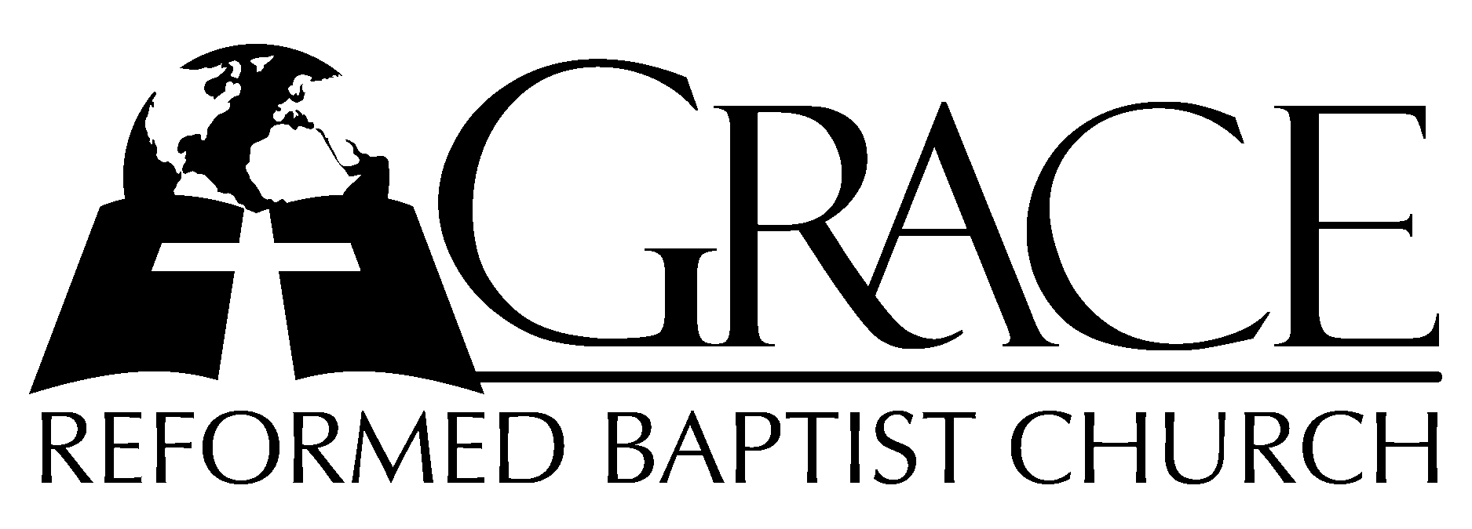
PO Box 221, 939 South Third Street
Mebane, North Carolina 27302
Phone: (919) 563-9249 Email: pastors@vor.org

Website: mebane.vor.org

The Lord’s Day Services
Sunday School……….………9:30
Morning Worship……….…10:55
Evening Worship.……………5:30

Wednesday Evening Prayer Service
7:15

We warmly welcome our Visitors today and request that you sign
the Guest Register located in the Foyer. We hope to greet you in a more personal way following the services.

PO Box 221, 939 South Third Street
Mebane, North Carolina 27302
Phone: (919) 563-9249 Email: pastors@vor.org
Website: mebane.vor.org

The Lord’s Day Services
Sunday School……….………9:30
Morning Worship……….…10:55
Evening Worship.……………5:30

Wednesday Evening Prayer Service
7:15

We extend a warm welcome to our visitors
Today. Please sign our Guest Register in the Foyer.
We hope to greet you in a more personal way
following the services.

The Lord’s Day
June 25, 2006

Call to Worship Pastor Andy Dunkerton

Hymn of Praise “Rejoice, the Lord is King”

- Rejoice, the Lord is King: Your Lord and King adore!
Rejoice, give thanks and sing, and triumph evermore:
Lift up your heart, lift up your voice; Rejoice, again-I say, Rejoice!

- The Lord, our Savior reigns, the God of truth and love;
When He had purged our stains, He took His seat above:
Lift up your heart, lift up your voice; Rejoice, again-I say, Rejoice!

- His kingdom cannot fail, He rules o’er earth and heav’n;
The keys of death and hell are to our Jesus giv’n:
Lift up your heart, lift up your voice; Rejoice, again-I say Rejoice!

- He sits at God’s right hand till all His foes submit,
And bow to His command, and fall beneath His feet:
Lift up your heart, lift up your voice; Rejoice, again-I say, Rejoice! AMEN
Text: Charles Wesley, based on Philippians 4:4 Tune: John Darwall Used by Permission CCLI # 1899094

Scripture Reading Romans 15: 14-33

Pastoral Prayer

Offertory Hymn “Our God Reigns”
- How lovely on the mountains are the feet of him---
Who brings good news,---good news---
Announcing peace, proclaiming news of happiness.
Our God reigns,--- Our God reigns!
(Refrain) Our God reigns! Our God reigns! Our God reigns! Our God reigns!
- He had no stately form, He had no majesty,---
That we should be---drawn to Him.
He was despised and we took no account of Him,
Yet now He reigns---with the Most High.
Our God reigns! Our God reigns! Our God reigns! Our God reigns!
- Out from the tomb He came with grace and majesty,---
He is alive,---He is alive.---
God loves us so, see here His hands, His feet, His side.
Yes, we know,--- He is alive!
Our God reigns! Our God reigns! Our God reigns! Our God reigns!
(Repeat Refrain a cappella with final AMEN)
Text and Music: Leonard E. Smith, Jr. 1974 & 1978 New Jerusalem Music Used by Permission CCLI # 1899094

Hymn of Preparation # 374 “Jesus Shall Reign”

Sermon Pastor Gary Hendrix
~~~~~~~~~~~~~~~~~~~~~~~~~~~~~~~~~~~~

Evening Worship

Call to Worship Pastor Charles Fortner

Hymn of Praise # 118 “O Savior, Precious Savior”
Scripture Reading Proverbs 1: 20-33

Pastoral Prayer

Offertory Hymn “As The Deer”
(Instrumental Introduction)

- As the deer panteth for the water, so my soul longeth after Thee.
You alone are my heart’s desire, and I long to worship Thee.
(Refrain)
You alone are my strength and shield:
To You alone may my spirit yield.
You alone are my heart’s desire and I long to worship Thee.

- You’re my friend and You are my brother, even though You are a King.
I love You more than any other, so much more than anything.
(Refrain)
- I want You more than gold or silver, only You can satisfy.
You alone are the real joy giver and the apple of my eye.
(Refrain, no amen) Instrumental Ending
Words and Music: Martin Nystrom Used by Permission CCLI # 1899094

Hymn of Preparation # 593 “Jesus, I My Cross
Have Taken”

Sermon Pastor Andy Dunkerton
~~~~~~~~~~~~~~~~~~~~~~~~~~~~~~~~~~~~

Baptismal Service Hymns
~~~~~
# 437 “Christ of All My Hopes the Ground”

# 580 “It Is Well With My Soul”
~~~~~
Suggested Bible Verses for Memorization
Romans 15: 14-15
“Now I myself am confident concerning you, my brethren, that you also are full of goodness, filled with all knowledge, able to admonish one another. Nevertheless, brethren, I have written more boldly to you on some points, as reminding you,
because of the grace given to me by God,…”

Evening Worship

Call to Worship Pastor Charles Fortner

Hymn of Praise # 10 “O Come My Soul”

Scripture Reading Proverbs 1

Pastoral Prayer

Offertory Hymn # 453 “O, The Deep, Deep
Love of Jesus”

Hymn of Preparation “I Will Glory in My
Redeemer”

- I will glory in my Redeemer, whose priceless blood has ransomed me.
Mine was the sin that drove the bitter nails and hung Him on that judgement tree.
I will glory in my Redeemer- Who crushed the pow’r of sin and death;
My only Savior before the Holy Judge, the Lamb who is my righteousness,
The Lamb who is my righteousness.

- I will glory in my Redeemer. My life He bought, my love He owns.
I have no longings for another- I’m satisfied in Him alone.
I will glory in my Redeemer- His faithfulness, my standing place-
Though foes are mighty and rush upon me- my feet are firm, held by His grace,
My feet are firm held by His grace.

- I will glory in my Redeemer Who carries me on eagle’s wings.
He crowns my life with loving kindness, His triumph song I’ll ever sing.
I will glory in my Redeemer Who waits for me at gates of gold-
And when He calls it will be Paradise- His face forever to behold,
His face forever to behold. (no amen)
Words and Music: Steve and Vikki Cook, 2001 PDI Worship
Used by Permission CCLI # 1899094

Sermon Pastor Andy Dunkerton

**********************************************

The fear of the Lord is the beginning of knowledge,
But fools despise wisdom and instruction.
Proverbs 1: 7

