But as it is written:
“Eye has not seen, nor ear heard,
Nor have entered into the heart of man the things which God has prepared for those who love Him.”
But God has revealed them to us through His Spirit. For the Spirit searches all things, yes, the deep things of God.

I Corinthians 2: 9-10

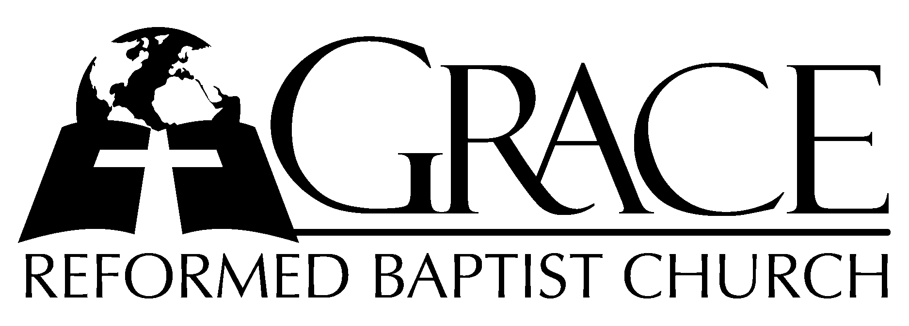
PO Box 221, 939 South Third Street
Mebane, North Carolina 27302
Phone: (919) 563-9249 Email: PASTORS@GRBC.NET

Website: WWW.GRBC.NET

The Lord’s Day Services
Sunday School……….………9:30
Morning Worship……….…10:55
Evening Worship.…………..5:30

Wednesday Evening Prayer Service
7:15

We warmly welcome our Visitors today and request that you sign
the Guest Register located in the Foyer. We hope to greet you in a more personal way following the services.

The Lord’s Day
July 30, 2006

Call to Worship Pastor Charles Fortner

Hymn of Praise # 125 “My Heart Doth
Overflow”

Scripture Reading I Corinthians 2: 1-16

Pastoral Prayer

Offertory Hymn # 126 “O Could I Speak
The Matchless Worth”

Hymn of Preparation “Come, Holy Spirit, Come”
(Words # 254, Tune # 438)

Sermon Pastor Stu Johnston

~~~~~~~~~~~~~~~~~~~~~~~~~~~~~~~~~~~

Evening Worship
Call to Worship Pastor Stu Johnston

Hymns of Praise “Majesty”/
# 70 “Praise My Soul,
The King of Heaven”

Majesty, worship His majesty. Unto Jesus, be all glory, honor and praise.
Majesty, kingdom authorityflow from His throne unto His own; His anthem raise.
So exalt, lift up on high the name of Jesus. Magnify, come glorify Christ Jesus the King.
Majesty, worship His majesty; Jesus who died, now glorified, King of all kings!
(Piano Introduction to “Praise My Soul”)

Scripture Reading Proverbs 6: 1-19
Pastoral Prayer

Offertory Hymn # 270 “The Church is
One Foundation”

Hymn of Preparation # 253 “O Spirit of the
Living God”
Sermon Pastor Bob Gonzales

Suggested Bible Verse for Memorization
I Corinthians 2: 12
“Now we have received, not the spirit of the world, but the Spirit who is from God, that we might know the things that have been freely given to us by God.”

