“Give to the Lord,
O families of the peoples,
Give to the Lord glory and strength,
Give to the Lord
the glory due to His name;
Bring an offering,
and come into His courts.
Oh, worship the Lord
in the beauty of holiness!
Tremble before Him, all the earth.”
Psalm 96: 7-9

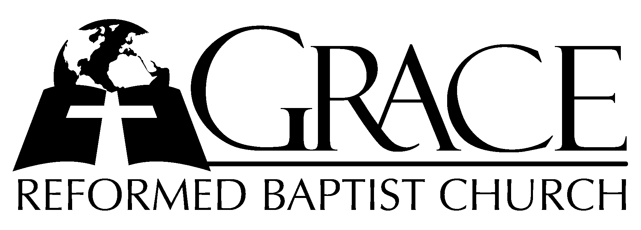
PO Box 221, 939 South Third Street
Mebane, North Carolina 27302
(919) 563-9249

Website: WWW.GRBC.NET

The Lord’s Day Services
Sunday School……….………9:30
Morning Worship……….…10:55
Evening Worship.…………..5:30

Wednesday Evening Prayer Service
7:15

We warmly welcome our Visitors today and request that you sign
the Guest Register located in the Foyer. We hope to greet you in a more personal way following the services.

The Lord’s Day
August 13, 2006

Call to Worship Pastor Charles Fortner

Hymn of Praise # 65 “Sing to the Lord”

Scripture Reading I Corinthians 4: 1-17

Pastoral Prayer

Offertory Hymn # 34 “All That I Am I Owe
to Thee”
Hymn of Preparation “Revive Thy Work, O Lord”

- Revive Thy work, O Lord, Thy mighty arm make bare;
Speak with the voice that wakes the dead, and make Thy people hear.

- Revive Thy work, O Lord, disturb this sleep of death;
Quicken the smould’ring embers now by Thine almighty breath.

- Revive thy work, O Lord, create soul-thirst for Thee;
And hung’ring for the Bread of Life O may our spirits be.

- Revive Thy work, O Lord, exalt Thy precious Name;
And by the Holy Ghost, our love for Thee and Thine inflame.

- Revive Thy work, O Lord, give Pentecostal show’rs:
The glory shall be all Thine own, the blessing, Lord, be ours. AMEN
Text: Albert Midlane, 1858 Tune: Lowell Mason, 1830

Sermon Pastor Stu Johnston

~~~~~~~~~~~~~~~~~~~~~~~~~~~~~~~~~~~

Suggested Bible Verses for Memorization
I Corinthians 4: 6-7
“…I have…written, that none of you may be puffed up on behalf of one against the other. For who makes you differ from another? And what do you have that you did not receive? Now if you did indeed receive it, why do you boast as if you had not received it?

Evening Worship

Call to Worship Pastor Charles Fortner

Hymn of Praise # 219 “Blessing and
Honor”

Scripture Reading Proverbs 6: 20-35
Pastoral Prayer

Offertory Hymn “O Love of God”
(Remain seated)
- O love of God,- how strong and true!- Eternal, and- yet ever new;
Uncomprehend-ed and unbought, beyond all know-ledge and all thought.

- O love of God,- how deep and great! Far deeper than- man’s deepest hate;
Self-fed, self-kindled like the light, changeless, eter-nal, infinite.

(Instrumental interlude while standing)

- O wide embrac-ing, wondrous love! We read Thee in- the sky above,
We read Thee in- the earth below, in seas that swell,- and streams that flow.

- We read Thee best- in Him who came- to bear for us- the cross of shame;
Sent by the Fa-ther from on high,- our life to live,- our death to die.

- We read Thy pow’r- to bless and save,- e’en in the dark-ness of the grave;
Still more in re-surrection light- we read the ful-ness of Thy might.

- O love of God,- our shield and stay- through all the pe-rils of our way!
Eternal love,- in Thee we rest,- forever safe- forever blest. (no amen)
Text: Horatius Bonar, 1861 Tune: Appalachian Folk Tune

Sermon Pastor Stu Johnston

~~~~~~~~~~~~~~~~~~~~~~~~~~~~~~~~~~~
Hymns for Baptismal and Communion Service

# 712 “I Know Whom I Have Believed”

# 507 “Take Up Thy Cross”

# 360 “According to Thy Gracious Word”

# 362 “Let Thy Blood in Mercy Poured”

# 552 “O Jesus, I Have Promised to Serve
Thee to the End”

