“All Your works shall praise You,
O Lord,
And Your saints shall bless You,
They shall speak of the glory
of Your kingdom,
and talk of Your power,
To make known to the sons
of men His mighty acts,
And the glorious majesty
of His kingdom.
Your kingdom is an everlasting
kingdom, and Your dominion endures
throughout all generations.”
Psalm 145: 10-13

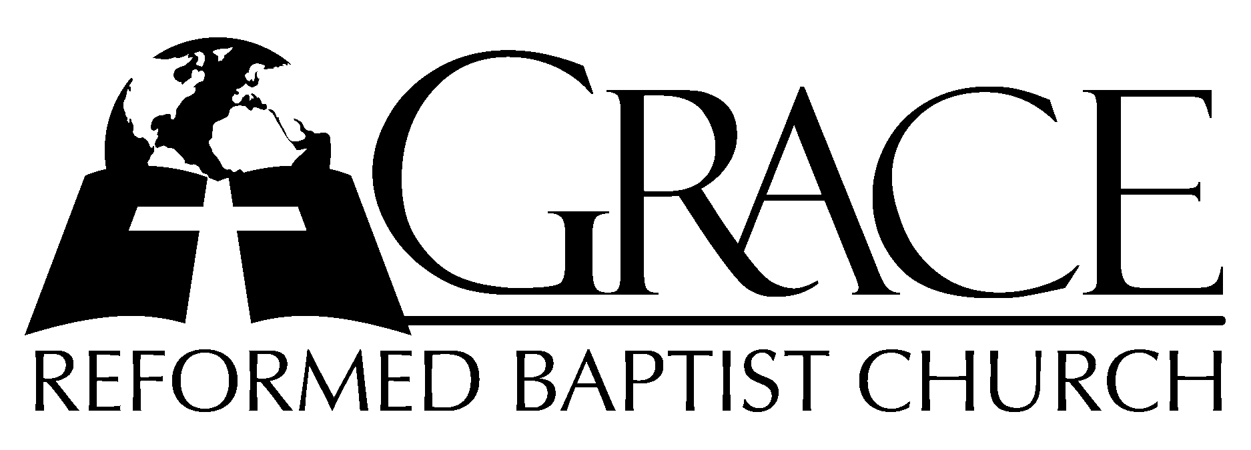
PO Box 221, 939 South Third Street
Mebane, North Carolina 27302
(919) 563-9249

Website: WWW.GRBC.NET

The Lord’s Day Services
Sunday School……….………9:30
Morning Worship……….…10:55
Evening Worship.…………..5:30

Wednesday Evening Prayer Service
7:15

We warmly welcome our Visitors today and request that you sign
the Guest Register located in the Foyer. We hope to greet you in a more personal way following the services.

The Lord’s Day
September 3, 2006

Call to Worship Pastor Stu Johnston

Hymn of Praise “Joyful, Joyful, We
Adore Thee/
# 50 “Praise to the Lord”

- Joyful, joyful, we adore Thee, God of glory, Lord of love;
Hearts unfold like flower’s before Thee opening to the sun above.
Melt the clouds of sin and sadness, drive the dark of doubt away;
Giver of immortal gladness, fill us with the light of day.

- All Thy works with joy surround Thee, earth and heaven reflect Thy rays,
Stars and angels sing around Thee, center of unbroken praise.
Field and forest, vale and mountain, flowery meadow, flashing sea,
Chanting bird and flowing fountain, call us to rejoice in Thee.

Piano Transition to “Praise to the Lord”

Scripture Reading I Corinthians 6

Pastoral Prayer

Offertory Hymn “I Love You, Lord”
Please silently meditate upon the text as the Instrumentalists
play two verses before we sing:
I love You, Lord, and I lift my voice to worship You, O my soul rejoice!
Take joy, my King, in what You hear: may it be a sweet, sweet sound in Your ear.
Repeat verse a cappella
AMEN
Text and Music: Laurie Klein, 1978, House of Mercy Used by Permission CCLI # 1899094

Hymn of Preparation “Teach Me O Lord”

- Teach me, O Lord, Thy holy way--, and give me an o-be-dient mind;
That in Thy ser-vice I- may find-my soul’s delight from day- to day.

- Guide me, O Savior, with Thy hand--, and so control my thoughts- and deeds,
That I may tread the path- which leads- right on-ward to the bless-ed land.

- Help me, O Savior, here to trace-- the sacred foot-steps Thou- has trod;
And, meekly walk-ing with- my God-, to grow in good-ness, truth- and grace.

- Guard me, O Lord, that I may ne’er-- forsake the right, or do- the wrong:
Against temp-ta-tion make-me strong-, and round me spread Thy shelt’ring care.

- Bless me in ev’ry task, O Lord--, begun, con-tin-ued, done- for Thee:
Fulfil Thy perfect work in me: and Thine a-bound-ing grace-afford. AMEN

Text: Willaim T. Matson, 1866 Tune: MARYTON, H. Percy Smih, 1874

Sermon Pastor An dy Dunkerton
~~~~~~~~~~~~~~~~~~~~~~~~~~~~~~~~~~

Evening Worship

Call to Worship Pastor Andy Dunkerton

Thou art worthy, Thou art worthy, Thou art worthy, O Lord,---
To receive glory-, glory and honor-, Glory and honor and pow’r.---
For Thou hast created, hast all things created;
Thou hast created all things.---And for Thy pleasure they are created;
For Thou art worthy, O Lord.

Prayer

Hymn of Praise # 13 “O Worship the King”

Scripture Reading Proverbs 8: 1-21

Pastoral Prayer

Offertory Hymn “Be Thou My Vision”

- Be Thou my Vision, O Lord of my heart;
Naught be all else to me, save that Thou art—
Thou my best thought, by day or by night,
Waking or sleeping, Thy presence my light.

- Be Thou my Wisdom, and Thou my true Word;
I ever with Thee and Thou with me, Lord;
Thou my great Fa-ther, I Thy true son,
Thou in me dwelling, and I with Thee one.

- Riches I heed not, nor man’s empty praise,
Thou mine inheritance, now and always;
Thou and Thou on-ly, first in my heart,
High King of heaven, my Treasure Thou art.

- High King of heaven, my victory won,
May I reach heav-en’s joys, O bright heav’n’s Sun!
Heart of my own heart, what every befall,
Still be my Vision, O Ruler of all. AMEN
Text: Ancient Irish hymn, translated by Mary E. Byrne; versified by Eleanor H. Hull
Music: Irish Folk melody: arranged by David Allen 1986 WORD MUSIC
Used by Permission CCLI # 1899094

Hymn of Preparation # 506 “Why Should Cross
and Trial Grieve Me”
Sermon Pastor Stu Johnston
~~~~~~~~~~~~~~~~~~~~~~~~~~~~~~~~~

