“A little while longer and the world will
see Me no more, but you will see me.
Because I live, you will live also.
At that day You will know that
I am in My Father,
and you in Me, and I in you.
He who has my commandments and keeps
them, it is he who loves me. And he who
loves Me will be loved by my Father,
and I will love him and manifest
Myself to Him.”

John 14: 19-21

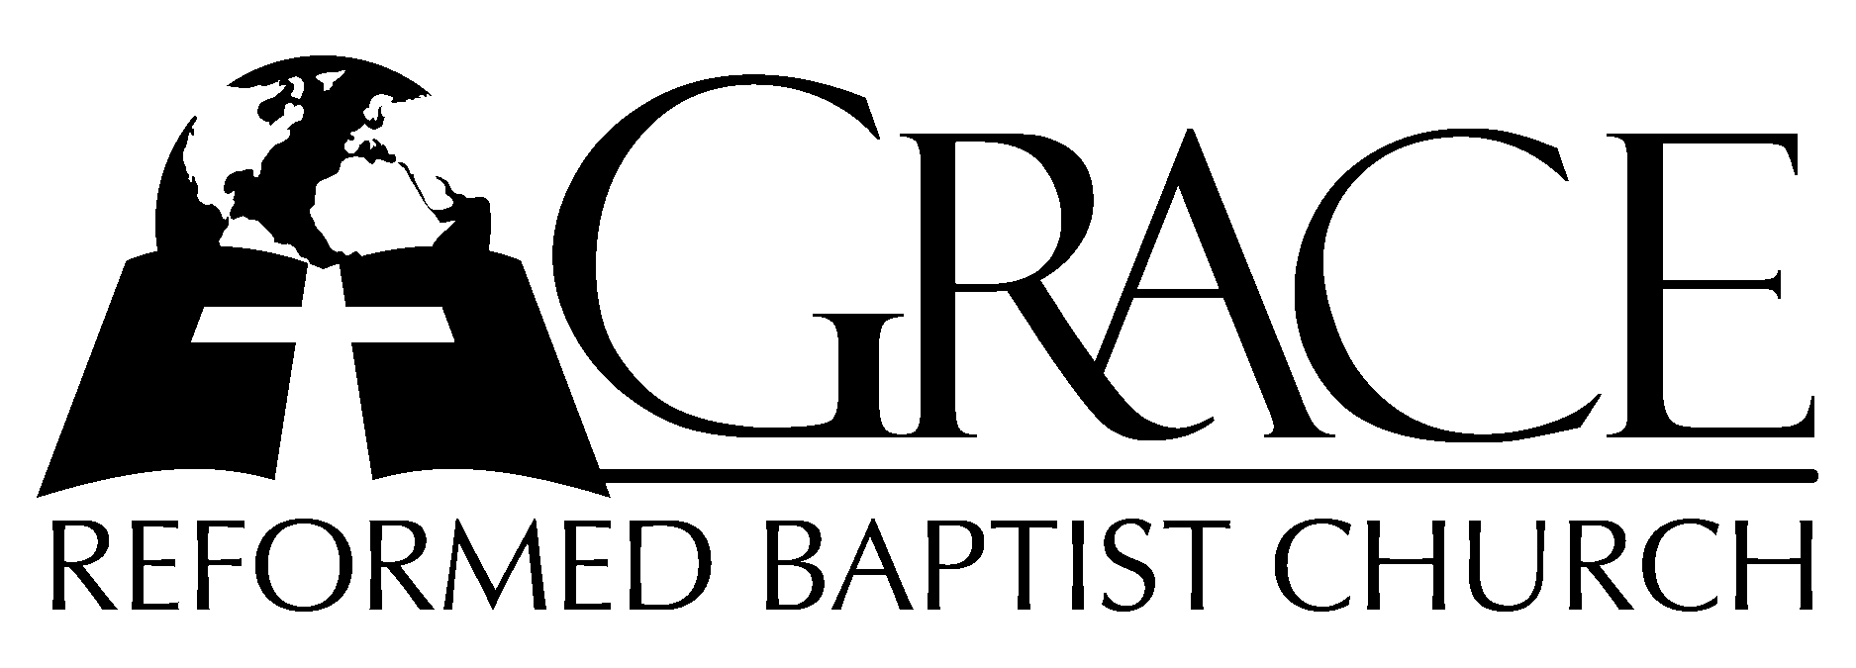
PO Box 221, 939 South Third Street
Mebane, North Carolina 27302
(919) 563-9249

Website: WWW.GRBC.NET

The Lord’s Day Services
Sunday School……….………9:30
Morning Worship……….…10:55
Evening Worship.…………..5:30

Wednesday Evening Prayer Service
7:15

We warmly welcome our Visitors today and request that you sign
the Guest Register located in the Foyer. We hope to greet you in a more personal way following the services.

The Lord’s Day
October 15, 2006

Call to Worship Pastor Stu Johnston

Hymn of Praise # 460 “Love Divine, All
Loves Excelling”
(2nd Tune)

Scripture Reading I Corinthians 9: 24 - 10:15

Pastoral Prayer

Offertory Hymn “Be Thou My Vision”

- Be Thou my Vision, O Lord of my heart; Naught be all else to me, save that Thou art-
Thou my best thought, by day or by night, Waking or sleeping, Thy presence my light.

- Be Thou my Wisdom, and Thou my true Word; I ever with Thee and Thou with me, Lord;
Thou my great Fa-ther, I Thy true son, Thou in me dwelling, and I with Thee One.

- Riches I heed not, nor man’s empty praise, Thou mine inheritance, now and always;
Thou and Thou on-ly, first in my heart, High King of heaven, my Treasure Thou art.

- High King of heaven, my victory won, May I reach heaven’s joys, O bright heav’n’s Sun!
Heart of my own heart, whatever befall, Still be my Vision, O Ruler of all. AMEN

Text: Ancient Irish Hymn, translated by Mary E. Byrne; versified by Eleanor H. Hull
Music: Irish Folk melody: arranged by David Allen 1986 WORD MUSIC Used by Permission CCLI # 1899094

Hymn of Preparation # 581 “To Thee, O Lord,
I Fly”

Sermon Pastor Gary Hendrix
~~~~~~~~~~~~~~~~~~~~~~~~~~~~~~~~~~~~

Evening Worship

Call to Worship Pastor Charles Fortner

Hymn of Praise # 87 “Holy, Holy, Holy”

Scripture Reading Proverbs 11: 16-31

Pastoral Prayer

Offertory Hymn “Take My Life”
(Instrumentalists will play 3 times during the offering before
standing to sing all verses.) ( Vs. 3-female voices, Vs. 4-young voices,
Vs. 5-male voices.)

1. Take my life and let it be con - se - crat - ed Lord to Thee;
2. Take my hands and let them move at the im – pulse of Thy love;
3. Take my voice and let me sing al - ways, on - ly, for my King;
4. Take my sil - ver and my gold - not a mite would I with – hold;

Take my mo - ments and my days; Let them flow in cease- less
Take my feet and let them be - swift and beau-ti - ful for
Take my lips and let them be - filled with mes- sa - ages from
Take my in - tel - lect and use ev’ ry pow’r as Thou shalt

praise, Let them flow in cease - less praise.
Thee, swift and beau –ti- ful for Thee.
Thee, filled with mes- sa - ages from Thee.
choose, ev’ ry pow’r as Thou shalt choose.

5. Take my will and make it Thine- 6. Take my love, my Lord, I pour
It shall be no longer mine; At Thy feet its treasure store;
Take my heart, it is Thine own, Take myself, and I will be
It shall be Thy royal throne, Ever, only, all for Thee,
It shall be Thy royal throne. Ever, only, all for Thee. (no amen)
Words: Frances R. Havergal Music: Mike Clark Used by Permission

Sermon Pastor Andy Dunkerton
~~~~~~~~~~~~~~~~~~~~~~~~~~~~~~~~~~~~
Communion Hymns

# 356 “Not Worthy, Lord”

# 189 “Sweet The Moments”

“What Wondrous Love is This”

- What wondrous love is this, O my soul, O my soul, what wondrous love is this, O my soul!
What wondrous love is this that caused the Lord of bliss to bear the dreadful curse for my soul, for my soul, to bear the dreadful curse for my soul!
- To God and to the Lamb, I will sing, I will sing, to God and to the Lamb , I will sing;
To God and to the Lamb, who is the great I AM, while millions join the theme, I will sing,
I will sing, while millions join the theme, I will sing!
- And when from death I’m free, I’ll sing on, I’ll sing on, and when from death I’m free, I’ll sing on;
And when from death I’m free, I’ll sing and joyful be, and through eternity, I’ll sing on,
I’ll sing on, and through eternity, I’ll sing on! (no amen)

1. Take my life and let it be con - se - crat - ed Lord to Thee;
2. Take my hands and let them move at the im – pulse of Thy love;
3. Take my voice and let me sing al - ways, on - ly, for my King;
4. Take my sil - ver and my gold - not a mite would I with – hold;

Take my mo - ments and my days; Let them flow in cease- less
Take my feet and let them be - swift and beau-ti - ful for
Take my lips and let them be - filled with mes- sa -ages from
Take my in - tel - lect and use ev’ ry pow’r as Thou shalt

praise, Let them flow in cease - less praise.
Thee, swift and beau –ti- ful for Thee.
Thee, filled with mes- sa - ages from Thee.
choose, ev’ ry pow’r as Thou shalt choose.

