“Praise, the Lord,
all you Gentiles!
Laud Him, all you peoples!
For His merciful kindness is great toward us,
And the truth of the Lord
endures forever.
Praise the Lord!”
Psalm 117

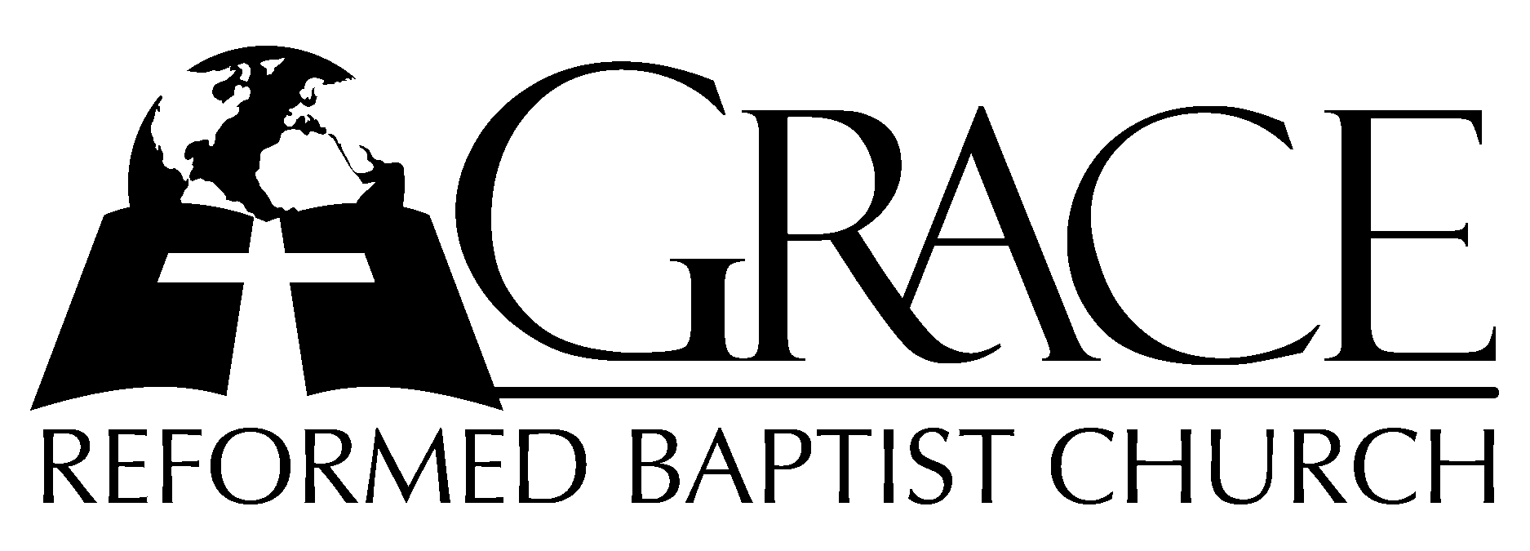
PO Box 221, 939 South Third Street
Mebane, North Carolina 27302
(919) 563-9249

Website: WWW.GRBC.NET

The Lord’s Day Services
Sunday School……….………9:30
Morning Worship……….…10:55
Evening Worship.…………..5:30

Wednesday Evening Prayer Service
7:15

We warmly welcome our Visitors today and request that you sign
the Guest Register located in the Foyer. We hope to greet you in a more personal way following the services.

The Lord’s Day
November 5, 2006

Call to Worship Pastor Stu Johnston

Hymn of Adoration “We Will Glorify”/
“From All That Dwell
Below the Skies”

- We will glorify the King of kings, we will glorify the Lamb;
We will glorify the Lord of lords, who is the great “I AM.”
Lord Jehovah reigns in majesty, we will bow before His throne;
We will worship Him in righteousness, we will worship Him alone.
He is Lord of heaven, Lord of earth, He is Lord of all who live;
He is Lord above the universe, all praise to Him we give.
Hallelujah to the King of kings, Hallelujah to the Lamb;
Hallelujah to the Lord of lords, who is the great “I AM!”

(Introduction to “From All That Dwell”)

- From all that dwell below the skies-Let the Creator’s praise arise:
Al-le-lu-ia! Al-le-lu-ia!
Let the Redeemer’s Name be sung-Through every land, by every tongue.
Al-le-lu-ia! Al-le-lu-ia! Al-le-lu-ia! Al-le-lu-ia! Al-le-lu-ia!

- Eternal are Thy mercies, Lord; Eternal truth attends Thy Word:
Al-le-lu-ia! Al-le-lu-ia!
Thy praise shall sound from shore to shore, till suns shall rise and set no more.
Al-le-lu-ia! Al-le-lu-ia! Al-le-lu-ia! Al-le-lu-ia! Al-le-lu-ia!
AMEN

We Will Glorify, Words and Music: Twiila Paris 1982 Singspiration Used by Permission CCLI # 1899094
From All That Dwell, from Psalm 117, Isaac Watts, 1719

Scripture Reading Deuteronomy 15: 1-11
Pastoral Prayer

Offertory Hymn # 538 “Something for
Thee”
Hymn of Preparation # 368 “Lord, Thou Lov’st
The Cheerful Giver”
Sermon Pastor Gary Hendrix
~~~~~~~~~~~~~~~~~~~~~~~~~~~~~~~~~~~~

Evening Worship

Call to Worship Pastor Charles Fortner

Hymn of Praise # 10 “O Come, My Soul”
From Psalm 103

Scripture Reading Proverbs 13

Pastoral Prayer

Offertory Hymn # 418 “We Have Not
Known Thee as We Ought”

Hymn of Preparation # 186 “When I Survey
The Wondrous Cross”
Sermon Pastor Gary Hendrix
~~~~~~~~~~~~~~~~~~~~~~~~~~~~~~~~~~~~

“Were the whole realm of nature mine,
that were a present far too small;
Love so amazing, so divine,
demands my soul, my life, my all.”
Isaac Watts, 1709

