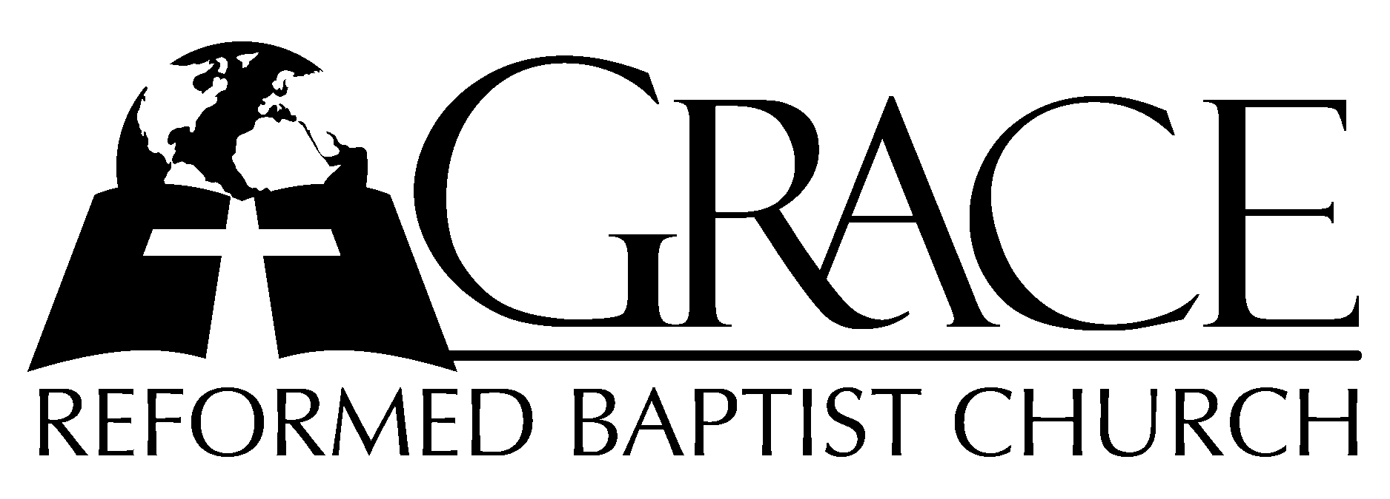
PO Box 221, 939 South Third Street
Mebane, North Carolina 27302
(919) 563-9249

Website: WWW.GRBC.NET

The Lord’s Day Services
Sunday School……….………9:30
Morning Worship……….…10:55
Evening Worship.…………..5:30

Wednesday Evening Prayer Service
7:15

We warmly welcome our Visitors today and request that you sign
the Guest Register located in the Foyer. We hope to greet you in a more personal way following the services.

