“There shall come forth a Rod
from the stem of Jesse.
And a Branch shall grow
out of his roots.
The Spirit of the Lord
shall rest upon Him,
The Spirit of wisdom and understanding,
The Spirit of counsel and might,
The Spirit of knowledge
and of the fear of the Lord.”
Isaiah 11: 1-2
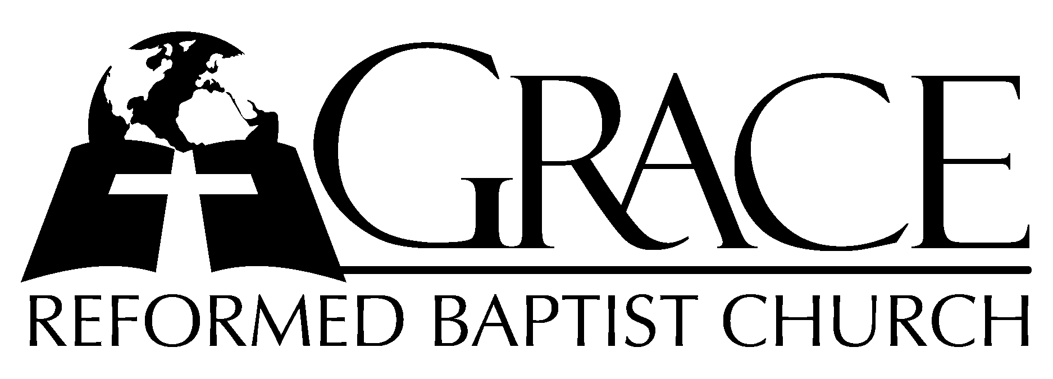
PO Box 221, 939 South Third Street
Mebane, North Carolina 27302
(919) 563-9249

Website: WWW.GRBC.NET

The Lord’s Day Services
Sunday School……….………9:30
Morning Worship……….…10:55
Evening Worship.…………..5:30

Wednesday Evening Prayer Service
7:15

We warmly welcome our Visitors today and request that you sign
the Guest Register located in the Foyer. We hope to greet you in a more personal way following the services.

The Lord’s Day
December 10, 2006

Call to Worship Pastor Stu Johnston

Hymn of Praise # 154 “As With Gladness
Men of Old”
Scripture Reading I Corinthians 14: 26-40

Pastoral Prayer

Offertory Hymn # 413 “O Thou That
Hear’st When Sinners Cry”

Hymn of Preparation # 153 “Behold a Branch”

Sermon Pastor Gary Hendrix

~~~~~~~~~~~~~~~~~~~~~~~~~~~~~~~~~~~~

Evening Worship

Call to Worship Pastor Charles Fortner

Hymn of Praise # 689 “One Day”

Scripture Reading Proverbs 15: 1-17

Pastoral Prayer

Offertory Hymn “The Unveiled Christ”
(Please refer to the opposite page)

Hymn of Preparation “Ancient Words”
- Holy words long preserved for our walk in this world,
They resound with God’s own heart. O, let the ancient words impart.
Words of life, words of hope, give us strength, help us cope.
In this world where’er we roam, ancient words will guide us home.
Ancient words, ever true, changing me and changing you;
We have come with open hearts, O, let the ancient words impart.

- Holy words of our faith handed down to this age,
Came to us through sacrifice. O, heed the faithful words of Christ.
Holy words long preserved for our walk in this world,
They resound with God’s own heart. O, let the ancient words impart.
Ancient words, ever true, changing me and changing you;
We have come with open hearts, O, let the ancient words impart.
Ancient words, ever true, changing me and changing you;
We have come with open hearts, O, let the ancient words impart.
We have come with open hearts, O, let the ancient words impart.
(piano ending, no amen)
Words and Music: Lynn Deshazo, 2001 Integrity’s Hosanna! Music Used by Permission CCLI # 1899094

Sermon Pastor Gary Hendrix
~~~~~~~~~~~~~~~~~~~~~~~~~~~~~~~~~~~

Communion Hymns

# 169 “Who is This So Weak and Helpless”
# 600 “When This Passing World is Done”
~~~~~~~~~~~~~~~

The Unveiled Christ

