“And behold, an angel of the Lord stood
before them, and the glory of the Lord
shone around them, and they were
greatly afraid. Then the angel said to them,
Do not be afraid, for behold, I bring you good tidings of great joy which will be to all people. For there is born to you this day in the city of David a Savior, who is Christ the Lord.
And this will be a sign to you:
You will find a Babe wrapped in swaddling cloths, lying in a manger.
And suddenly there was with the angel
a multitude of the heavenly host
praising God and saying:
Glory to God in the highest,
and on earth peace, goodwill toward men !”
Luke 2: 9-14

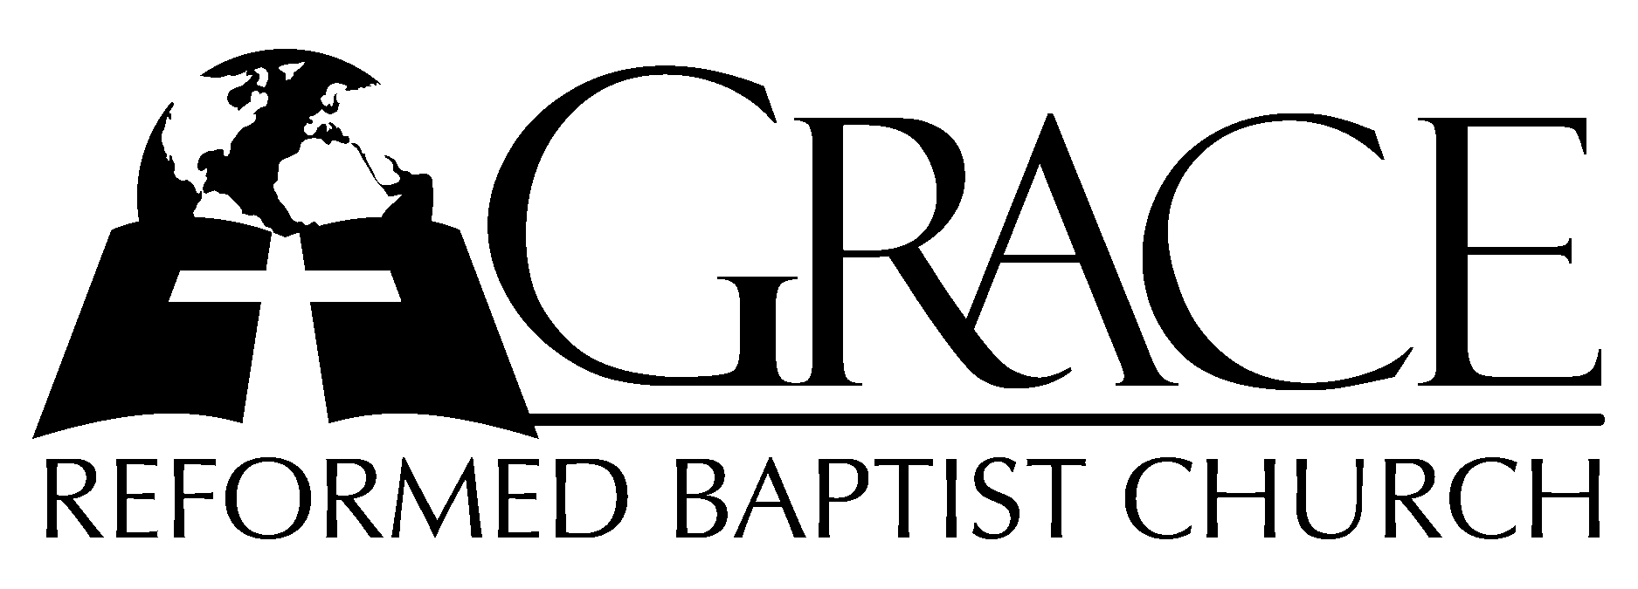
PO Box 221, 939 South Third Street
Mebane, North Carolina 27302
(919) 563-9249

Website: WWW.GRBC.NET

The Lord’s Day Services
Sunday School……….………9:30
Morning Worship……….…10:55
Evening Worship.…………..5:30

Wednesday Evening Prayer Service
7:15

We warmly welcome our Visitors today and request that you sign
the Guest Register located in the Foyer. We hope to greet you in a more personal way following the services.

The Lord’s Day
December 24, 2006

Call to Worship Pastor Andy Dunkerton

Hymn of Praise # 149 “Joy to the World”

Scripture Reading Luke 2: 1-20

Pastoral Prayer

Offertory Hymn “How Deep the Father’s
Love for Us”

1. How deep the Father’s love for us, how vast beyond all measure
that He should give His only Son to make a wretch a treasure.
How great the pain of searing loss. The Father turns His face away
as wounds which mar the Chosen One bring many sons to glory.

2. Behold the Man upon a cross, my sin upon His shoulders.
Ashamed, I hear my mocking voice call out among the scoffers.
It was my sin that held Him there until it was accomplished;
His dying breath has brought me life. I know that it is finished.

3. I will not boast in anything: No gifts, no pow’r, no wisdom.
But I will boast in Jesus Christ: His death and resurrection.
Why should I gain from His reward? I cannot find an answer.
But this I know with all my heart: His wounds have paid my ransom.
(Coda, a cappella) Why should I gain from His reward? I cannot find an answer.
But this I know with all my heart: His wounds have paid my ransom. (no amen)

Words and Music: Stuart Townend Used by Permission CCLI # 1899094

Hymn of Preparation “Angels We Have Heard
on High”

1. Angels we have heard on high, sweetly singing o’er the plains,
And the mountains in reply echo back their joyous strains.
Glo---ri-a in ex-cel-sis De-o, Glo---ri-a in ex-cel-sis De-o!

2. Shepherds, why this jubilee? Why your joyous strains prolong?
Say what may the tidings be, which inspire your heav’nly song?
Glo---ri-a in ex-cel-sis De-o, Glo---ri-a in ex-cel-sis De-o!

3. Come to Bethlehem and see Him whose birth the angels sing;
Come adore on bended knee Christ the Lord, the newborn King.
Glo---ri-a in ex-cel-sis De-o, Glo---ri-a in ex-cel-sis De-o! (no amen)

Traditional French Carol Arranged by Edward S. Barnes, 1937 Used by Permission CCLI # 1899094

Sermon Pastor Gary Hendrix

~~~~~~~~~~~~~~~~~~~~~~~~~~~~~~~~~~~~

Afternoon Worship

Call to Worship Pastor Charles Fortner

Hymn of Praise # 159 “Good Christian
Men Rejoice”

Scripture Reading Isaiah 49: 1-13

Pastoral Prayer

Offertory Hymns “All My Heart This Night
Rejoices”/ “Silent Night”

1. All my heart this night rejoices as I hear far and near
sweetest angel voices.
“Christ is born,” their choirs are singing til the air ev’ry where now with joy is ringing.

2. Hark! A voice from yonder manger, soft and sweet, doth entreat:
“Flee from woe and danger.”
Brethren, from all ills that grieve you, you are freed; All you need I will surely give you.”

3. Come, then, banish all your sadness, one and all, great and small;
Come with songs of gladness.
Love Him who with love is glowing; Hail the star, near and far light and joy bestowing.
(Piano Introduction)
1. Silent Night! Holy Night! All is calm, all is bright
Round yon virgin mother and Child. Holy infant, so tender and mild,
Sleep in heavenly peace, sleep in heavenly peace.

2. Silent Night! Holy Night! Son of God, love’s pure light
Glories stream from heaven afar, heav’nly hosts sing: Alleluia,
Christ, the Savior is born! Christ the Savior is born!

3. Silent Night! Holy Night! Son of God, love’s pure light
Radiant beams from Thy holy face, with the dawn of redeeming grace,
Jesus, Lord, at Thy birth, Jesus, Lord, at Thy birth. AMEN

Hymn of Preparation # 170 “Thou Dost Reign
on High”

Sermon Pastor Andy Dunkerton
~~~~~~~~~~~~~~~~~~~~~~~~~~~~~~~~~~~

