“If you love Me, keep my commandments.
And I will pray the Father, and He will
give you another Helper, that He may
abide with you forever---…
A little while longer and the world will see Me no more, but you will see me. Because I live, you will live also. At that day you will know that I am in My Father, and you in Me, and I in you. He who has my commandments and keeps them, it is he
who loves Me. And He who loves Me will be loved by My Father, and I will love
him and manifest myself to him.”

John 14: 15-16, 19-21

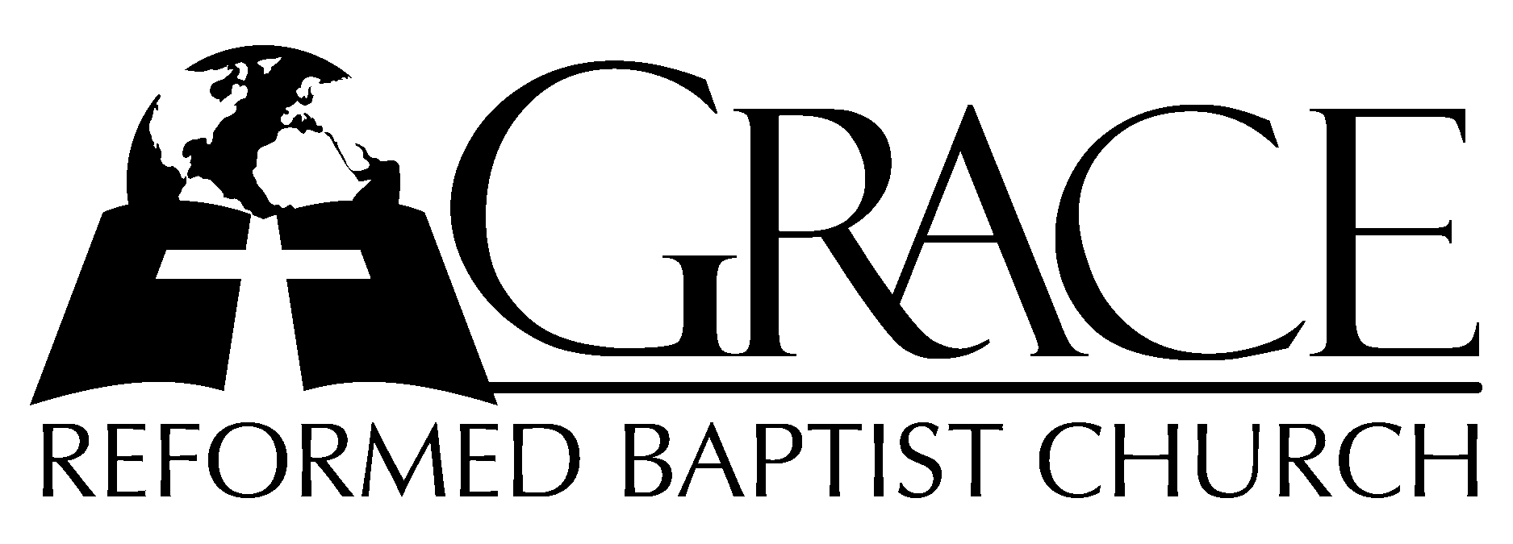
PO Box 221, 939 South Third Street
Mebane, North Carolina 27302
(919) 563-9249

Website: WWW.GRBC.NET

The Lord’s Day Services
Sunday School……….………9:30
Morning Worship……….…10:55
Evening Worship.…………..5:30

Wednesday Evening Prayer Service
7:15

We warmly welcome our Visitors today and request that you sign
the Guest Register located in the Foyer. We hope to greet you
in a more personal way following the services.
The Lord’s Day
January 14, 2007

Call to Worship Pastor Stu Johnston

Hymn of Praise # 218 “All Hail the
Power of Jesus’ Name!”
Scripture Reading John 6: 1-40

Pastoral Prayer

Offertory Hymn # 544 “How Sweet the
Name of Jesus Sounds”
Hymn of Preparation “O, How I Love Jesus”
(Repeat final refrain- a cappella, no amen)

Sermon Pastor Gary Hendrix

~~~~~~~~~~~~~~~~~~~~~~~~~~~~~~~~~~~~

Evening Worship

Call to Worship Pastor Andy Dunkerton

Hymn of Praise # 269 “Glorious Things
of Thee are Spoken”

Scripture Reading I Timothy 3: 1-15
Pastoral Prayer

Offertory Hymn “Jesus, Master Whose
I Am”
1. Jesus, Master, whose I am, purchased Thine a-lone to be—by Thy blood, O spotless Lamb, Shed so will-ing-ly for me, Let my heart be all Thine own, let me live to Thee alone.

2. Jesus, Master, I am Thine: Keep me faithful, keep near; Let Thy presence in me shine
All my homeward way to cheer. Jesus, at Thy feet I fall, O be Thou my all in all.

3. Jesus, Master, Whom I serve, thought so feebly and so ill, strengthen hand and heart and nerve All Thy bidding to fulfil. Open Thou mine eyes to see all the work Thou hast for me.

4. Lord, Thou need-est not, I know, service such as I can bring; Yet I long to prove and show
full al-le-giance to my King. Thou an honor art to me: Let me be a praise to Thee.
Test: Frances R. Havergal, 1865 Tune: James Ward, 1984 Used by Permission

Hymn of Preparation “Take My Life and Let it Be”

Sermon Pastor Gary Hendrix
~~~~~~~~~~~~~~~~~~~~~~~~~~~~~~~~~~~

