“Praise the Lord!
I will praise the Lord with my whole heart,
In the assembly of the upright and in the congregation.
The works of the Lord are great, studied by all who have pleasure in them. His work is honorable and glorious,
and His righteousness endures forever.
He has made His wonderful works to be remembered;
The Lord is gracious and full of compassion.
He has given food to those who fear Him;
He will ever be mindful of His covenant.
He has declared to His people the power of His works,
in giving them the heritage of nations.
The works of His hands are verity and justice;
All His precepts are sure. They stand fast forever and ever,
and are done in truth and uprightness.
He has sent redemption to His people;
He has commanded His covenant forever:
Holy and awesome is His name.
The fear of the Lord is the beginning of wisdom;
A good understanding have all those who do His commandments. His praise endures forever.”
Psalm 111

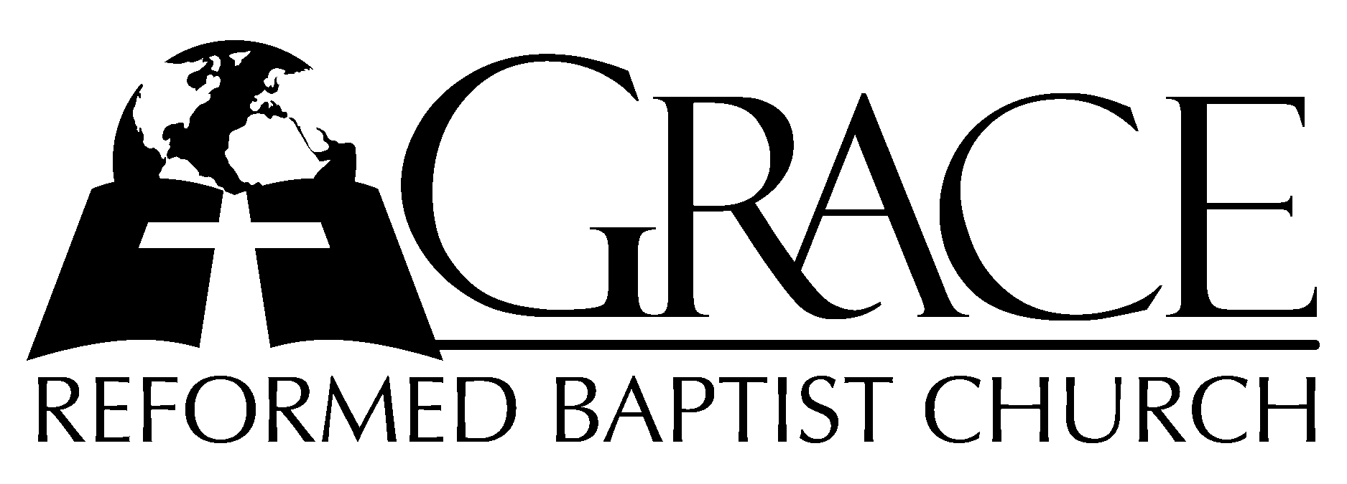
PO Box 221, 939 South Third Street
Mebane, North Carolina 27302
(919) 563-9249

Website: WWW.GRBC.NET

The Lord’s Day Services
Sunday School……….………9:30
Morning Worship……….…10:55
Evening Worship.…………..5:30

Wednesday Evening Prayer Service
7:15

We warmly welcome our Visitors today and request that you sign
the Guest Register located in the Foyer. We hope to greet you
in a more personal way following the services.

The Lord’s Day
February 4, 2007

Call to Worship Pastor Stu Johnston

Hymns of Praise “Thou Art Worthy”
Thou art worthy, Thou art worthy, Thou art worthy, O Lord, to receive glory, glory and honor, glory and honor and pow’r. For Thou hast created, hast all things created; Thou hast created
all things. And for Thy pleasure they are created; for Thou art worthy, O Lord.

“All Creatures of Our God and King”

Thou Art Worthy Text and Music : Pauline Mills, 1975 Fred Bock Music Used by Permission CCLI # 1899094
All Creatures of Our God and King Text: St. Francis of Assisi; translated by William Draper Music: Lasst Uns Erfreuen Arr. by Ralph V. Williams
Oxford University Press Used by Permission CCLI # 1899094

Scripture Reading II Corinthians 3

Pastoral Prayer

Offertory Hymn # 590 “Peace, Perfect
Peace”

Hymn of Preparation # 397 “I Sought the
Lord”

Sermon Pastor Andy Dunkerton

~~~~~~~~~~~~~~~~~~~~~~~~~~~~~~~~~

Evening Worship

Call to Worship Pastor Charles Fortner

Hymn of Praise # 5 “Mighty God, While
Angels Bless Thee”
Scripture Reading Genesis 27: 1-41
Pastoral Prayer

Offertory Hymn # 370 “Jesus Saves”
Hymn of Preparation # 393 “Come, Ye Sinners”
Sermon Pastor Stu Johnston

~~~~~~~~~~~~~~~~~~~~~~~~~~~~~~~~~

“Lo! The incarnate God, ascended, pleads the merit
of His blood; Venture on Him, venture wholly,
let no other trust intrude:
None but Jesus, none but Jesus, none but Jesus
can do helpless sinners good.”

