“For we do no preach ourselves,
but Christ Jesus, the Lord,
and ourselves your bondservants
for Jesus’ sake.
For it is the God who commanded
light to shine out of darkness,
who has shone in our hearts
to give the light of the knowledge
of the glory of God in the face
of Jesus Christ.
But we have this treasure in earthen vessels, that the excellence
of the power may be of God
and not of us.”

II Corinthians 4: 5-7

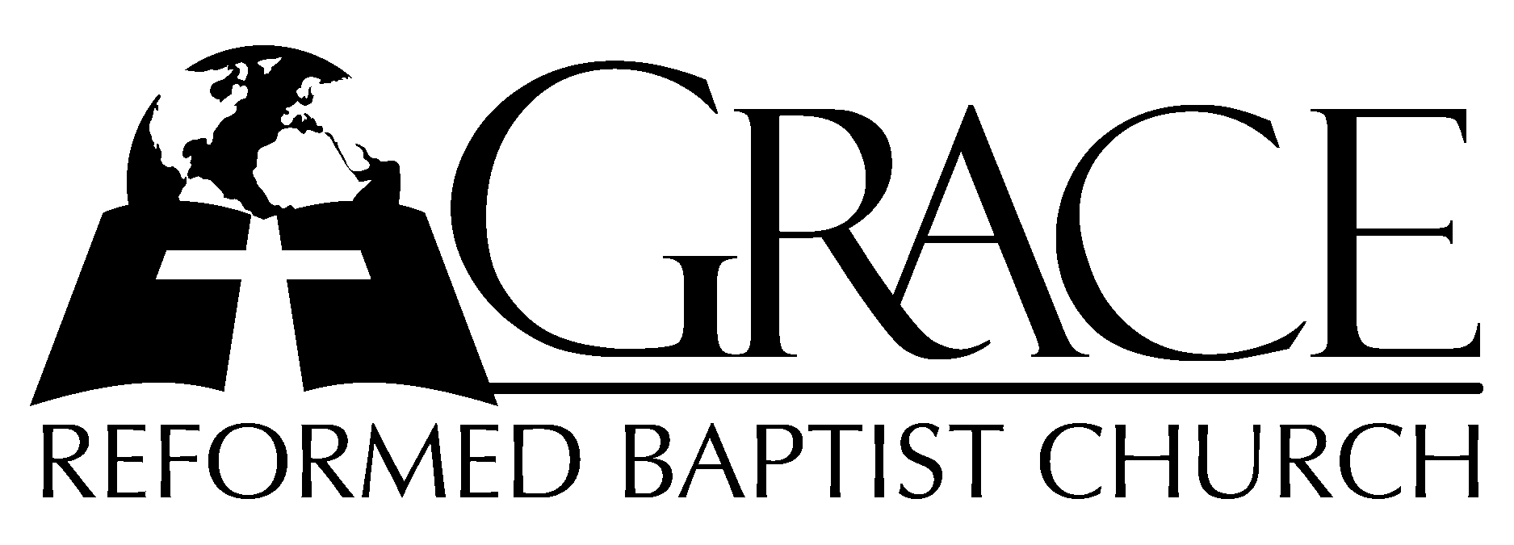
PO Box 221, 939 South Third Street
Mebane, North Carolina 27302
(919) 563-9249

Website: WWW.GRBC.NET

The Lord’s Day Services
Sunday School……….………9:30
Morning Worship……….…10:55
Evening Worship.…………..5:30

Wednesday Evening Prayer Service
7:15

We warmly welcome our Visitors today and request that you sign
the Guest Register located in the Foyer. We hope to greet you
in a more personal way following the services.

The Lord’s Day
February 18, 2007

Call to Worship Pastor Stu Johnston

Hymn of Praise # 218 “All Hail the Pow’r
of Jesus’ Name!”
(Third Tune)
Scripture Reading II Corinthians 4

Pastoral Prayer

Offertory Hymn # 76 “With Grateful
Heart’

Hymn of Preparation “In Christ Alone,
My Hope is Found”

1. In Christ alone my hope is found, He is my light, my strength, my song;
This Cornerstone, this Solid Ground, firm through the fiercest drought and storm.
What heights of love, what depths of peace, when fears are stilled, when strivings cease.
My Comforter, my All in All, here in the love of Christ I’ll stand.

2. In Christ alone, Who took on flesh, fullness of God in helpless Babe!
This Gift of Love and Righteousness, scorned by the ones He came to save.
‘Til on the cross as Jesus died, the wrath of God was satisfied.
For ev’ry sin on Him was laid; here in the death of Christ I live.

3. There in the ground His body lay, Light of the World by darkness slain;
Then, bursting forth in glorious day, up from the grave he rose again!
And as He stands in victory, sin’s curse has lost its grip on me;
For I am His and He is mine, bought with the precious blood of Christ.

4. No guilt in life, no fear in death, this is the pow’r of Christ in me;
From life’s first cry to final breath, Jesus commands my destiny.
No pow’r of hell, no scheme of man, can ever pluck me from His hand;
‘Til He returns or calls me home, here in the pow’r of Christ I’ll stand.

Words and Music: Keith Getty and Stuart Townend 2002 Thankyou Music Used by Permission CCLI # 1899094

Sermon Pastor Andy Dunkerton

*****************************************

Evening Worship

Call to Worship Pastor Charles Fortner

Hymn of Praise # 132 “Wondrous King
All Glorious”

Scripture Reading I Samuel 20: 1-42

Offertory Hymn “Weary of Earth”

1. Weary of earth, and laden with my sin, I look at heav’n and long to enter in;
But there no evil thing may find a home; and yet I hear a voice that bids me “Come.”

2. So vile I am, how dare I hope to stand in the pure glory of that holy land?
Before the whiteness of that throne appear? Yet there are hands stretched out to draw me near.

3. The while I fain would tread the heav’nly way, evil is ever with me day by day;
Yet on mine ears the gracious tidings fall, “Repent, confess, thou shalt be loosed from all.”

4. It is the voice of Jesus that I hear; His are the hands stretched out to draw me near,
And His the blood that can for all atone and set me faultless there before the throne.

5. O great Absolver, grant my soul may wear the lowliest garb of penitence and prayer,
That in the Father’s courts my glorious dress may be the garment of Thy righteousness.

6. Yea, Thou wilt answer for me, righteous Lord; Thine all the merits, mine the great reward;
Thine the sharp thorns, and mine the golden crown; Mine the life won, and Thine the
life laid down. AMEN

Pastoral Prayer

Hymn of Preparation “Ancient Words”

1. Holy words long preserved for our walk in this world,
They resound with God’s own heart. O, let the ancient words impart.
Words of life, words of hope, give us strength, help us cope.
In this world where’er we roam, ancient words will guide us home.
Ancient words, ever true, changing me and changing you;
We have come with open hearts, O, let the ancient words impart.

2. Holy words of our faith handed down to this age,
Came to us through sacrifice. O, heed the faithful words of Christ.
Holy words long preserved for our walk in this world,
They resound with God’s own heart. O, let the ancient words impart.
Ancient words, ever true, changing me and changing you;
We have come with open hearts, O, let the ancient words impart.
Ancient words, ever true, changing me and changing you;
We have come with open hearts, O, let the ancient words impart.
We have come with open hearts, O, let the ancient words impart.

Words and Music: Lynn Deshazo, 2001 Integrity’s Hosanna! Music Used by Permission CCLI # 1899094

Sermon Pastor Stu Johnston

******************************************

