“Praise the Lord!

Praise the Lord from the heavens;
Praise Him in the heights!
Praise Him, all His angels; Praise Him, all His hosts!
Praise Him, sun and moon;
Praise Him, all you stars of light!
Praise Him, you heavens of heavens,
and you waters above the heavens!
Let them praise the name of the Lord,
for He commanded and they were created.
He also established them forever and ever;
He made a decree which shall not pass away.
Let them praise the name of the Lord,
for His name alone is exalted;
His glory is above the earth and heaven.

Praise the Lord!”

Psalm 148: 1-6, 13

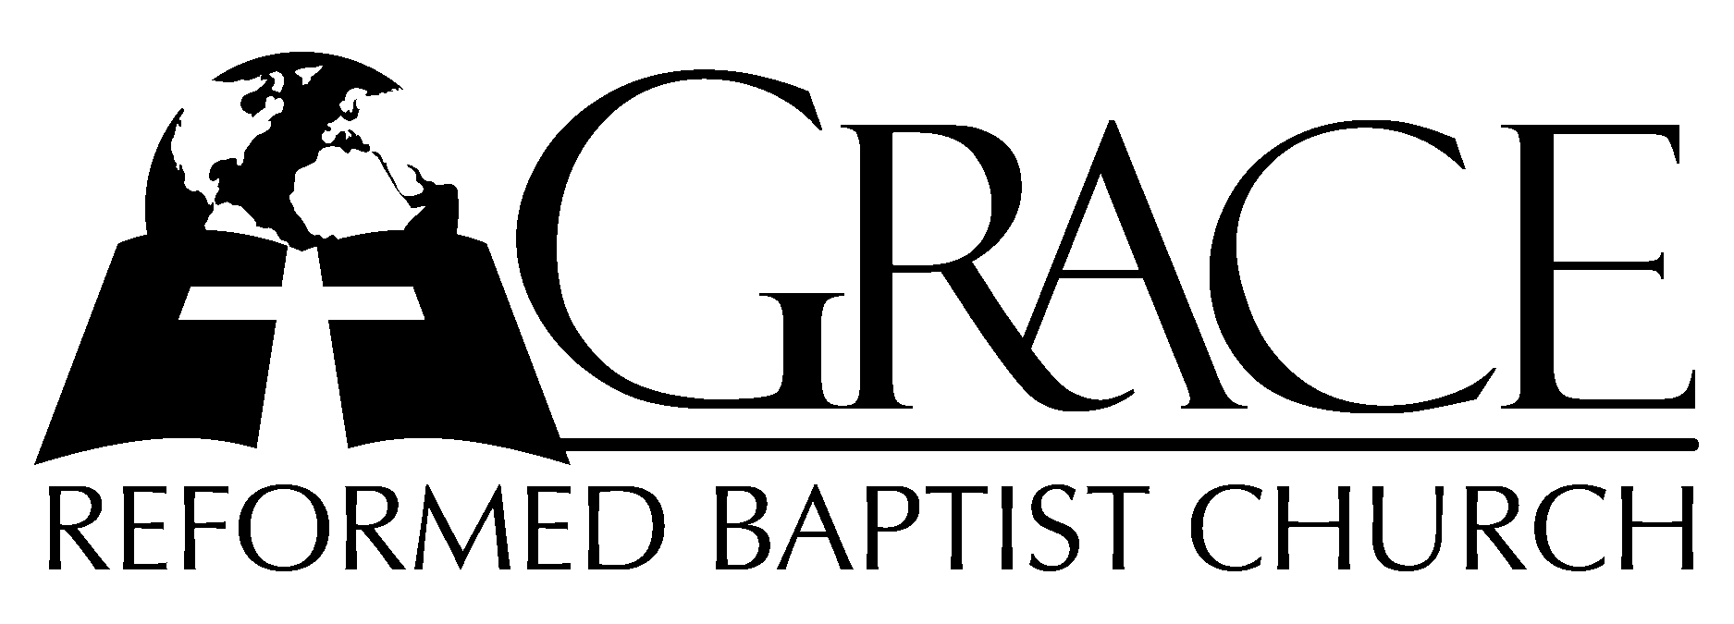
PO Box 221, 939 South Third Street
Mebane, North Carolina 27302
(919) 563-9249

Website: WWW.GRBC.NET

The Lord’s Day Services
Sunday School……….………9:30
Morning Worship……….…10:55
Evening Worship.…………..5:30

Wednesday Evening Prayer Service
7:15

We warmly welcome our Visitors today and request that you sign
the Guest Register located in the Foyer. We hope to greet you
in a more personal way following the services.

The Lord’s Day
March 18, 2007

Call to Worship Pastor Andy Dunkerton

Hymn of Praise “Hallelujah, Praise
Jehovah”
1. Hallelujah, praise Jehovah; from the heavens praise His name.
Praise Jehovah in the highest; All His angels praise proclaim.
All His hosts together praise Him, sun and moon and stars on high;
Praise Him, O ye heav’ns of heavens, and ye floods above the sky,
And ye floods above the sky.
2. Let them praises give Jehovah, they were made at His command;
Them forever He established, His decree shall ever stand.
From the earth, O praise Jehovah, all ye seas, ye monsters all,
Fire and hail and snow and vapors, stormy winds that hear His call,
Stormy winds that hear his call.
3. All ye fruitful trees and cedars, all ye hills and mountains high;
Creeping things and beasts and cattle, birds that in the heavens fly,
Kings of earth, and all ye people, princes great, earth’s judges all;
Praise His Name, young men and maidens, aged men, and children small,
Aged men, and children small.
4. Hallelujah, praise Jehovah; from the heavens praise His name.
Praise Jehovah in the highest; All His angels praise proclaim.
All His hosts together praise Him, sun and moon and stars on high;
Praise Him, O ye heav’ns of heavens, and ye floods above the sky,
And ye floods above the sky.

Text: Psalm 148: 1-13 Music: Mike Clark Used by Permission

Scripture Reading II Corinthians 8

Pastoral Prayer

Offertory Hymn “Riches Ours in Christ
Above”
1. Choirs of angels worshiped Thee, wreathed in glorious majesty;
Object of Your Father’s love, riches Yours in realms above.

2. Left heav’ns praise, for sinners sake, humble servant’s form dids’t take;
Died beneath God’s wrathful blow, poverty Your cup below.

3. Guilty, wretched, hopeless we, held in sin’s dark misery,
Worthy of God’s wrathful blow, poor our sinful state below.

4. Through His willing poverty, freed from sin and death are we,
Safe in God’s eternal love, riches ours in Christ above! AMEN

Hymn of Preparation # 309 “Jesus, Where’er
Thy People Meet”

Sermon Pastor Gary Hendrix

*****************************************

Evening Worship

Call to Worship Pastor Charles Fortner

Hymn # 267 “O Word of God
Incarnate”
Scripture Reading Proverbs 20: 1-15

Offertory Hymn # 262 “God, in the Gospel”

Pastoral Prayer

Hymn of Preparation # 297 “Revive Thy Work,
O Lord”
Sermon Pastor Gary Hendrix

*****************************************

“Revive Thy work, O Lord, exalt Thy precious Name;
And, by the Holy Ghost, our love For Thee
and Thine inflame.”

Albert Midlane, 1858, vs. 4, Revive Thy Work, O Lord

