“His name shall endure forever;
His name shall continue as long as the sun.
And men shall be blessed in Him;
All nations shall call Him blessed.
Blessed be the Lord God, the God of Israel,
Who only does wondrous things!
And blessed be His glorious name forever!
And let the whole earth be filled
with His glory. Amen and Amen”

Psalm 72: 17-19

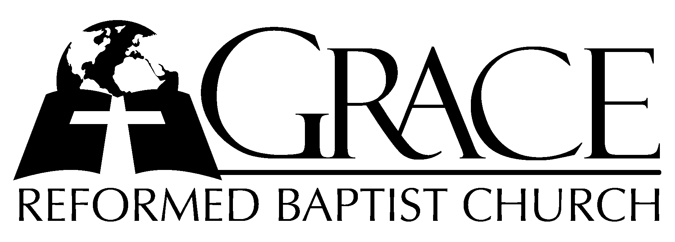
PO Box 221, 939 South Third Street
Mebane, North Carolina 27302
(919) 563-9249

Website: WWW.GRBC.NET

The Lord’s Day Services
Sunday School……….………9:30
Morning Worship……….…10:55
Evening Worship.…………..5:30

Wednesday Evening Prayer Service
7:15

We warmly welcome our Visitors today and request that you sign
the Guest Register located in the Foyer. We hope to greet you
in a more personal way following the services.

The Lord’s Day
April 1, 2007

Call to Worship Pastor Charles Fortner

Hymn of Praise # 63 “God is Known
Among His People”

Scripture Reading II Corinthians 10

Pastoral Prayer

Offertory Hymn “Jesus Shall Reign”

Text: Based on Psalm 72, Isaac Watts, 1719 Tune: DUKE STREET , John Halton, 1793

Hymn of Preparation # 173 “All Glory, Laud,
and Honor”

Sermon Pastor Andy Dunkerton

*****************************************

Evening Worship

Call to Worship Pastor Andy Dunkerton

Doxology

Praise God from whom all blessings flow; Praise Him all creatures here below.
Praise Him above ye heavenly host; Praise Father, Son and Holy Ghost.
(Repeat verse, ladies may sing the “descant”) AMEN

Prayer

Hymn of Adoration # 18 “Thee We Adore,
Eternal Lord”

Scripture Reading Proverbs 21: 1-16

Offertory Hymn # 280 “I Love Thy
Kingdom, Lord” (first tune)
Pastoral Prayer

Hymn of Preparation # 132 “Wondrous King,
All Glorious”

Sermon Pastor Gary Hendrix

*****************************************

“Oh, my soul, rejoicing, sing, Thy praises voicing,
Sing, with hymns of faith adore Him! All who here have being, shout, your voices freeing, bow down in the dust before Him. He is God, Sabaoth; praise alone the Savior,
here and there forever.”

Wondrous King, All-Glorious, Verse 3

