“All the kings of the earth shall praise You, O Lord,
when they hear the words of Your mouth.
Yes, they shall sing of the ways of the Lord,
for great is the glory of the Lord.
Though the Lord is on high,
yet He regards the lowly;
but the proud He knows from afar.
Though I walk in the midst of trouble,
You will revive me;
You will stretch out Your hand against
the wrath of my enemies,
and Your right hand will save me.
The Lord will perfect that which concerns me;
Your mercy, O Lord, endures forever;
do not forsake the works of Your hands.”

Psalm 138: 4-8

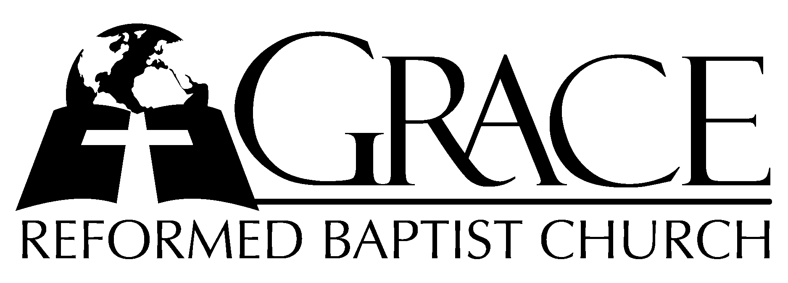
PO Box 221, 939 South Third Street
Mebane, North Carolina 27302
(919) 563-9249

Website: WWW.GRBC.NET

The Lord’s Day Services
Sunday School……….………9:30
Morning Worship……….…10:55
Evening Worship.…………..5:30

Wednesday Evening Prayer Service
7:15

We warmly welcome our Visitors today and request that you sign
the Guest Register located in the Foyer. We hope to greet you
in a more personal way following the services

The Lord’s Day
April 22, 2007

Call to Worship Pastor Stu Johnston

Hymns of Praise “Holy, Holy, Holy”/
“Worthy, You Are Worthy”

1. Worthy, You are worthy, King of kings, Lord of lords, You are worthy;
Worthy, You are worthy, King of King, Lord of lords, I worship You.
2. Holy, You are holy, King of kings, Lord of lords, You are holy;
Holy, You are holy, King of kings, Lord of lords, I worship You.
2. Jesus, You are Jesus, King of kings, Lord of lords, You are Jesus;
Jesus, You are Jesus, King of kings, Lord of lords, I worship You. AMEN

Words and Music: Don Moen 1986, 1992 Integrity’s Hosanna! Music Used by Permission CCLI # 1899094

Scripture Reading II Corinthians 12

Pastoral Prayer

Offertory Hymn # 101 “My Song Forever
Shall Record”

Hymn of Preparation # 543 “O Lord, I Would
Delight in Thee”

Sermon Pastor Andy Dunkerton

~~~~~~~~~~~~~~~~~~~~~~~~~~~~~~~~~~~~~

Evening Worship

Call to Worship Pastor Charles Fortner
Hymn of Praise # 76 “With Grateful
Heart My Thanks I Bring”

Scripture Reading Proverbs 22: 16-29

Pastoral Prayer

Offertory Hymn # 453 “O The Deep, Deep
Love of Jesus”

Hymn of Preparation “Before The Throne
of God Above”

1. Before the throne of God above, I have a strong – a perfect plea,
A great High Priest whose name is “Love,” Who ever lives and pleads for me.
My name is graven on His hands, my name is written on His heart;
I know that while in heav’n He stands no tongue can bid me thence depart,
No tongue can bid me thence depart.

2. When Satan tempts me to despair, and tells me of the guilt within,
Upward I look to see Him there Who made and end to all my sin.
Because the sinless Savior died, my sinful soul is counted free;
For God, the Just, is satisfied to look on Him and pardon me,
To look on Him and pardon me.

3. Behold Him there! The risen Lamb, my perfect, spotless Righteousness,
The great unchangable I AM, the King of glory and of grace!
One with Himself I cannot die, my soul is purchased by His blood;
My life is hid with Christ on high, with Christ, my Savior and my God,
With Christ my Savior and my God.

Words: Charitie Lees Bancroft (1841-1923) Music: Vikki Cook, 1997 PDI Worship
Used by Permission CCLI # 1899094

Sermon Pastor Stu Johnston
~~~~~~~~~~~~~~~~~~~~~~~~~~~~~~~~~~~~~

