“His Name shall endure forever;
His Name shall continue
as long as the sun.
And men shall be blessed in Him;
All nations shall call Him blessed.
Blessed be the Lord God,
the God of Israel,
Who only does wondrous things!
And blessed be His glorious
Name forever!
And let the whole earth
be filled with His glory.
Amen and Amen.”

Psalm 72: 17-19

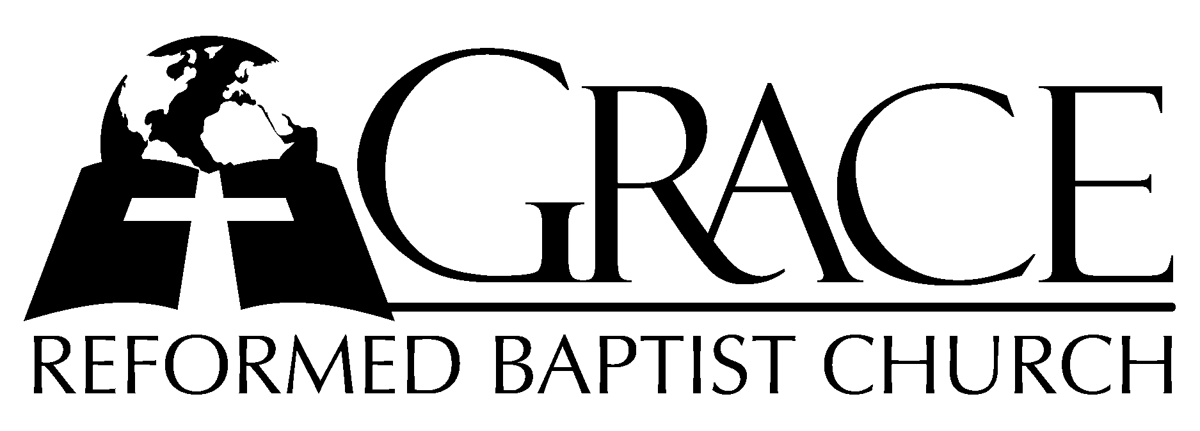
PO Box 221, 939 South Third Street
Mebane, North Carolina 27302
(919) 563-9249

Website: WWW.GRBC.NET

The Lord’s Day Services
Sunday School……….………9:30
Morning Worship……….…10:55
Evening Worship.…………..5:30

Wednesday Evening Prayer Service
7:15

We warmly welcome our Visitors today and request that you sign
the Guest Register located in the Foyer. We hope to greet you
in a more personal way following the services

The Lord’s Day
April 29, 2007

Call to Worship Pastor Stu Johnston

Hymn of Praise “Jesus Shall Reign”

Text: Based on Psalm 72 Isaac Watts, 1719 Tune: DUKE STREET, John Hatton, 1793 Used by Permission CCLI # 1899094

Scripture Reading II Corinthians 13

Pastoral Prayer

Offertory Hymn “There is a Redeemer”
1. There is a Redeemer, Jesus, God’s own Son; Precious Lamb of God, Messiah, Holy One.
(Refrain)
Thank You, O my Father, for giving us Your Son, and leaving Your Spirit
`Til the work on earth is done.
2. Jesus, my Redeemer, name above all names; Precious Lamb of God, Messiah,
O for sinners slain. (Refrain)
( a cappella) 3. When I stand in Glory, I will see His face, There I’ll serve my King forever
In that holy place. (Refrain, AMEN)
Text and Music: Melody Green Birdwing Music, 1982 Used by Permission CCLI # 1899094

Hymn of Preparation “Ancient Words”

1. Holy words long preserved for our walk in this world,
They resound with God’s own heart. O, let the ancient words impart.
Words of life, words of hope, give us strength, help us cope.
In this world where’er we roam, ancient words will guide us home.
Ancient words, ever true, changing me and changing you;
We have come with open hearts, O, let the ancient words impart.

2. Holy words of our faith handed down to this age,
Came to us through sacrifice. O, heed the faithful words of Christ.
Holy words long preserved for our walk in this world,
They resound with God’s own heart. O, let the ancient words impart.

Ancient words, ever true, changing me and changing you;
We have come with open hearts, O, let the ancient words impart.
Ancient words, ever true, changing me and changing you;
We have come with open hearts, O, let the ancient words impart.
We have come with open hearts, O, let the ancient words impart. (instrumental ending)

Words and Music: Lynn Deshazo, 2001 Integrity’s Hosanna! Music Used by Permission CCLI # 1899094

Sermon Pastor Gary Hendrix

~~~~~~~~~~~~~~~~~~~~~~~~~~~~~~~~~~~~~

Evening Worship
Call to Worship Pastor Charles Fortner

Hymn of Praise “O God, the Rock of Ages”
1. O God, the Rock of Ages, Who evermore hast been,
What time the tempest rages, our dwelling place serene:
Before Thy first cre-a-tions, O Lord, the same as now,
To endless ge-ner-a-tions the Everlasting Thou!

2. Our years are like the shadows on sunny hills that lie,
Or grasses in the meadows that blossom but to die;
A sleep, a dream, a sto-ry by strangers quickly told,
An un-re-main-ing glo-ry of things that soon are old.

3. O Thou who can-not slumber, Whose light grows never pale,
Teach us aright to number our years before they fail;
On us Thy mercy light-en, on us Thy goodness rest,
And let Thy Spirit bright-en the hearts Thyself hast blessed.

4. Lord, crown our faith’s endeavor with beauty and with grace,
Till, clothed in light for-ev-er, we see Thee face to face:
A joy no language mea-sures; a fountain brimming o’er;
An endless flow of plea-sures; and ocean without shore. AMEN

Tesxt: Edward Bickersteth, 1860 Music: ST. THEODULPH, Melchior Teschner, c. 1615

Scripture Reading Proverbs 23: 1-18

Offertory Hymn # 518 “Come,
Ye Disconsolate”
Pastoral Prayer

Hymn of Preparation # 44 “O Lord Most High”

Sermon Pastor Andy Dunkerton
~~~~~~~~~~~~~~~~~~~~~~~~~~~~~~~~~~~~~

