“Bless the Lord, O my soul;
and all that is within me, bless His holy name!
Bless the Lord, O my soul,
and forget not all His benefits:
Who forgives all your iniquities,
Who heals all your diseases,
Who redeems your life from destruction,
Who crowns you with lovingkindness
and tender mercies,
Who satisfies your mouth with good things,
so that your youth is renewed
like the eagle’s….
Bless the Lord, O my soul!”

Psalm 103: 1-5

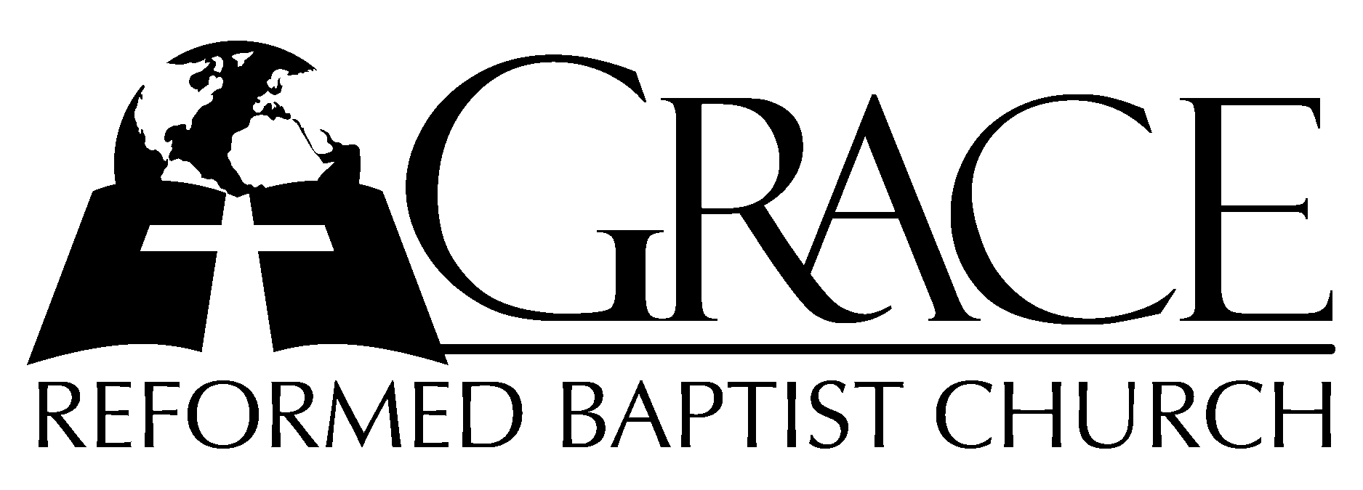
PO Box 221, 939 South Third Street
Mebane, North Carolina 27302
(919) 563-9249

Website: WWW.GRBC.NET

The Lord’s Day Services
Sunday School……….………9:30
Morning Worship……….…10:55
Evening Worship.…………..5:30

Wednesday Evening Prayer Service
7:15

We warmly welcome our Visitors today and request that you sign
the Guest Register located in the Foyer. We hope to greet you
in a more personal way following the services.

The Lord’s Day
June 10, 2007

Call to Worship Pastor Andy Dunkerton

Hymn of Praise # 50 “Praise to the Lord”

Scripture Reading Galatians 4: 19-31

Pastoral Prayer

Offertory Hymn # 27 “Great is Thy
Faithfulness”

Hymn of Preparation “How Deep the Father’s
Love for Us”

1. How deep the Father’s love for us, how vast beyond all measure
That He should give His only Son to make a wretch a treasure.
How great the pain of searing loss. The Father turns His face away
As wounds which mar the Chosen One bring many sons to Glory.

2. Behold the Man upon the cross, my sin upon His shoulders.
Ashamed, I hear my mocking voice call out among the scoffers.
It was my sin that held Him there until it was accomplished;
His dying breath has brought me life. I know that it is finished.

3. I will not boast in anything: No gifts, no pow’r, no wisdom.
But I will boast in Jesus Christ: His death and resurrection.
Why should I gain from His reward? I cannot find an answer.
But this I know with all my heart: His wounds have paid my ransom.

(Coda, a cappella)

Why should I gain from His reward? I cannot find an answer.
But this I know with all my heart: His wounds have paid my ransom.

Words and Music: Stuart Townend, 1995 Kingsway ThankYou Music, Used by Permission CCLI # 1899094

Sermon Pastor Gary Hendrix
~~~~~~~~~~~~~~~~~~~~~~~~~~~~~~~~~~~~

Evening Worship

Call to Worship Pastor Charles Fortner

Hymn of Praise # 135 “I Greet Thee Who
My Sure Redeemer Art”

Scripture Reading Proverbs 25: 1-13

Offertory Hymn # 115 “None Other Lamb”

Pastoral Prayer
Hymn of Preparation # 95 “How Vast the
Benefits Divine”
Sermon Pastor Gary Hendrix
~~~~~~~~~~~~~~~~~~~~~~~~~~~~~~~~~~~~

Communion Hymns

# 359 “ ‘Twas On That Night”

“Lamb of God”

1. Your only Son – no sin to hide, but You have sent Him from Your side
To walk upon this guilty sod and to become the Lamb of God.
O Lamb of God, sweet Lamb of God, I love the holy Lamb of God.
O wash me in His precious blood, my Jesus Christ, the Lamb of God.

2. Your gift of love they crucified, they laughed and scorned Him as He died,
The humble King they named a fraud and sacrificed the Lamb of God.
O Lamb of God, sweet Lamb of God, I love the holy Lamb of God.
O wash me in His precious blood, my Jesus Christ, the Lamb of God.

3. I was so lost – I should have died, but You have brought me to Your side
To be led by Your staff and rod, and to be called a lamb of God.
O Lamb of God, sweet Lamb of God, I love the holy Lamb of God.
O wash me in His precious blood, till I become a lamb of God.

Words and Music: Twila Paris, 1985 StraightWay Music and Mountain Spring Music, Used by Permission CCLI # 1899094

# 436 “O Mystery of Love Divine”
~~~~~~~~~~~

“But the Scripture has confined all under sin,
that the promise by faith in Jesus Christ might be given to those who believe. But before faith came, we were kept under guard by the law,
kept for the faith which would afterward be revealed. Therefore the law was our tutor to bring us to Christ, that we might be justified by faith. But after faith has come, we are no longer under a tutor. For you are all sons of God through faith in Christ Jesus. For as many of you as were baptized into Christ have put on Christ. There is neither Jew nor Greek, there is neither slave nor free, there is neither male nor female; for you are all one in Christ Jesus.”
Galatians 3: 22-28

PO Box 221, 939 South Third Street
Mebane, North Carolina 27302
(919) 563-9249

Website: WWW.GRBC.NET

The Lord’s Day Services
Sunday School……….………9:30
Morning Worship……….…10:55
Evening Worship.…………..5:30

Wednesday Evening Prayer Service
7:15

We warmly welcome our Visitors today and request that you sign
the Guest Register located in the Foyer. We hope to greet you
in a more personal way following the services.

