“Let this mind be in you which is also in Christ Jesus, who, being
in the form of God, did not consider
it robbery to be equal with God,
but made Himself of no reputation, taking on the form of a bondservant, and coming in the likeness of men.
And being found in appearance
as a man, He humbled Himself and became obedient to the point of death, even the death of the cross.”
Philippians 2: 5-8

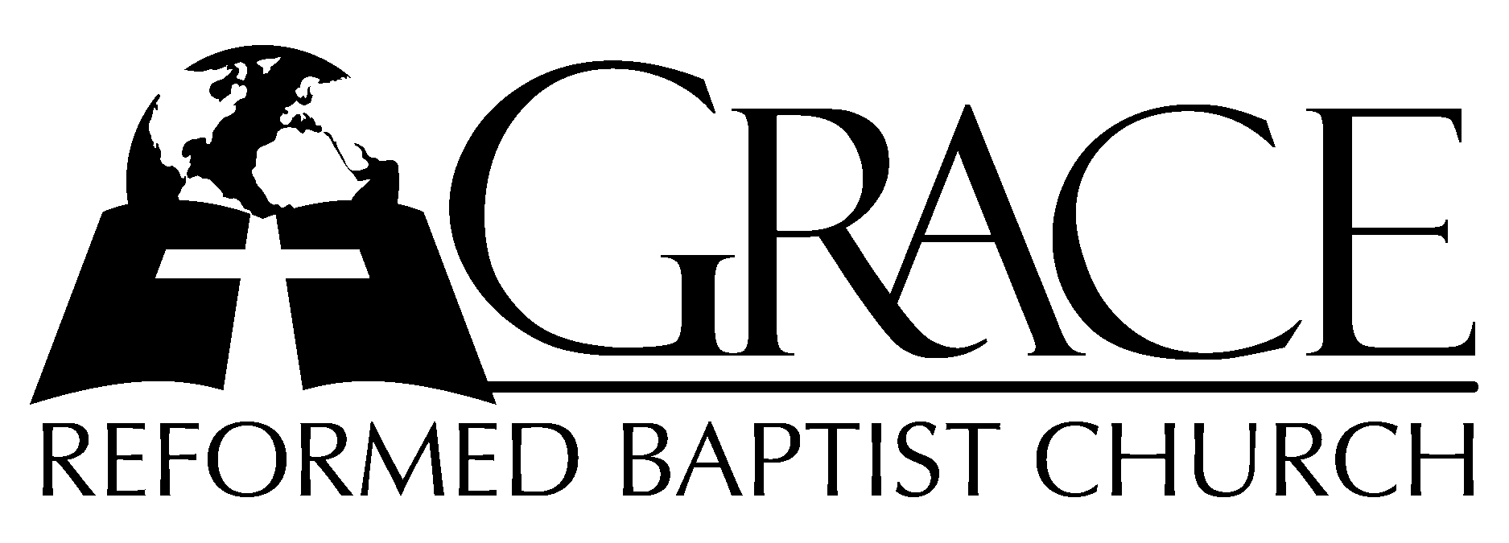
PO Box 221, 939 South Third Street
Mebane, North Carolina 27302
(919) 563-9249

Website: WWW.GRBC.NET

The Lord’s Day Services
Sunday School……….………9:30
Morning Worship……….…10:55
Evening Worship.…………..5:30

Wednesday Evening Prayer Service
7:15

We warmly welcome our Visitors today and request that you sign
the Guest Register located in the Foyer. We hope to greet you
in a more personal way following the services.

The Lord’s Day
September 2, 2007

Call to Worship Pastor Stu Johnston

Hymn of Praise # 81 “A Mighty Fortress
is Our God”
Scripture Reading Philippians 2: 1-11

Pastoral Prayer

Offertory Hymn “Before the Throne
of God Above”

1. Before the throne of God above I have a strong, a perfect plea,
A great High Priest whose name is “Love,” Who ever lives and pleads for me.
My name is graven on His hands, my name is written on His heart;
I know that while in heav’n He stands no tongue can bid me thence depart,
No tongue can bid me thence depart.

2. When Satan tempts me to despair, and tells me of the guilt within,
Upward I look and see Him there Who made an end to all my sin.
Because the sinless Savior died, my sinful soul is counted free;
For God, the Just, is satisfied to look on Him and pardon me,
To look on Him and pardon me.

3. Behold Him there! the risen Lamb, my perfect, spotless Righteousness,
The great unchangable “I AM,” the King of glory and of grace!
One with Himself I cannot die, my soul is purchased by His blood;
My life is hid with Christ on high, with Christ, my Savior and my God,
With Christ, my Savior and my God. (no amen)

Text: Charitie Lees Bancroft (1841-1923) Music: Vikki Cook, PDI Worship
Used by Permission CCLI # 1899094

Hymn of Preparation “Am I a Soldier
of The Cross?”
1. Am I a soldier of the cross? A foll’wer of the Lamb?
And shall I fear to own His cause or blush to speak His name?

2. Must I be carried to the skies on flow’ry beds of ease,
While others fought to win the prize and sailed thru bloody seas?

3. Are there no foes for me to face? Must I not stem the flood?
Is this vile world a friend to grace, to help me on to God?

4. Sure I must fight if I would reign: Increase my courage, Lord;
I’ll bear the toil, endure the pain, supported by Thy Word.

5. Thy saints, in all this glorious war, shall conquer, though they die;
They view the triumph from afar, and seize it with their eye.

6. When that illustrious day shall rise, and all Thine armies shine
In robes of vict’ry through the skies, the glory shall be Thine. AMEN

Text: Isaac Watts, 1724 Tune: ARLINGTON, Thomas A. Arne

Sermon Pastor Gary Hendrix
~~~~~~~~~~~~~~~~~~~~~~~~~~~~~~~
Evening Worship

Call to Worship Pastor Charles Fortner

Hymn of Praise “For All The Saints”

Text: William W. How, 1875 Tune: Ralph V. Williams, 1906, Oxford University Press Used by Permission CCLI # 1899094

Scripture Reading Proverbs 28: 15-28

Offertory Hymn # 94 “What e’er My God Ordains is Right”

Hymn of Preparation “How Firm a Foundation”

1. How firm a foundation, ye saints of the Lord, is laid for your faith in His excellent Word!
What more can He say than to you He hath said, you who unto Jesus for refuge have fled?

2. “Fear not, I am with thee, O be not dismayed; I, I am thy God, and will still give thee aid;
I’ll strengthen thee, help thee, and cause thee to stand, upheld by My righteous, omnipotent hand.

3. When through fiery trials thy pathway shall lie, My grace, all sufficient, shall be thy supply:
The flame shall not hurt thee; I only design thy dross to consume and thy gold to refine.

4. The soul that on Jesus hath leaned for repose-I will not, I will not desert to its foes;
That soul, though all hell should endeavor to shake, I’ll never, no never, no, never forsake!” AMEN

Text: Rippon’s Selection of Hymns, 1787 Tune: Traditional American Melody

Sermon Pastor Andy Dunkerton

