“He is the image of the invisible God,
the firstborn over all creation. For by Him all things were created that are in heaven and that are on earth, visible and invisible, whether thrones or dominions or principalities or powers. All things were created through Him and for Him.
And He is before all things, and in Him all things consist. And He is head of the body, the church, who is the beginning,
the firstborn from the dead, that in all things He may have the preeminence.”

Colossians 1: 15-18

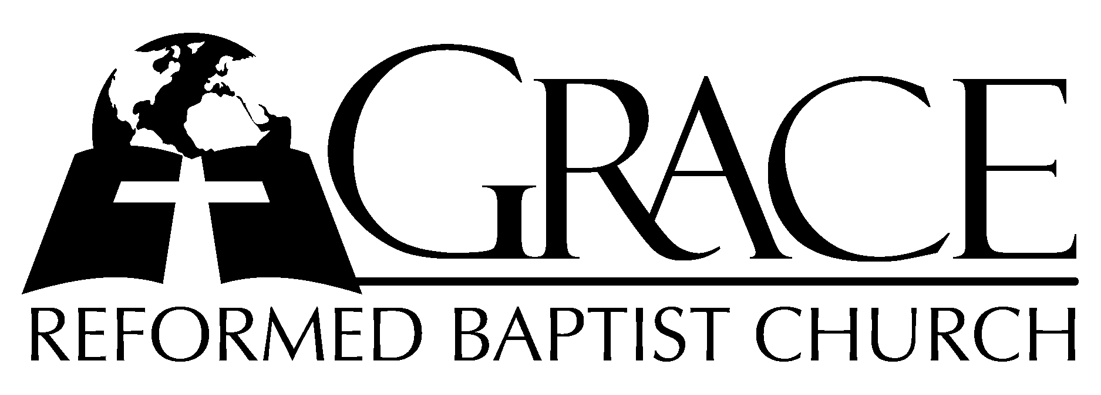
PO Box 221, 939 South Third Street
Mebane, North Carolina 27302
(919) 563-9249

Website: WWW.GRBC.NET

The Lord’s Day Services
Sunday School……….………9:30
Morning Worship……….…10:55
Evening Worship.…………..5:30

Wednesday Evening Prayer Service
7:15

We warmly welcome our Visitors today and request that you sign
the Guest Register located in the Foyer. We hope to greet you
in a more personal way following the services.

The Lord’s Day
October 7, 2007

Call to Worship Pastor Stu Johnston

Hymn of Praise # 219 “Blessing and
Honor”

Scripture Reading Colossians 1: 15-29

Pastoral Prayer

Offertory Hymn “Be Exalted, O God”/
“With Grateful Heart”

1. I will give thanks to Thee, O Lord, among the people.
I will sing praises to Thee among the nations.
For Thy steadfast love is great, is great to the heavens;
And Thy faithfulness, Thy faithfulness to the clouds.
Be exalted, O God, above the heavens; let Thy glory be over all the earth.
Be exalted, O God, above the heavens; let Thy glory be over all the earth.

(piano introduction)

1. With grateful heart my thanks I bring, before the great thy praise I sing;
I worship in Thy holy place and praise Thee for Thy truth and grace;
For truth and grace together shine in Thy most holy Word divine.

2. Thou wilt stretch forth Thy mighty arm to save me when my foes alarm;
The work Thou hast for me begun shall by Thy grace be fully done;
For ever mercy dwells with Thee; O Lord, my Maker, think on me. AMEN

Be Exalted, O God, Text and Music: Brent Chanbers; based on Psalm 57: 9-11 1977, MARANATHA!MUSIC Used by Permission CCLi # 1899094
With Grateful Heart, from Psalm 138 , Music: Dimitri Bortniansky, 1752-1825

Hymn of Preparation # 209 “How Calm and
Beautiful the Morn”
Sermon Pastor Gary Hendrix

◊◊◊◊◊◊◊◊◊◊◊◊◊◊◊◊◊◊◊◊◊◊◊◊◊◊◊◊◊

Evening Worship

Call to Worship Pastor Charles Fortner

Hymn of Praise # 37 “God is Our Refuge
And Our Strength”

Scripture Reading Proverbs 31

Pastoral Prayer

Offertory Hymn “What E’er My God
Ordains is Right”

Text: Samuel Rodigast, 1675 Tr. By Catherine Winkworth, 1829-1878 Music: Joy Medford Malone, 2002 Used by Permission

Hymn of Preparation # 550 “Jesus, Priceless
Treasure”

Sermon Pastor Stu Johnston

◊◊◊◊◊◊◊◊◊◊◊◊◊◊◊◊◊◊◊◊◊◊◊◊◊◊◊◊◊

