“…that their hearts may be encouraged, being knit together
in love, and attaining to all
riches of the full assurance
of understanding, to the knowledge of the mystery of God, both of the Father and of Christ,
in Whom are hidden all the treasures of wisdom and knowledge.”

Colossians 2: 2-3

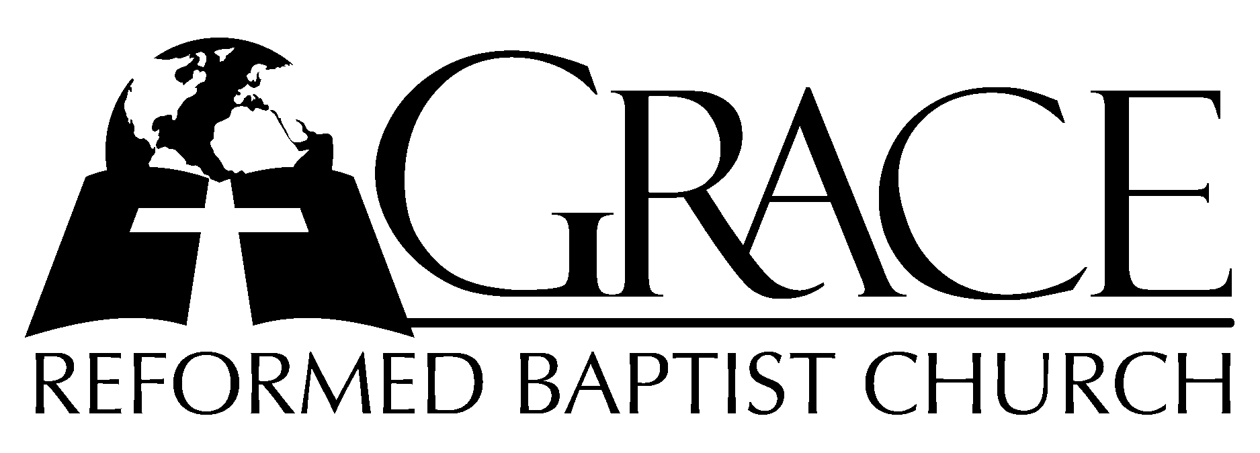
PO Box 221, 939 South Third Street
Mebane, North Carolina 27302
(919) 563-9249

Website: WWW.GRBC.NET

The Lord’s Day Services
Sunday School……….………9:30
Morning Worship……….…10:55
Evening Worship.…………..5:30

Wednesday Evening Prayer Service
7:15

We warmly welcome our Visitors today and request that you sign
the Guest Register located in the Foyer. We hope to greet you
in a more personal way following the services.

The Lord’s Day
October 14, 2007

Call to Worship Pastor Stu Johnston

Hymn of Praise “Our God Reigns/
“Jesus Shall Reign”

1. How lovely on the mountains are the feet of Him-who brings good news, good news –
Announcing peace, proclaiming news of happiness. Our God reigns, our God reigns!
(Chorus) Our God reigns! Our God reigns! Our God reigns! Our God reigns!

2. He had no stately form, He had no majesty, that we should be drawn to Him.
He was despised and we took no account of Him, yet now He reigns with the Most High. (Chorus)

3. Out from the tomb He came with grace and majesty, He is alive, He is alive!
God loves us so, see here His hands, His feet, His side. Yes, we know, He is alive! (Chorus)

(piano introduction)

Our God Reigns, Text and Music: Leonard Smith, Jr. 1978 L. E. Smith, Jr./New Jerusalem Music Used by Permission CCLI # 1899094
Jesus Shall Reign, Text: Isaac Watts, based on Psalm 72 Tune: DUKE STREET, John Hatton, c. 1793

Scripture Reading Colossians 2: 1-10

Pastoral Prayer

Offertory/Preparatory # 432 “Jesus! What
Hymn a Friend for Sinners!
(Piano meditation for 2 verses during the offering ~
afterwards, please stand for singing.)

Sermon Pastor Gary Hendrix

~~~~~~~~~~~~~~~~~~~~~~~~~~~~~~~

Evening Worship

Call to Worship Pastor Stu Johnston

Hymn of Praise # 217 “Look, Ye Saints”

Scripture Reading Hosea 1: 1-11

Pastoral Prayer

Offertory/Preparatory # 185 “By the Cross of
Hymn Jesus Standing”

Sermon Pastor Gary Hendrix
~~~~~~~~~~~~~~~~~~~~~~~~~~~~~~

Communion Hymns

# 181 “O Dearest Jesus, What Law Hast Thou Broken”

“Behold the Lamb”

1. Behold the Lamb who bears our sins away, slain for us – and we remember
The promise made that all who come in faith find forgiveness at the cross.
So we share in this bread of life, and we drink of His sacrifice
As a sign of our bonds of peace - around the table of the King.

2. The Body of our Saviour Jesus Christ, torn for you – eat and remember
The wounds that heal, the death that brings us life paid the price to make us one.
So we share in the bread of life, and we drink of His sacrifice
As a sign of our bonds of love – around the table of the King.

3. The blood that cleanses ev’ry stain of sin, shed for you – drink and remember
He drained death’s cup that we may enter in to receive the life of God.
So we share in this bread of life, and we drink of His sacrifice
As a sign of our bonds of grace – around the table of the King.

4. And so with thankfulness and faith we rise to respond – and to remember
Our call to follow in the steps of Christ as His body here on earth.
As we share in His suffering, we proclaim Christ will come again!
And we’ll join in the feast of heav’n – around the table of the King.

Worda and Music: Keith and Kristyn Getty 2006 ThankYou Music Used by Permission CCLI # 1899094

“Man of Sorrows”

1. Man of Sorrows! What a name - for the Son of God, who came - ruined sinners
to reclaim: Hallelujah! Hallelujah! Hallelujah! What a Savior!

2. Bearing shame and scoffing rude, - in my place condemned He stood, - sealed my pardon with His blood: Hallelujah! Hallelujah! Hallelujah! What a Savior!

3. Guilty, vile, and helpless, we; - Spotless Lamb of God was He; - Full atonement!
Can it be? Hallelujah! Hallelujah! Hallelujah! What a Savior!

4. Lifted up was He to die, - “It is finished!” was His cry: - Now in heav’n
exalted high: Hallelujah! Hallelujah! Hallelujah! What a Savior!

5. When He comes our glorious King, - all His ransomed home to bring,- then anew this
song we’ll sing: Hallelujah! Hallelujah! Hallelujah! What a Savior!
AMEN

Words: Philip Bliss, 1838-1876 Music: Katie Malone Redfern, 2002 Used by Permssion

