“Oh, that men would give thanks
to the Lord for His goodness,
and for His wonderful
works to the children of men!
For He satisfies the longing soul,
and fills the hungry soul
with goodness.
Let them sacrifice the sacrifices
of thanksgiving, and declare
His works with rejoicing.”

Psalm 107: 21-22

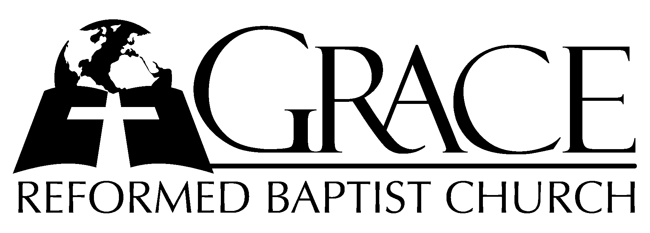
PO Box 221, 939 South Third Street
Mebane, North Carolina 27302
(919) 563-9249

Website: WWW.GRBC.NET

The Lord’s Day Services
Sunday School……….………9:30
Morning Worship……….…10:55
Evening Worship.…………..5:30

Wednesday Evening Prayer Service
7:15

We warmly welcome our Visitors today and request that you sign
the Guest Register located in the Foyer. We hope to greet you
in a more personal way following the services.

The Lord’s Day
October 28, 2007

Call to Worship Pastor Andy Dunkerton

Hymn of Praise # 4 “All Praise to God”

Scripture Reading Colossians 3: 1-11

Pastoral Prayer

Offertory Hymn “How Great Thou Art”

1. O Lord my God, when I in awesome wonder~
Consider all the worlds Thy hands have made,
I see the stars, I hear the rolling thunder,
Thy pow’r through out the universe displayed.

Refrain

Then sings my soul, my Savior God, to Thee:
How great Thou art, how great Thou art!
Then sings my soul, my Savior God, to Thee:
How great Thou art, how great~ Thou art!

2. When through the woods and forest glades I wander~
And hear the birds sing sweetly in the trees,
When I look down from lofty mountain grandeur,
And hear the brook and feel the gentle breeze;

Refrain

3. And when I think that God, His Son not sparing,
Sent Him to die, I scarce can take it in,
That on the cross, my burden gladly bearing,
He bled and died to take away my sin.

Refrain

4. When Christ shall come with shout of acclamation~
And take me home, what joy shall fill my heart!
Then I shall bow in humble adoration,
And there proclaim, my God, how great Thou art!

Refrain
AMEN

Text: Stuart K. Hine, 1949; alt. Music: Swedish Folk Melody, arr. by Stuart K. Hine
1953 Manna Music
Used by Permission CCLI # 1899094

Hymn of Preparation # 437 “Christ, of All My
Hopes The Ground”

Sermon Pastor Gary Hendrix
◊◊◊◊◊◊◊◊◊◊◊◊◊◊◊◊◊◊◊◊◊◊◊◊◊◊◊◊◊◊

Evening Worship

Call to Worship Pastor Charles Fortner

Hymn of Praise # 12 “Exalt The Lord”
Scripture Reading Hosea 3: 1-5

Pastoral Prayer

Offertory Hymn # 70 “Praise, My Soul,
The King of Heaven”
Hymn of Preparation # 441 “Thy Works,
Not Mine, O Christ”

Sermon Pastor Andy Dunkerton

◊◊◊◊◊◊◊◊◊◊◊◊◊◊◊◊◊◊◊◊◊◊◊◊◊◊◊◊◊◊

“Oh, that men would give thanks to the Lord
for His goodness, and for His wonderful works to
the children of men! For He satisfies the longing soul,
and fills the hungry soul with goodness.”
Psalm 107: 8-9

