“But above all these things put on love,
which is the bond of perfection.
And let the peace of God rule in your
hearts, to which also you were called
in one body; and be thankful.
Let the word of Christ dwell in you richly in all wisdom, teaching and admonishing one another in psalms and hymns and spiritual songs, singing with grace in your hearts to the Lord.
And whatever you do in word or deed,
do all in the name of the Lord Jesus,
giving thanks to God the father
through Him.”

Colossians 3: 14-17

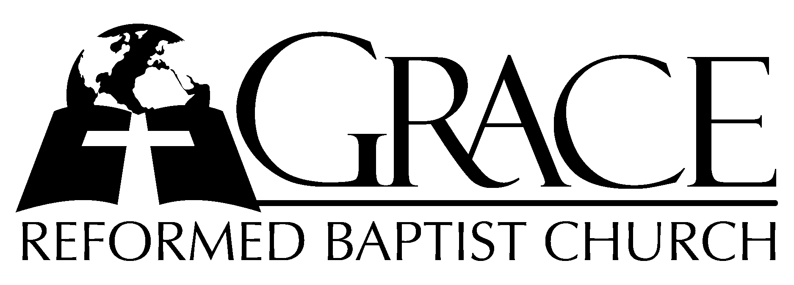
PO Box 221, 939 South Third Street
Mebane, North Carolina 27302
(919) 563-9249

Website: WWW.GRBC.NET

The Lord’s Day Services
Sunday School……….………9:30
Morning Worship……….…10:55
Evening Worship.…………..5:30

Wednesday Evening Prayer Service
7:15

We warmly welcome our Visitors today and request that you sign
the Guest Register located in the Foyer. We hope to greet you
in a more personal way following the services.

The Lord’s Day
November 4, 2007

Call to Worship Pastor Andy Dunkerton

Hymns of Petition “Have Thine Own Way”/
and Adoration “Glorify Thy Name”

1. Have Thine own way, Lord! Have Thine own way! Thou art the Potter; I am the clay.
Mold me and make me after Thy will, while I am waiting, yielded and still~
While I am waiting, yielded and still.

2. Have Thine own way, Lord! Have Thine own way! Search me and try me, Master today!
Whiter than snow, Lord, wash me just now, as in Thy presence humbly I bow~
As in Thy presence humbly I bow.

3. Have Thine own way, Lord! Have Thy own way! Wounded and weary, help me, I pray!
Power~ all power~ surely is Thine! Touch me and heal me, Savior divine!
Touch me and heal me, Savior divine!

4. Have Thine own way, Lord! Have Thine own way! Hold o’er my being absolute sway!
Fill with Thy Spirit till all shall see~ Christ only, always, living in me!
Christ only, always, living in me!

(piano introduction)

1. Father, we love You, we worship and adore You. Glorify Thy name in all the earth.
Glorify Thy name, glorify Thy name, glorify Thy name in all the earth.

2. Jesus, we love You, we worship and adore You. Glorify Thy name in all the earth.
Glorify Thy name, glorify Thy name, glorify Thy name in all the earth.

3. Spirit, we love You, we worship and adore You. Glorify Thy name in all the earth.
Glorify Thy name, glorify Thy name, glorify Thy name in all the earth.
AMEN

Have Thine Own Way, Text: Adelaide Pollard, 1902 Music: Katie Malone Redfern, 2002 Used by Permission
Glorify Thy Name, Text and Music: Donna Adkins, 1986 MARANATHA! MUSIC Used by Permission CCLI # 1899094

Scripture Reading Colossians 3: 12 – 4: 1

Pastoral Prayer

Offertory Hymn # 76 “With Grateful
Heart”
Hymn of Preparation # 81 “A Mighty Fortress
is Our God”

Sermon Pastor Gary Hendrix
◊◊◊◊◊◊◊◊◊◊◊◊◊◊◊◊◊◊◊◊◊◊◊◊◊◊◊◊◊◊

Evening Worship

Call to Worship Pastor Charles Fortner

Hymn of Praise “Praise the Lord”

1. Praise the Lord: Ye heav’ns adore~ Him; Praise Him, angels in the~ height;
Sun and moon, rejoice before~ Him; Praise Him, all ye stars and~ light.
Praise the Lord,~ for He hath spo~ken; Worlds His mighty voice obeyed:
Laws which never shall be bro~ken for their~ guid~ence~ He hath made.

2. Praise the Lord, for He is glo-ri-ous; Never shall His promise~ fail;
God hath made His saints vic-tor-i-ous; Sin and death shall not pre~vail.
Praise the God~ of our salva~tion; Hosts on high, His pow’r proclaim;
Heav’n and earth and all crea~tion, laud and~ mag~ni~fy His Name.

3. Worship, honor, glory, bless~ing, Lord, we offer unto~ Thee;
Young and old, Thy praise express~ing, in glad homage bend the~ knee.
All the saints in heav’n adore~ Thee; We would bow before Thy throne:
As Thine angels serve before~ Thee, so on~ earth~ Thy~ will be done. AMEN

Text: Verses 1 & 2, Anon, c. 1801 Verse 3, Edward Osler, 1836 Music: AUSTRIAN HYMN, Franz Josef Haydn, 1797

Scripture Reading Hosea 4: 1-11

Pastoral Prayer

Offertory Hymn “As the Deer”
1. As the deer panteth for the water, so my soul longeth after Thee.
You alone are my heart’s desire~ and I long to worship Thee.
Refrain
You alone are my strength, my shield; To You, alone, may my spirit yield.
You alone are my heart’s desire~, and I long to worship Thee.

2. You’re my friend and You are my Brother, even tho’ You are a King.
I love You more than any other, so much more than anything. Refrain

3. I want You more than gold or silver, only You can satisfy.
You alone are the real joy giver, and the apple of my eye. Refrain

Text and Music: Martin Nystrom, 1984 MARANATHA! MUSIC Used by Permission CCLI # 1899094

Hymn of Preparation “Nearer, Still Nearer”

1. Nearer, still nearer, close to Thy heart, draw me, my Savior ~ so precious Thou art!
Fold me, O fold me close to Thy breast. Shelter me safe in that haven of rest;
Shelter me safe in that haven of rest.

2. Nearer, still nearer, nothing I bring, naught as an off’ring to Jesus, my King~
Only my sinful, now contrite heart. Grant me the cleansing Thy blood doth impart;
Grant me the cleansing Thy blood doth impart.

3. Nearer, still nearer, Lord, to be Thine! Sin, with its follies, I gladly resign,
All of its pleasures, pomp and its pride. Give me but Jesus, my Lord crucified;
Give me but Jesus, my Lord, crucified.

4. Nearer, still nearer, while life shall last, till safe in glory my anchor is cast;
Thro’ endless ages ever to be ~ nearer, my Savior, still nearer to Thee;
Nearer, my Savior, still nearer to Thee. AMEN

Text and Music: Lelia N. Morris

Sermon Pastor Gary Hendrix

◊◊◊◊◊◊◊◊◊◊◊◊◊◊◊◊◊◊◊◊◊◊◊◊◊◊◊◊◊◊

