“Oh, sing to the Lord a new song!
For He has done marvelous things;
His right hand and His holy arm
have gained the victory.
The Lord has made known His salvation;
His righteousness He has revealed
in the sight of the nations.
He has remembered His mercy and His faithfulness to the house of Israel;
All the ends of the earth have seen
the salvation of our God.”

Psalm 98: 1-3

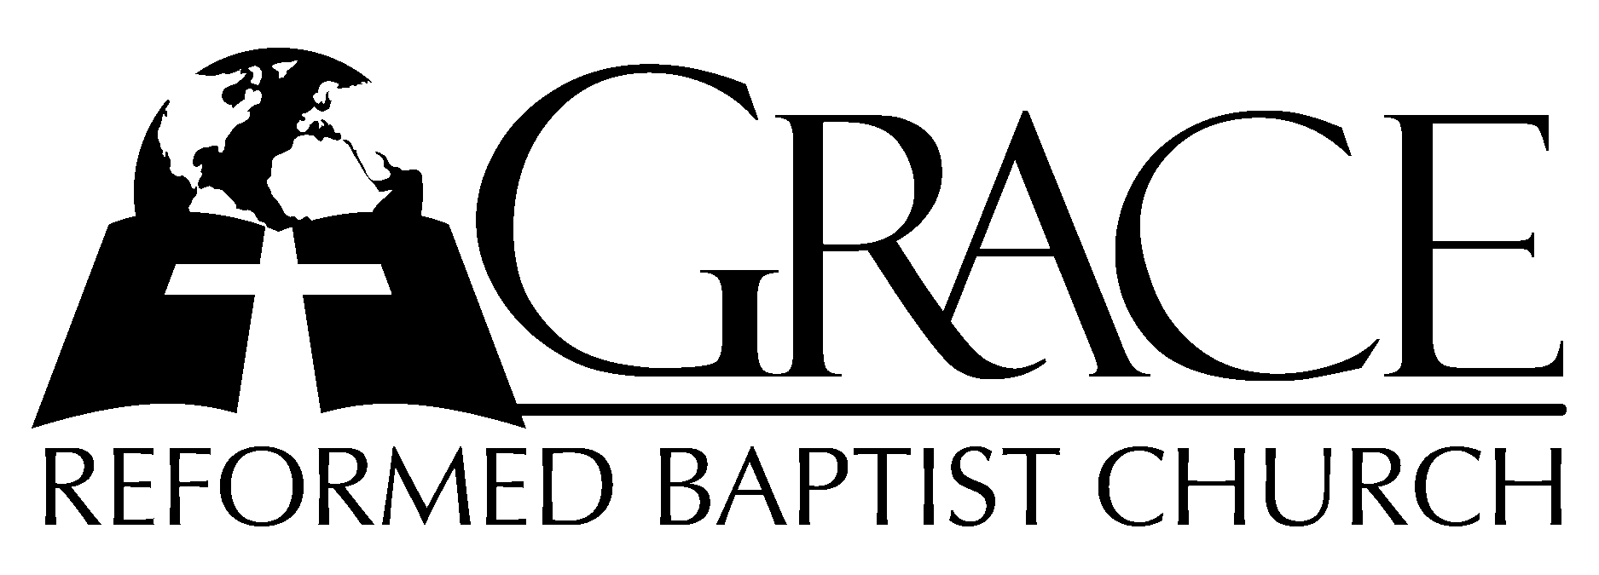
PO Box 221, 939 South Third Street
Mebane, North Carolina 27302
(919) 563-9249

Website: WWW.GRBC.NET

The Lord’s Day Services
Sunday School……….………9:30
Morning Worship……….…10:55
Evening Worship.…………..5:30

Wednesday Evening Prayer Service
7:15

We warmly welcome our Visitors today and request that you sign
the Guest Register located in the Foyer. We hope to greet you
in a more personal way following the services.

The Lord’s Day
November 11, 2007

Call to Worship Pastor Andy Dunkerton

Hymn of Praise # 149 “Joy to the World”
Scripture Reading Isaiah 65

Pastoral Prayer

Offertory Hymn “There is a Higher Throne”
1. There is a higher throne ~ than all this world has known,
Where faithful ones from ev’ry tongue ~ will one day come.
Before the Son we’ll stand, ~ made faultless thro’ the Lamb;
Believing hearts find promised grace; Salvation comes.
Hear heaven’s voices sing;
Their thund’rous anthem rings thro’ emerald courts and sapphire skies;
Their praises rise.~~~
All glory, wisdom, pow’r, strength, thanks, and honor are to God, our King,
Who reigns on high ~ forevermore.
2. And there we’ll find our home; Our life before the throne.
We’ll honor Him in perfect song ~ where we belong.
He’ll wipe each tear-stained eye ~ as thirst and hunger die.
The Lamb becomes our Shepherd King; We’ll reign with Him.
Hear heaven’s voices sing;
Their thund’rous anthem rings thro’ emerald courts and sapphire skies;
Their praises rise.~~~
All glory, wisdom, pow’r, strength, thanks, and honor are to God, our King,
Who reigns on high ~ forevermore.

Text and Music: Keith and Kristyn Getty 2002 ThankYou Music
Used by Permission CCLI # 1899094

Hymn of Preparation # 129 “Fairest Lord
Jesus”

Sermon Pastor Gary Hendrix
◊◊◊◊◊◊◊◊◊◊◊◊◊◊◊◊◊◊◊◊◊◊◊◊◊◊◊◊◊◊

Evening Worship

Call to Worship Pastor Stu Johnston

Hymn of Praise # 223 “Arise, My Soul,
Arise”

Scripture Reading Isaiah 52:13-15, 53:1-12

Pastoral Prayer

Offertory /Preparatory “Speak, O Lord”
Hymn

1. Speak, O Lord, as we come to You, to receive the food of Your Holy Word.
Take Your Truth, plant it deep in us; Shape and fashion us in Your likeness;
That the light of Christ might be seen today in our acts of love and our deeds of faith.
Speak, O Lord and fulfill in us all Your purposes for Your glory.

2. Teach us Lord, full obedience, holy reverence, true humility.
Test our thoughts and our attitudes; in the radiance of Your purity.
Cause our faith to rise, cause our eyes to see Your majestic love and authority.
Words of pow’r that can never fail; Let their truth prevail over unbelief.

3. Speak, O Lord, and renew our minds; Help us grasp the heights of Your plans for us.
Truths unchanged from the dawn of time, that will echo down through eternity-
And by grace we’ll stand on Your promises; and by faith we’ll walk as You walk with us.
Speak, O Lord, ‘til Your church is built, and the earth is filled with Your glory. (piano ending)

Sermon Pastor Andy Dunkerton

◊◊◊◊◊◊◊◊◊◊◊◊◊◊◊◊◊◊◊◊◊◊◊◊◊◊◊◊◊◊

Communion Hymns

“Alas and Did My Savoir Bleed”

Alas, and did my Savior bleed, and did my Sovereign die!
Would He devote that sacred head for such a worm as I?
Was it for crimes that I had done He groaned upon the tree?
Amazing pity! Grace unknown! And love beyond degree!
My God, why would Your shed Your blood, so pure and undefiled,
To make a sinful one like me ~ Your chosen, precious child?
Well might the sun in darkness hide, and shut His glories in,
When Christ, the mighty Maker, died, for man the creature’s sin.
Thus might I hide my blushing face while His dear cross appears;
Dissolve my heart in thankfulness, and melt mine eyes in tears.
My God, why would Your shed Your blood, so pure and undefiled,
To make a sinful one like me ~ Your chosen, precious child?
But drops of grief can ne’er repay the debt of love I owe.
Here, Lord, I give myself away; ‘tis all that I can do.
My God, why would Your shed Your blood, so pure and undefiled,
To make a sinful one like me ~ Your chosen, precious child?
Test: Isaac Watts, 1707 Music: Bob Kauflin, 1997 People of Destiny International, Sovereign Grace Muisc
Used by Permission CCLI # 1899094

# 193 “O Jesus, We Adore Thee”

◊◊◊◊◊◊◊◊◊◊◊◊

