“How beautiful upon the mountains are the feet
of him who brings good news, who proclaims peace, who brings glad tidings of good things,
who proclaims salvation, who says to Zion,
“Your God reigns!” Your watchmen shall
lift up their voices, with their voices they shall
sing together; for they shall see eye to eye
when the Lord brings back Zion.
You waste places of Jerusalem!
For the Lord has comforted His people,
He has redeemed Jerusalem.
The Lord has made bare His holy arm in the eyes
of all the nations; and all the ends of the earth shall see the salvation of our God.”

Isaiah 52: 7-10

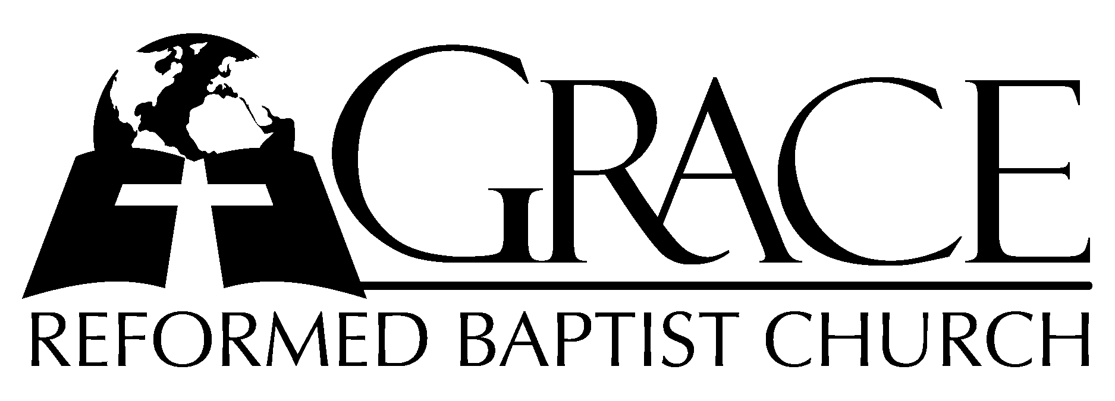
PO Box 221, 939 South Third Street
Mebane, North Carolina 27302
(919) 563-9249

Website: WWW.GRBC.NET

The Lord’s Day Services
Sunday School……….………9:30
Morning Worship……….…10:55
Evening Worship.…………..5:30

Wednesday Evening Prayer Service
7:15

We warmly welcome our Visitors today and request that you sign
the Guest Register located in the Foyer. We hope to greet you
in a more personal way following the services

The Lord’s Day
December 2, 2007
Call to Worship Pastor Andy Dunkerton

Hymn of Praise # 151 “O Come, All Ye
Faithful”

Scripture Reading Isaiah 52

Pastoral Prayer

Offertory Hymn “Our God Reigns”

1. How lovely on the mountains are the feet of him who brings good news, good news-
Announcing peace, proclaiming news of happiness. Our God reigns, our God reigns!
Our God reigns! Our God reigns! Our God reigns ~ Our God reigns!
2. He had no stately form, He had no majesty, that we would be drawn to Him.
He was despised and we took no account of Him, yet now He reigns wit the Most High.
Our God reigns! Our God reigns! Our God reigns ~ Our God reigns!
3. Out from the tomb He came with grace and majesty, He is alive, He is alive.
God loves us so, see here His hands, His feet, His side. Yes, we know, He is alive.
Our God reigns! Our God reigns! Our God reigns ~ Our God reigns!
Text and Music: Leonard Smith, Jr. 1978 New Jerusalem Music Used by Permission CCLI # 1899094

Hymn of Preparation “Jesus Shall Reign”

Sermon Pastor Gary Hendrix

◊◊◊◊◊◊◊◊◊◊◊◊◊◊◊◊◊◊◊◊◊◊◊◊◊◊◊◊◊◊

Evening Worship

Call to Worship Pastor Charles Fortner
Hymn of Praise # 122 “Of the Father’s
Love Begotten”

Scripture Reading Hosea 5

Pastoral Prayer

Offertory /Preparatory # 270 “The Church’s One
Hymn Foundation” Verses 1-3, seated during the offering,
piano interlude, Verses 4-6, standing.

1. The church’s one Foundation is Jesus Christ her Lord;
She is His new creation by water and the Word:
From heav’n He came and sought her to be His holy bride;
With His own blood He bought her, and for her life He died.

2. Elect from ev’ry nation, yet one o’er all the earth,
Her charter of salvation one Lord, one faith, one birth;
One holy Name she blesses, partakes one holy food,
And to one hope she presses, with ev’ry grace endued.

3. Though with a scornful wonder men see her sore oppressed,
By schisms rent asunder, by heresies distressed,
Yet saints their watch are keeping, their cry goes up, “How long?”
And soon the night of weeping shall be the morn of song.
Interlude (please stand)
4. The church shall never perish! Her dear Lord to defend,
To guide, sustain and cherish, is with her to the end;
Though there be those that hate her, and false sons in her pale,
Against or foe or traitor she ever shall prevail.

5. ’Mid toil and tribulation, and tumult of her war,
She waits the consummation of peace for evermore;
Till with the vision glorious her longing eyes are blest,
And the great church victorious shall the church at rest.

6. Yet she on earth hath union with God the Three in One,
And mystic sweet communion with those whose rest is won:
O happy ones and holy! Lord, give us grace that we,
Like them, the meek and lowly, on high may dwell with Thee. AMEN

Sermon Pastor Stu Johnston

◊◊◊◊◊◊◊◊◊◊◊◊◊◊◊◊◊◊◊◊◊◊◊◊◊◊◊◊◊◊

