“In the beginning was the Word, and the Word was with God and the Word was God. He was in the beginning with God. All things were made through Him, and without Him nothing was made that was made. In Him was life,
and the life was the light of men. And the light shines
in the darkness, and the darkness did not comprehend it.
There was a man sent from God, whose name
was John. This man came for a witness, to bear witness
of the Light, that all through him might believe.
He was not that Light, which gives light
to every man coming into the world.
He was in the world, and the world was made
through Him, and the world did not receive Him.
But as many as received Him, to them He gave the right to become children of God, to those who believe in His name:
Who were born, not of blood, nor of the will
of the flesh, nor of the will of man, but of God.
And the Word became flesh and dwelt among us, and we beheld His glory, the glory of the only begotten
of the Father, full of grace and truth.”
John 1: 1-14

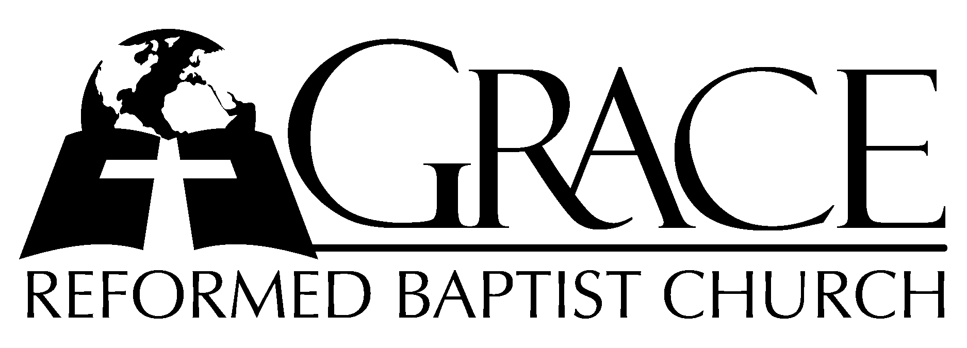
PO Box 221, 939 South Third Street
Mebane, North Carolina 27302
(919) 563-9249

Website: WWW.GRBC.NET

The Lord’s Day Services
Sunday School……….………9:30
Morning Worship……….…10:55
Evening Worship.…………..5:30

Wednesday Evening Prayer Service
7:15

We warmly welcome our Visitors today and request that you sign
the Guest Register located in the Foyer. We hope to greet you
in a more personal way following the services

The Lord’s Day
December 16, 2007

Call to Worship Pastor Stu Johnston

Hymn of Praise #168 “Hark! The Herald
Angels Sing”

Scripture Reading I Thessalonians 3

Pastoral Prayer

Offertory Hymn # 125 “My Heart Doth
Overflow”
Hymn of Preparation # 170 “Thou Dost Reign
on High”

Sermon Pastor Gary Hendrix

◊◊◊◊◊◊◊◊◊◊◊◊◊◊◊◊◊◊◊◊◊◊◊◊◊◊◊◊◊◊

Evening Worship

Call to Worship Pastor Charles Fortner

Hymn of Praise # 689 “One Day!”

Scripture Reading Isaiah 9: 1-7

Offertory Hymn “Of the Father’s Love
Begotten”
(Verse 4, a cappella)
Text: Aurelius Clemens Prudentius, 348-413
Music: Plainsong, 12th Century

Pastoral Prayer

Hymn of Preparation “Saviour of the Nations,
Come”
1. Saviour of~ the~ nations, come, Virgin’s Son,~ make~ here Thy~ home!
Marvel now, O~ heav’n and earth,~ that the Lord chose such~ a~ birth,~
That the Lord chose~ such a birth.
2. Not of flesh~ and~ blood the Son, Offsrpring of~ the~ Holy~ One;
Born of Mary~ ever blest~ God in flesh is man-i-fest,
God in flesh is~ manifest.
3. Wondrous birth!~ O~ wondrous Child of the vir-gin~ unde-filed!
Though by all the~ world disowned,~ still to be in heav’n~ en-throned,
Still to be in~ heav’n en-throned.
4. From the Father~ forth He came and return-eth to the~ same,
Captive leading~ death and hell,~ high the song of tri-umph~ swell,~
High the song of~ triumph swell!
5. Thou, the Fa-ther’s~ only Son, hast o’er sin~ and~ vic-t’ry~ won.
Boundless shall Thy~ kingdom be;~ when shall we its glo-ries~ see,~
When shall we its~ glories see?
6. Praise to God~ the~ Father sing, praise to God~ the~ Son, our~ King,
Praise to God the~ Spirit be~ ever and eter-nal-ly,~
Ever and e-ter-nal-ly. AMEN

Text: Ambrose of Milan, 340-397 Trans. By Martin Luther, 1524, alt. 1860 Tune: HENDON, H.A. Cesar Malan, 1827

Sermon Pastor Gary Hendrix

