(Abbreviated Version of 12/23/07 Bulletin Below)

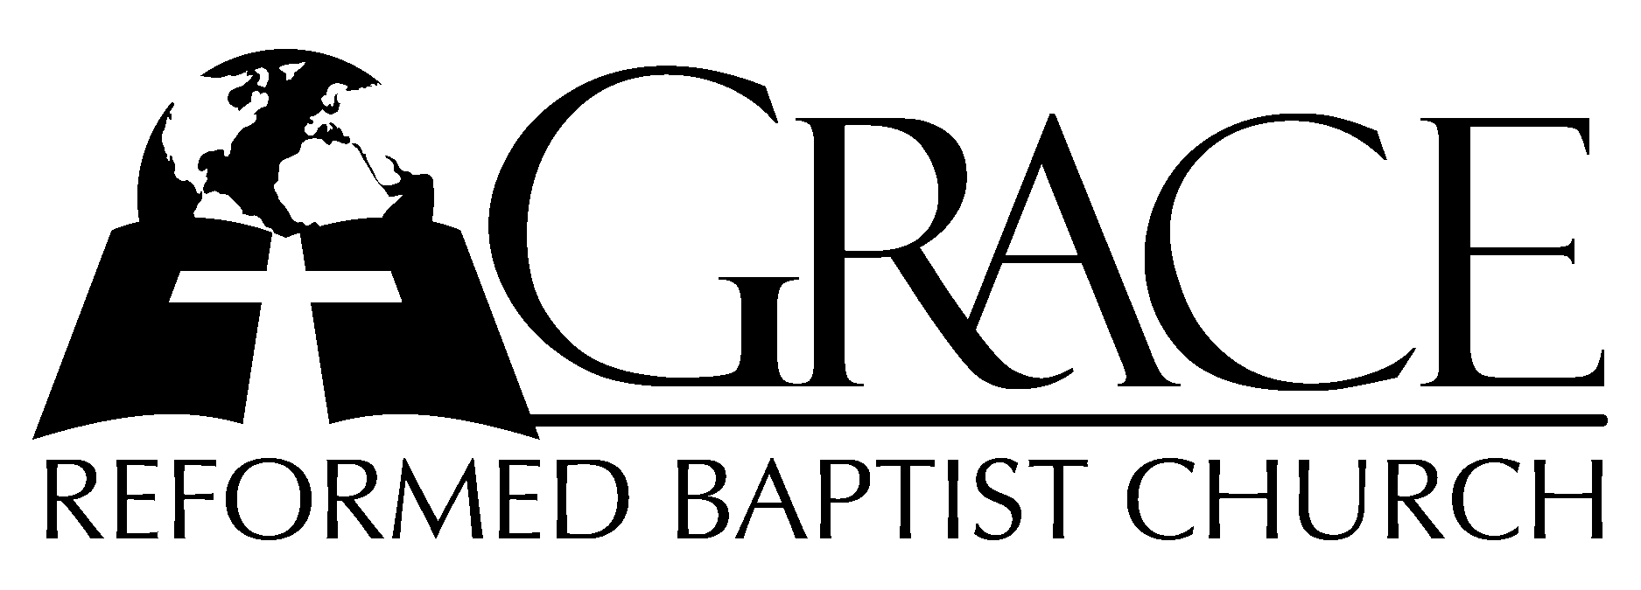
PO Box 221, 939 South Third Street
Mebane, North Carolina 27302
(919) 563-9249

Website: WWW.GRBC.NET

The Lord’s Day Services
Sunday School……….………9:30
Morning Worship……….…10:55
Evening Worship.…………..5:30

Wednesday Evening Prayer Service
7:15

We warmly welcome our Visitors today and request that you sign
the Guest Register located in the Foyer. We hope to greet you
in a more personal way following the services

The Lord’s Day
December 23, 2007

Call to Worship Pastor Charles Fortner

Hymn of Praise # 151 “O Come, All Ye
Faithful”
Scripture Reading Matthew 1: 18-25

Pastoral Prayer

Offertory Hymn # 641 “Away in a Manger”

Hymn of Preparation # 152 “O Little Town of
Bethlehem”

Sermon Pastor Gary Hendrix

◊◊◊◊◊◊◊◊◊◊◊◊◊◊◊◊◊◊◊◊◊◊◊◊◊◊◊◊◊◊

Evening Worship

Call to Worship Pastor Charles Fortner

Hymn of Praise # 164 “Angels, From the
Realms of Glory”

Scripture Reading Luke 2: 1-20
Offertory Hymn # 161 “Silent Night”

Pastoral Prayer

Hymn of Preparation # 150 “All My Heart This
Night Rejoices”

Sermon Pastor Gary Hendrix

◊◊◊◊◊◊◊◊◊◊◊◊◊◊◊◊◊◊◊◊◊◊◊◊◊◊◊◊◊

We warmly welcome our Visitors today and request that you sign
our Guest Register located in the Foyer. We hope to greet you
in a more personal way following the services.

