Then the seventh angel sounded:
And there were loud voices
in heaven saying,
“The kingdoms of this world have become the kingdoms
of our Lord and of His Christ,
and He shall reign for
ever and ever!”

Revelation 11: 15

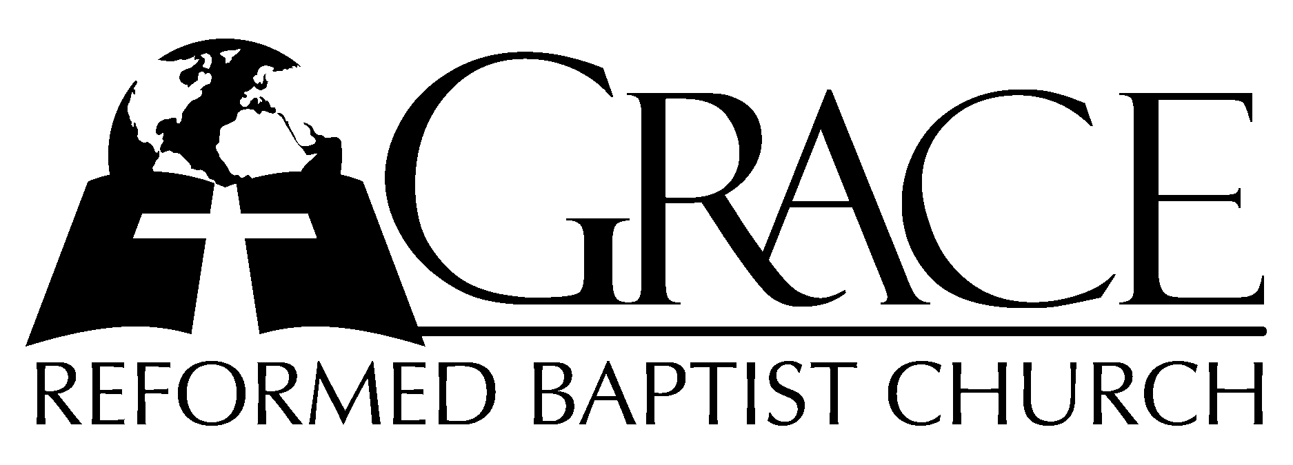
PO Box 221, 939 South Third Street
Mebane, North Carolina 27302
(919) 563-9249

Website: WWW.GRBC.NET

The Lord’s Day Services
Sunday School……….………9:30
Morning Worship……….…10:55
Evening Worship.…………..5:30

Wednesday Evening Prayer Service
7:15

We warmly welcome our Visitors today and request that you sign
our Guest Register located in the Foyer. We hope to greet you
in a more personal way following the services.

The Lord’s Day
December 30, 2007

Call to Worship Pastor Andy Dunkerton

Hymn of Praise # 149 “Joy to the World!
The Lord is Come”

Scripture Reading I Thessalonians 4
Pastoral Prayer

Offertory Hymn # 129 “Fairest Lord
Jesus”

Hymn of Preparation “Speak, O Lord”

1. Speak, O Lord, as we come to You, to receive the food of Your Holy Word.
Take Your Truth, plant it deep in us; Shape and fashion us in Your likeness;
That the light of Christ might be seen today in our acts of love and our deeds of faith.
Speak, O Lord and fulfill in us all Your purposes for Your glory.

2. Teach us Lord, full obedience, holy reverence, true humility.
Test our thoughts and our attitudes; in the radiance of Your purity.
Cause our faith to rise, cause our eyes to see Your majestic love and authority.
Words of pow’r that can never fail; Let their truth prevail over unbelief.

3. Speak, O Lord, and renew our minds; Help us grasp the heights of Your plans for us.
Truths unchanged from the dawn of time, that will echo down through eternity-
And by grace we’ll stand on Your promises; and by faith we’ll walk as You walk with us.
Speak, O Lord, to; ’til Your church is built, and the earth is filled with Your glory. (piano ending)

Words and Music: Keith Getty and Stuart Townend, 2005 ThankYou Music, Used by Permission CCLI # 1899094
Sermon Pastor Scott Carter

◊◊◊◊◊◊◊◊◊◊◊◊◊◊◊◊◊◊◊◊◊◊◊◊◊◊◊◊◊◊

Evening Worship

Call to Worship Pastor Stu Johnston

Hymns of Praise “Thou Art Worthy”/
“Join All the Glorious
Names”
Thou art worthy, Thou art worthy, Thou art worthy, O Lord,
To receive glory, glory and honor, glory and honor and pow’r.
For Thou hast created, hast all things created;
Thou hast created all things.
And for Thy pleasure they are created; For Thou art worthy, O Lord.

Words and Music: Pauline Mills; based on Rev.4:11; 5:9
1963 & 1975 Fred Bock Music Co. Used by Permission CCLI # 1899094

(piano introduction)

1. Join all the glorious names of wisdom, love and pow’r,
That ever mortals knew, that angels ever bore:
All are too poor to speak His worth, to poor to set my Savior forth.

2. Great Prophet of my God, my tongue would bless Thy name:
By Thee the joyful news of our salvation came,
The joyful news of sins forgiv’n, of hell subdued and peace with heav’n.

3. Jesus, my great High Priest, offered His blood and died;
My guilty conscience seeks no sacrifice beside:
His pow’rful blood did once atone and now it pleads before the throne.

4. Thou art my Counselor, my Pattern, and my Guide,
And Thou my Shepherd art; O, keep me near Thy side;
Nor let my feet e’er turn astray to wander in the crooked way.

5. My Savior and my Lord, my Conqu’ror and my King,
Thy scepter and Thy sword, Thy reigning grace I sing:
Thine is the pow’r; behold I sit in willing bonds beneath Thy feet. AMEN

Text: Isaac Watts Tune: John Darwall

Scripture Reading Hosea 6

Pastoral Prayer

Offertory Hymn “In Sweet Communion,
Lord, with Thee”
From Psalm 73: 23-28

1. In sweet communion, Lord, with Thee I constantly abide;
My hand Thou holdest in Thine own to keep me near Thy side.

2. Thy counsel through my earthly way shall guide me and control,
And then to glory afterward Thou wilt receive my soul.

3. Whom have I, Lord, in heav’n but Thee, to whom my thoughts aspire?
And, having Thee, on earth is nought that I can yet desire.

4. Though flesh and heart should faint and fail, the Lord will ever be
The strength and portion of my heart, my God eternally.

5. To live apart from God is death, ’tis good His face to seek;
My refuge is the living God, His praise I long to speak. AMEN

Hymn of Preparation # 599 “ The Sands of Time”
Sermon Pastor Scott Carter

◊◊◊◊◊◊◊◊◊◊◊◊◊◊◊◊◊◊◊◊◊◊◊◊◊◊◊◊◊

“Making God
Small”
by
Pastor Gary Hendrix

Grace Reformed Baptist Church
PO Box 221
939 South Third Street
Mebane, North Carolina 27302
Web: www.grbc.net

