“Therefore we also pray always
for you that our God would
count you worthy of this calling,
and fulfill all the good pleasure
of His goodness and the work
of faith with power,
that the name of our Lord Jesus Christ may be glorified in you,
and you in Him,
according to the grace of our God
and the Lord Jesus Christ.”

II Thessalonians 1: 11-12

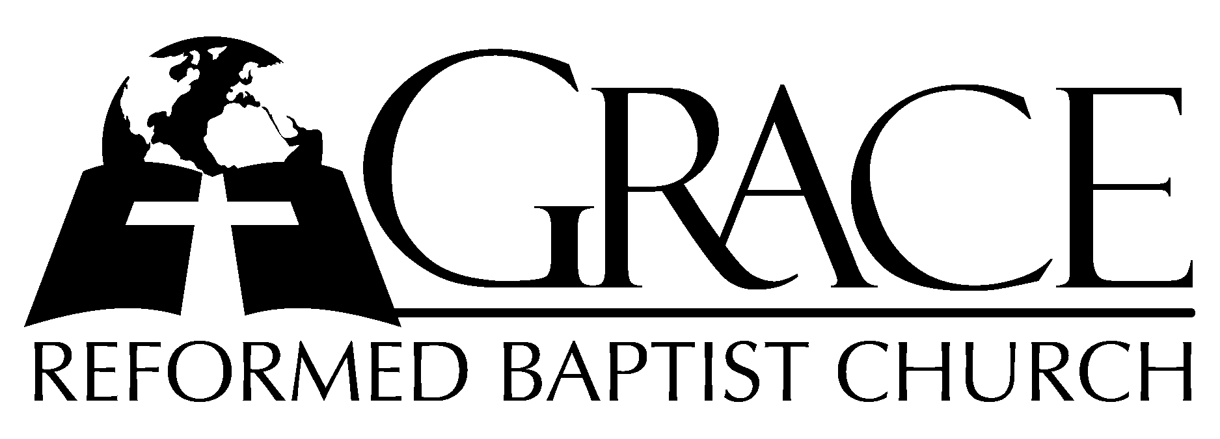
PO Box 221, 939 South Third Street
Mebane, North Carolina 27302
(919) 563-9249

Website: WWW.GRBC.NET

The Lord’s Day Services
Sunday School……….………9:30
Morning Worship……….…10:55
Evening Worship.…………..5:30

Wednesday Evening Prayer Service
7:15

We warmly welcome our Visitors today and request that you sign
our Guest Register located in the Foyer. We hope to greet you
in a more personal way following the services.

The Lord’s Day
January 13, 2008

Call to Worship Pastor Stu Johnston

Hymn of Praise # 198 “Jesus Christ is
Risen Today”

Scripture Reading II Thessalonians 1

Pastoral Prayer

Offertory Hymn # 2 “God, My King,
Thy Might Confessing”

Hymn of Preparation # 188 “There is a
Fountain”

Sermon Pastor Gary Hendrix

◊◊◊◊◊◊◊◊◊◊◊◊◊◊◊◊◊◊◊◊◊◊◊◊◊◊◊◊◊◊

Evening Worship

Call to Worship Pastor Andy Dunkerton

Hymn of Adoration “Before the Throne
of God Above”

1. Before the throne of God above, I have a strong a perfect plea,
A great High Priest whose name is “Love,” Who ever lives and pleads for me.
My name is graven on His hands, my name is written on His heart;
I know that while in heav’n He stands no tongue can bid me thence depart,
No tongue can bid me thence depart.

2. When Satan tempts me to despair, and tells me of the guilt within,
Upward I look and see Him there Who made and end to all my sin.
Because the sinless Savior died, my sinful soul is counted free;
For God, the Just, is satisfied to look on Him and pardon me,
To look on Him and pardon me.

3. Behold Him there! The risen Lamb, my perfect, spotless Righteousness,
The great unchangeable I AM, the King of glory and of grace!
One with Himself I cannot die, my soul is purchased by His blood;
My life is hid with Christ on high, with Christ, my Savior and my God,
With Christ my Savior and my God.

Words: Charitie Lees Bancroft (1841-1923) Music: Vikki Cook, 1997 PDI Worship Used by Permission CCLI #1899094

Scripture Reading Psalm 32

Pastoral Prayer

Offertory /Preparatory # 415 “God Be Merciful
Hymn To Me”

Sermon Pastor Gary Hendrix

◊◊◊◊◊◊◊◊◊◊◊◊◊◊◊◊◊◊◊◊◊◊◊◊◊◊◊◊◊

Communion Hymns

# 175 “Man of Sorrows”

# 181 “O Dearest Jesus”

“Look to the Cross”

“Jesus Christ is
Lord”

by
Pastor Gary Hendrix

Grace Reformed Baptist Church
PO Box 221
939 South Third Street
Mebane, North Carolina 27302
Web: www.grbc.net

