“Before the throne there was a sea of glass,
like crystal. And in the midst of the throne,
and around the throne, were four living creatures full of eyes in front and in back.
The first living creature was like a lion,
the second living creature like a calf,
the third living creature had a face like
a man, and the fourth living creature was
like a flying eagle. The four living
creatures, each having six wings,
were full of eyes around and within.
And they do not rest day or night, saying:

‘Holy, Holy, Holy,
Lord God Almighty,
Who was and is and is to come!’ ”

Revelation 4: 6-8

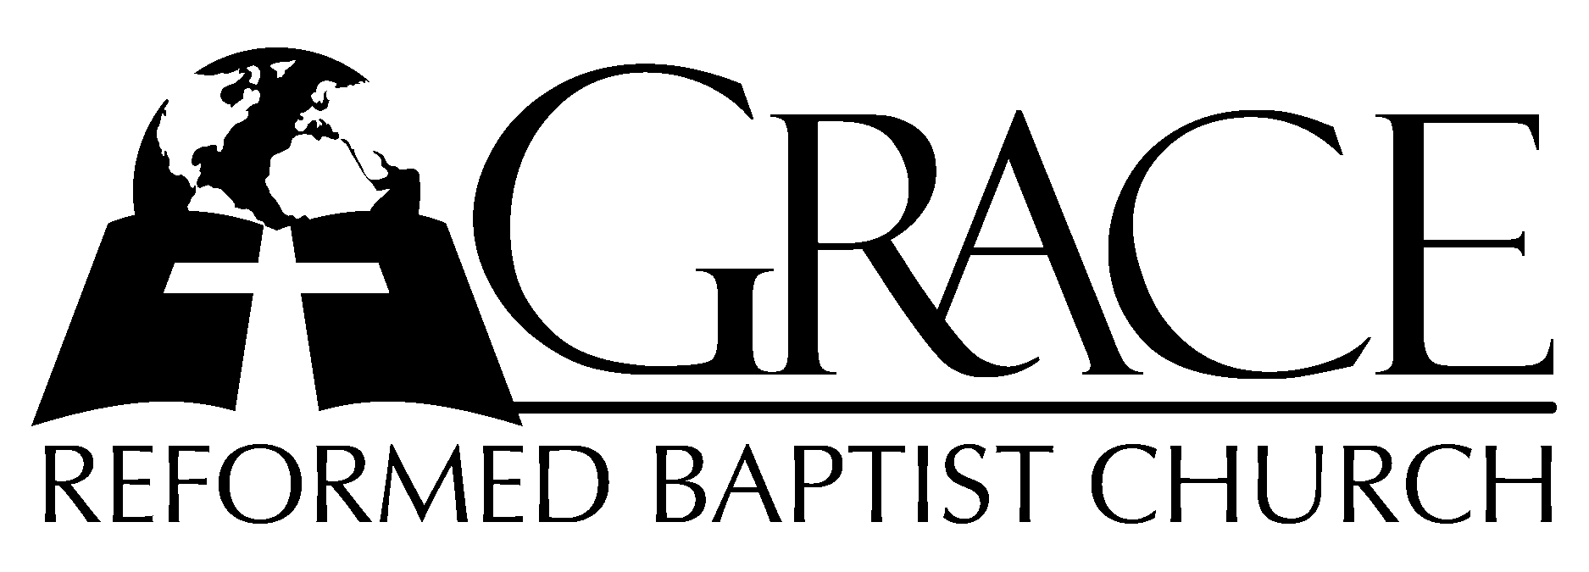
PO Box 221, 939 South Third Street
Mebane, North Carolina 27302
(919) 563-9249

Website: WWW.GRBC.NET

The Lord’s Day Services
Sunday School……….………9:30
Morning Worship……….…10:55
Evening Worship.…………..5:30

Wednesday Evening Prayer Service
7:15

We warmly welcome our Visitors today and request that you sign
our Guest Register located in the Foyer. We hope to greet you
in a more personal way following the services.

The Lord’s Day
February 10, 2008

Call to Worship Pastor Andy Dunkerton

Hymn of Praise # 87 “Holy, Holy, Holy”

Scripture Reading I Timothy 2

Pastoral Prayer

Offertory Hymn “How Deep the Father’s
Love for Us”
1. How deep the Father’s love for us, how vast beyond all measure-
That He should give His only Son to make a wretch His treasure.
How great the pain of searing loss. The Father turns His face away
As wounds which mar the Chosen One bring many sons to glory.

2. Behold the Man upon a cross, my sin upon His shoulders.
Ashamed, I hear my mocking voice call out among the scoffers.
It was my sin that held Him there until it was accomplished;
His dying breath has brought me life. I know that it is finished.

3. I will not boast in anything: no gifts, no pow’r, no wisdom.
But I will boast in Jesus Christ: His death and resurrection.
Why should I gain from this reward? I cannot find an answer.
But this I know with all my heart: His wounds have paid my ransom.

Words and Music: Stuart Townend, 1995 Kingsway’s ThankYou Music Used by Permission CCLI # 1899094

Hymn of Preparation # 393 “Come, Ye Sinners”

Sermon Pastor Gary Hendrix

◊◊◊◊◊◊◊◊◊◊◊◊◊◊◊◊◊◊◊◊◊◊◊◊◊◊◊◊◊◊

Evening Worship

Call to Worship Pastor Charles Fortner

Hymns of Praise “Crown His Head With
Endless Blessing/ “Loved With Everlasting
Love”
1. Crown His head with endless blessing, Who, in God the Father’s Name,
With compassions never ceasing, comes salvation to proclaim.
Hail, ye saints, who know His favor, who within His gates are found.
Hail, ye saints, th’exalted Saviour, let His courts with praise resound.

2. Jesus, Thee our Saviour hailing, Thee our God in praise we own;
Highest honors, never failing, rise eternal round Thy throne.
Now, ye saints, His pow’r confessing, in your grateful strains adore;
For His mercy, never ceasing, flows, and flows forever more.

(piano introduction)

1. Loved with everlasting love, drawn by grace that love to know; Spirit sent from Christ above,
Thou dost witness it is so. O, this full and precious peace from His presence all divine;
In a love which cannot cease, I am His and He is mine;
In a love which cannot cease, I am His and He is mine.

2. Heav’n above is deeper blue, earth around is sweeter green, that which glows in ev’ry hue Christless eyes have never seen. Birds in song His glories show, flow’rs with richer beauties shine-
Since I know, as now I know, I am His and He is mine;
Since I know, as now I know, I am His and He is mine.

3. Taste the goodness of the Lord: welcomed home to His embrace, all His love as blood outpoured seals the pardon of His grace. Can I doubt His love for me,
when I trace that love’s design?
By the cross of Calvary I am His and He is mine;
By the cross of Calvary I am His and He is mine.

4. His forever, only His – who the Lord and me shall part? Ah, with what a rest of bliss Christ can
fill the loving heart. Heav’n and earth may fade and flee, firstborn light in gloom decline,
But while God and I shall be, I am His and He is mine;
But while God and I shall be, I am His and He is mine. AMEN

Words: George W. Robinson, 1890, Revised by Edmund P. Clowney, 1986 Tune: James Mountain, ca. 1890
Used by Permission CCLI # 1899094

Scripture Reading Exodus 12: 1-28

Pastoral Prayer

Offertory/ # 177 “Beneath the Cross
Preparatory Hymn of Jesus”

Sermon Pastor Stu Johnston

◊◊◊◊◊◊◊◊◊◊◊◊◊◊◊◊◊◊◊◊◊◊◊◊◊◊◊◊◊◊

Communion Hymns

# 431 “Just As I Am”

# 190 “Glory Be to Jesus”

“And Can it Be”

1. And can it be that I should gain and int’rest in the Savior’s blood?
Died He for me, who caused His pain? For me, who Him to death pursued?
Amazing love! How can it be that Thou, my God, shouldst die for me?
Amazing love! How can it be that Thou, my God shouldst die for me?

2. He left His Father’s throne above (so free, so infinite His grace!)
Humbled Himself (so great His love!), and bled for all His chosen race.
’Tis mercy all, immense and free; for, O my God, it found out me.
Amazing love! How can it be that Thou, my God shouldst die for me?

3. Long my imprisoned spirit lay fast bound in sin and nature’s night;
Thine eye diffused a quick’ning ray; I woke, the dungeon flamed with light;
My chains fell off, my heart was free; I rose, went forth, and followed Thee.
Amazing love! How can it be that Thou, my God shouldst die for me?

4. No condemnation now I dread; Jesus, and all in Him, is mine!
Alive in Him, my living Head, and clothed in righteousness divine,
Bold I approach th’eternal throne, and claim the crown, through Christ, my own.
Amazing love! How can it be that Thou, my God shouldst die for me?

AMEN

Text: Charles Wesley, 1738 Alt. 1990 Music: Thomas Campbell, 1825

“Do You Have a
Christian Conscience?”

by
Pastor Gary Hendrix

Grace Reformed Baptist Church
PO Box 221
939 South Third Street
Mebane, North Carolina 27302
Web: www.grbc.net

