“My heart is overflowing with a good theme;
I recite my composition concerning the King;
My tongue is the pen of a ready writer.
You are fairer than the sons of men;
Grace is poured upon Your lips;
Therefore God has blessed You forever.
Gird Your sword upon Your thigh,
O mighty One, with Your glory and Your majesty.
And in Your majesty ride prosperously
because of truth, humility, and righteousness;
And Your right hand shall teach You
awesome things. Your arrows are sharp
in the heart of the King’s enemies;
The peoples fall under You.
Your throne, O God, is forever and ever;
A scepter of righteousness is the scepter
of Your kingdom.”

Psalm 45: 1-6

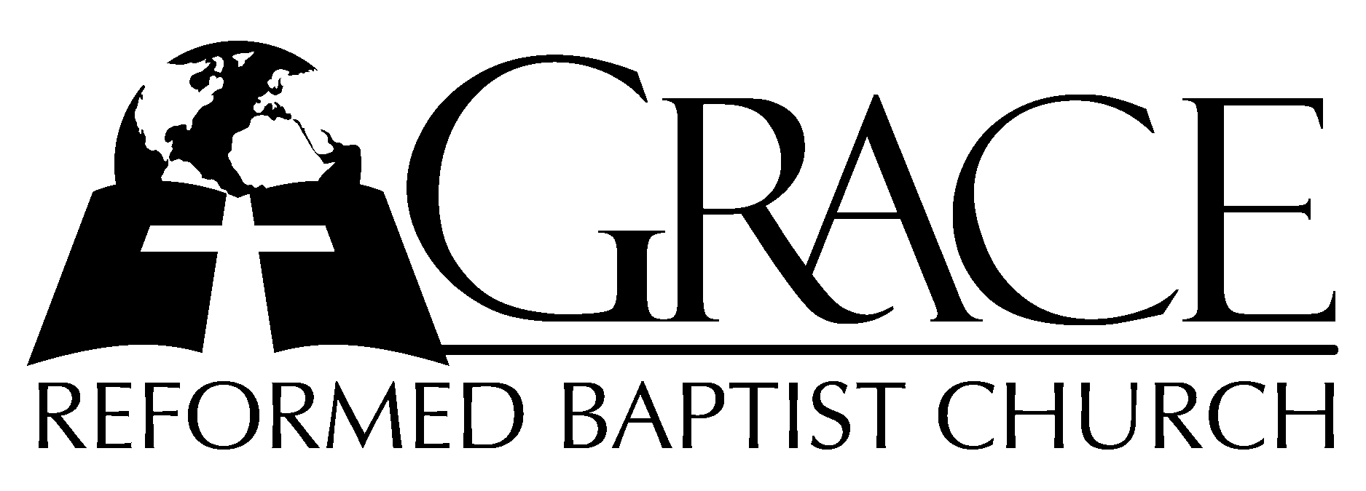
PO Box 221, 939 South Third Street
Mebane, North Carolina 27302
(919) 563-9249

Website: WWW.GRBC.NET

The Lord’s Day Services
Sunday School……….………9:30
Morning Worship……….…10:55
Evening Worship.…………..5:30

Wednesday Evening Prayer Service
7:15

We warmly welcome our Visitors today and request that you sign
our Guest Register located in the Foyer. We hope to greet you
in a more personal way following the services.

The Lord’s Day
March 9, 2008

Call to Worship Pastor Andy Dunkerton

Hymns of Praise “Fairest Lord Jesus”/
“O Come, Let Us Adore Him”

1. Fairest Lord Jesus, Ruler of all nature, Son of God and Son of Man!
Thee will I cherish, Thee will I honor, Thou, my soul’s glory, joy and crown.

2. Fair are the meadows, fairer are the woodlands, robed in the blooming garb of spring:
Jesus is fairer, Jesus is purer, Who makes the woeful heart to sing.

3. Fair is the sunshine, fair is the moonlight, and all the twinkling, starry host:
Jesus shines brighter, Jesus shines purer, than all the angels heav’n can boast.

4. Beautiful Savior! Lord of the nations! Son of God and Son of Man!
Glory and honor, praise, adoration, now and forevermore be Thine!
(piano introduction)
1. O come, let us adore Him, O come, let us adore Him,
O come, let us adore Him, Christ the Lord.
2. We’ll give Him all the glory,…
3. For He alone is worthy,… AMEN

Scripture Reading I Timothy 6

Pastoral Prayer

Offertory Hymn # 177 “Beneath the Cross
of Jesus”

Hymn of Preparation “Nearer, Still Nearer

1. Nearer, still nearer, close to Thy heart, draw me, my Savior - so precious Thou art!
Fold me, O fold me close to Thy breast. Shelter me safe in that haven of rest;
Shelter me safe in that haven of rest.
2. Nearer, still nearer, nothing I bring, naught as an off’ring to Jesus, my King-
Only my sinful, now contrite heart. Grant me the cleansing Thy blood doth impart;
Grant me the cleansing Thy blood dot impart.
3. Nearer, still nearer, Lord to be Thine! Sin, with its follies, I gladly resign,
All of its pleasures, pomp and its pride. Give me but Jesus, my Lord crucified;
Give me but Jesus, my Lord, crucified.
4. Nearer, still nearer, while life shall last, till safe in glory my anchor is cast;
Thro’ endless ages ever to be nearer, my Savior, still nearer to Thee;
Nearer, my Savior, still nearer to Thee. AMEN

Text and Music: Lelia N. Morris Used by Permission CCLI # 1899094

Sermon Pastor Gary Hendrix

◊◊◊◊◊◊◊◊◊◊◊◊◊◊◊◊◊◊◊◊◊◊◊◊◊◊◊◊◊◊

Evening Worship

Call to Worship Pastor Stu Johnston

Hymn of Praise # 441 “Thy Works,
Not Mine, O Christ”

Scripture Reading John 17

Pastoral Prayer

Offertory/Hymn of “Jesus, Lover of My Soul”
Preparation

1. Jesus lover of my soul, let me to Thy bosom fly, while the nearer waters roll,
While the tempest still is high: Hide me, O my Savior hide, till the storm of life is past:
Safe into the haven guide: O receive my soul at last.
2. Other refuge have I none, hangs my helpless soul on Thee; Leave, O, leave me not alone,
Still support and comfort me: All my trust on Thee is stayed, all my help from Thee I bring;
Cover my defenseless head with the shadow of Thy wing.
3. Thou, O Christ, art all I want; more than all in Thee I find; Raise the fallen, cheer the faint,
Heal the sick and lead the blind; just and holy is Thy name, I am all unrighteousness:
False and full of sin I am, Thou art full of truth and grace.
4. Plenteous grace with Thee is found, grace to cover all my sin; let the healing streams abound;
Make and keep me pure within: Thou of life the fountain art, freely let me take of Thee;
Spring Thou up within my heart, rise to all eternity. AMEN

Text: Charles Wesley Music:: Katie Malone Redfern, 2002 Used by Permission

Sermon Pastor Charles Fortner

◊◊◊◊◊◊◊◊◊◊◊◊◊◊◊◊◊◊◊◊◊◊◊◊◊◊◊◊◊◊

Communion Hymns

# 189 “Sweet the Moments”

“Alas, and Did My Savior Bleed”
(piano introduction)
Alas, and did my Savior bleed, and did my Sovereign die?
Would He devote that sacred head for such a worm as I?
Was is for crimes that I had done He groaned upon the tree?
Amazing pity, grace unknown, and love beyond degree.
My God, why would You shed Your blood, so pure and undefiled,
To make a sinful one like me Your chosen, precious child?

Well might the sun in darkness hide, and shut His glories in,
When Christ, the mighty Maker, died, for man, the creature’s sin.
Thus might I hide my blushing face while His dear cross appears,
Dissolve my heart in thankfulness, and melt my eyes in tears.
My God, why would You shed Your blood, so pure and undefiled,
To make a sinful one like me Your chosen, precious child?

But drops of grief can ne’er repay the debt of love I owe.
Here, Lord, I give myself away; ’tis all that I can do.
My God, why would You shed Your blood, so pure and undefiled,
To make a sinful one like me Your chosen, precious child?
(piano ending)

Text: Isaac Watts Music: Bob Kaufllin, 1997 Sovereign Grace Music Used by Permission CCLI # 1899094

# 223 “Arise, My Soul Arise”

