“Moreover, brethren, I declare to you the gospel which I preached to you, which also you received and in which you stand, by which also you are saved, if you hold fast that word which
I preached to you---unless you believed in vain.
For I delivered to you first of all that which I
also received: that Christ died for our sins according to the Scriptures, and that He was buried, and that He rose again the third day according to the Scriptures, and that He was
seen by Cephas, then by the twelve. After that
He was seen by over five hundred brethren at once, of whom the greater part remain to the present, but some have fallen asleep.
After that He was seen by James, then by
all the apostles. Then last of all He was seen
by me also, as by one born out of due time.”

I Corinthians 15: 1-8

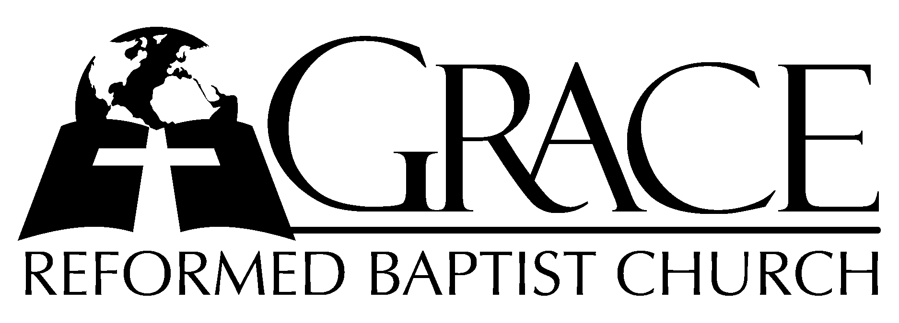
PO Box 221, 939 South Third Street
Mebane, North Carolina 27302
(919) 563-9249

Website: WWW.GRBC.NET

The Lord’s Day Services
Sunday School……….………9:30
Morning Worship……….…10:55
Evening Worship.…………..5:30

Wednesday Evening Prayer Service
7:15

We warmly welcome our Visitors today and request that you sign
our Guest Register located in the Foyer. We hope to greet you
in a more personal way following the services.

The Lord’s Day
March 23, 2008

Call to Worship Pastor Stu Johnston

Hymn of Praise # 198 “Jesus Christ is
Risen Today”

Scripture Reading II Timothy 2: 1-13

Pastoral Prayer

Offertory Hymn “O, to See the Dawn”
(The Power of the Cross)

1. O, to see the dawn-- of the darkest day;-- Christ on the road to Calvary.
Tried by sinful men,-- torn and beaten, then-- nailed to a cross of wood.
This the pow’r-- of the cross:-- Christ became-- sin for us.-- Took the blame,--
Bore the wrath; We stand forgiven at the cross.

2. O, to see the pain-- written on Your face,-- bearing the awesome weight of sin.
Ev’ry bitter thought,-- ev’ry evil deed-- crowning Your blood-stained brow.
This the pow’r-- of the cross:-- Christ became-- sin for us.-- Took the blame,--
Bore the wrath; We stand forgiven at the cross.

3. Now the daylight flees;-- Now the ground beneath-- quakes as its Maker bows His head.
Curtain torn in two,-- dead are raised to life-- “Finished!” the vic’try cry!
This the pow’r-- of the cross:-- Christ became-- sin for us.-- Took the blame,--
Bore the wrath; We stand forgiven at the cross.

4. O, to see my name-- written in the wounds,-- for through Your suff’ring I am free.
Death is crushed to death, life is mine to live, won through Your selfless love!
This the pow’r-- of the cross:-- Son of God-- slain for us. What a love,--
What a cost! We stand forgiven at the cross.

Words and Music: Keith Getty & Stuart Townend
ThankYou Music, Used by Permission CCLI # 1899094

Hymn of Preparation “Hallelujah! What a
Savior!”
1. Man of Sorrows! What a name for the Son of God, Who came,
Ruined sinners to reclaim:
Hallelujah, hallelujah, hallelujah! What a Savior!
2. Bearing shame and scoffing rude, in my place condemned He stood,
Sealed my pardon with His blood:
Hallelujah, hallelujah, hallelujah! What a Savior!
3. Guilty, vile, and helpless we; Spotless Lamb of God was He;
Full atonement! Can it be?
Hallelujah, hallelujah, hallelujah! What a Savior!
4. Lifted up was He to die, “It is finished!” was His cry:
Now in heav’n exalted high:
Hallelujah, hallelujah, hallelujah! What a Savior!
5. When He comes, our glorious King, all His ransomed home to bring,
Then anew this song we’ll sing:
Hallelujah, hallelujah, hallelujah! What a Savior! AMEN

Words: Philip P. Bliss, 1838-1876 Music: Katie Malone Redfern, 2002 Used by Permission

Sermon Pastor Gary Hendrix

◊◊◊◊◊◊◊◊◊◊◊◊◊◊◊◊◊◊◊◊◊◊◊◊◊◊◊◊◊◊

Evening Worship

Call to Worship Pastor Stu Johnston

Hymn of Praise # 206 “Low in the Grave
He Lay”

Scripture Reading Joel 1

Pastoral Prayer

Offertory Hymn “See, What a Morning”

1. See, what a morning, gloriously bright, with the dawning of hope in Jerusalem;
Folded the grave clothes, tomb filled with light,
As the angels announce, “Christ is ri~sen!”
See God’s salvation~ plan, wrought in love, borne in pain~ paid in sacrifice,
Fulfilled in Christ the~ Man, for He lives: Christ is risen from the dead!

2. See, Mary weeping, “Where is He laid?” As in sorrow she turns from the empty tomb.
Hears a voice speaking, calling her name;
It’s the Master, the Lord, raised to life again!
The voice that spans the~ years, speaking life, stirring hope,~ bringing peace to us,
Will sound till He ap~pears, for He lives: Christ is risen from the dead!

3. One with the Father, Ancient of Days, through the Spirit Who clothes faith with certainty.
Honor and blessing, glory and praise to the King crowned with pow’r and authority.
And we are raised with~ Him; Death is dead, life has won,~ Christ has con~ quered.
And we shall reign with~ Him, for He lives: Christ is risen from the dead.
(Repeat chorus)
And we are raised with~ Him; Death is dead, life has won,~ Christ has conquered.
And we shall reign with~ Him, for He lives: Christ is risen from the dead!

Words and Music: Keith Getty and Stuart Townend, ThankYou Music, Used by Permission CCLI # 1899094

Hymn of Preparation # 346 “Sun of My Soul”
Sermon Robert Fisher

◊◊◊◊◊◊◊◊◊◊◊◊◊◊◊◊◊◊◊◊◊◊◊◊◊◊◊◊◊◊

“And He opened their understanding, that they might comprehend the Scriptures.
Then He said to them, ‘Thus it is written, and thus it was necessary for the Christ to suffer and to rise from the dead the third day, and that repentance and remission of sins should be preached in His name to all nations, beginning at Jerusalem. And you are witnesses of these things.’ ”

Luke 24: 45-48

