“John, to the seven churches which are in Asia:
Grace to you and peace from Him who is and who was and who is to come, and from the seven
Spirits who are before His throne,
and from Jesus Christ, the faithful witness,
the firstborn from the dead, and the ruler
over the kings of the earth. To Him who loved us
and washed us from our sins in His own blood,
and has made us kings and priests to His God
and Father, to Him be glory and dominion
forever and ever. Amen
Behold, He is coming with clouds, and every eye
will see Him, even they who pierced Him.
And all the tribes of the earth will mourn
because of Him. Even so, Amen.”

Revelation 1: 4-7

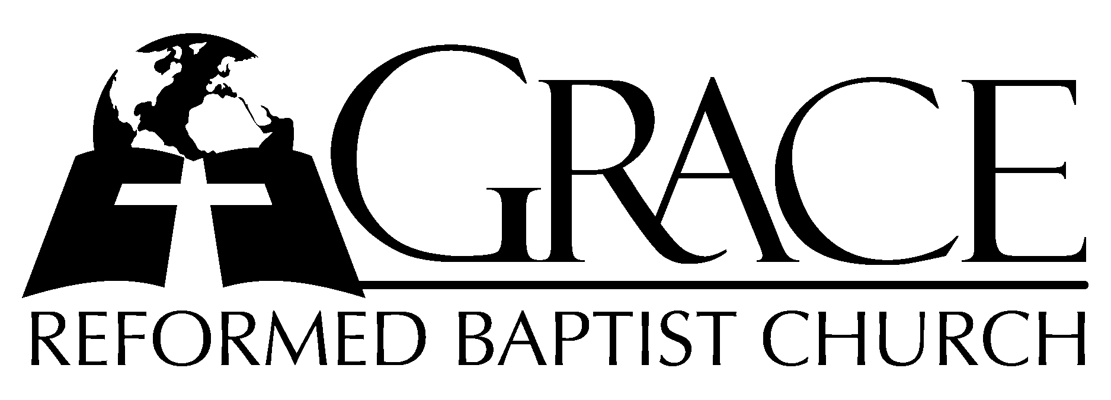
PO Box 221, 939 South Third Street
Mebane, North Carolina 27302
(919) 563-9249

Website: WWW.GRBC.NET

The Lord’s Day Services
Sunday School……….………9:30
Morning Worship……….…10:55
Evening Worship.…………..5:30

Wednesday Evening Prayer Service
7:15

We warmly welcome our Visitors today and request that you sign
our Guest Register located in the Foyer. We hope to greet you
in a more personal way following the services.

The Lord’s Day
April 13, 2008

Call to Worship Pastor Andy Dunkerton

Hymn of Praise # 127 “Let Us Love and
and Sing and Wonder”

Scripture Reading II Timothy 4

Pastoral Prayer

Offertory Hymn “Beautiful Savior”

1. All my days I will sing this song of gladness, give my praise to the Fountain of delights;
For in my helplessness You heard my cry, and waves of mercy poured down on my life.
Beautiful Savior, Wonderful Counselor, clothed in majesty, Lord of history,
You’re the Way, the Truth the Life.
Star of the Morning, glorious in holiness, You’re the Risen One,
Heaven’s Champion, and You reign, You reign over all!

2. I will trust in the cross of my Redeemer; I will sing of the blood that never fails,
Of sins forgiven, of conscience cleansed, of death defeated and life without end.
Beautiful Savior, Wonderful Counselor, clothed in majesty, Lord of history,
You’re the Way, the Truth the Life.
Star of the Morning, glorious in holiness, You’re the Risen One,
Heaven’s Champion, and You reign, You reign over all!

3. I long to be where the praise is never ending; Yearn to dwell where the glory never fades,
Where countless worshipers will share one song, and cries of ‘Worthy’ will honor the Lamb!
Beautiful Savior, Wonderful Counselor, clothed in majesty, Lord of history,
You’re the Way, the Truth the Life.
Star of the Morning, glorious in holiness, You’re the Risen One,
Heaven’s Champion, and You reign, You reign over all!

Words and Music: Stuart Townend, 1998 Thankyou Music, Used by Permission CCLI # 1899094

Hymn of Preparation “Christ for the World
We Sing”

1. Christ for the world we sing; the world to Christ we bring-
With loving zeal; the poor and them that mourn, the faint and overborne,
Sinsick and sorrow worn, whom Christ doth heal.

2. Christ for the world we sing; the world to Christ we bring-
With fervent prayer; the wayward and the lost, by restless passions tossed,
Redeemed at countless cost from dark despair.

3. Christ for the world we sing; the world to Christ we bring-
With one accord; with us the work to share, with us reproach to dare,
With us the cross to bear, for Christ our Lord.

4. Christ for the world we sing; the world to Christ we bring-
With joyful song; the newborn souls whose days, reclaimed from error’s ways,
Inspired with hope and praise, to Christ belong. AMEN

Words: Samuel Wolcott, 1869 Tune: ITALIAN HYMN, Felice de Giardini, 1769

Sermon Pastor Gary Hendrix

◊◊◊◊◊◊◊◊◊◊◊◊◊◊◊◊◊◊◊◊◊◊◊◊◊◊◊◊◊◊

Evening Worship

Call to Worship Pastor Charles Fortner

Opening Hymn # 310 “Here, O My Lord”
Scripture Reading Ephesians 1: 1-14
Offertory Hymn # 95 “How Vast the
Benefits”
Pastoral Prayer

Hymn of Preparation # 432 “Jesus, What a
Friend for Sinners”

Sermon Pastor Andy Dunkerton

Communion Hymns

“The Power of the Cross”

1. O, to see the dawn- of the darkest day;- Christ on the road to Calvary.
Tried by sinful men,- torn and beaten, then- nailed to a cross of wood.
This the pow’r- of the cross:- Christ became- sin for us.
Took the blame,- bore the wrath; We stand forgiven at the cross.

2. O, to see the pain- written on Your face, bearing the awesome weight of sin.
Ev’ry bitter thought,- ev’ry evil deed- crowning Your blood-stained brow.
This the pow’r- of the cross:- Christ became- sin for us.
Took the blame,- bore the wrath; We stand forgiven at the cross.

3. Now the daylight flees;- Now the ground beneath- quakes as its Maker bows His head.
Curtain torn in two,- dead are raised to life,- “Finished!” the vic’try cry!
This the pow’r- of the cross:- Christ became- sin for us.
Took the blame,- bore the wrath; We stand forgiven at the cross.

4. O, to see my name- written in the wounds,- for through Your suff’ring I am free.
Death is crushed to death, life is mine to live, won through Your selfless love!
This the pow’r- of the cross: Son of God- slain for us. What a love,-
What a cost! We stand forgiven at the cross.

Words and Music: Keith Getty & Stuart Townend ThankYou Music, Used by Permission CCLI # 1899094

# 600 “When This Passing World is Done”
◊◊◊◊◊◊◊◊◊◊◊◊◊◊◊◊◊◊◊◊◊◊◊◊◊◊◊◊◊◊

