“For in that He put all in subjection under him, He left nothing that is not put under him. But we see Jesus, who was made a little lower than the angels, for the suffering of death crowned with glory and honor,
that He, by the grace of God,
might taste death for everyone.
For it was fitting for Him, for whom are all things and by whom are all things,
in bringing many sons to glory,
to make the captain of their salvation perfect through sufferings.”

Hebrews 2: 8b-10

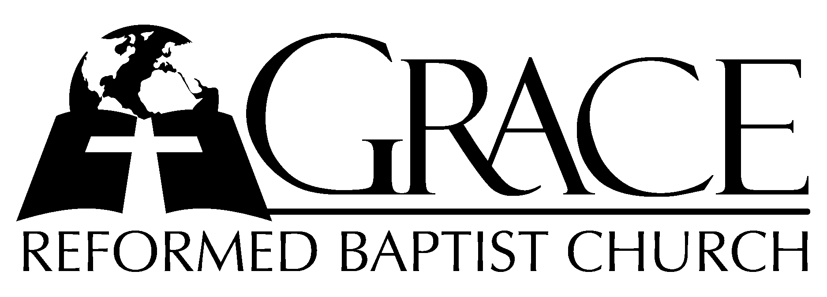
PO Box 221, 939 South Third Street
Mebane, North Carolina 27302
(919) 563-9249

Website: WWW.GRBC.NET

The Lord’s Day Services
Sunday School……….………9:30
Morning Worship……….…10:55
Evening Worship.…………..5:30

Wednesday Evening Prayer Service
7:15

We warmly welcome our Visitors today and request that you sign
our Guest Register located in the Foyer. We hope to greet you
in a more personal way following the services.

The Lord’s Day
June 1, 2008

Call to Worship Pastor Andy Dunkerton

Hymn of Praise # 108 “Praise Ye, Praise
Ye The Lord”

Scripture Reading Hebrews 2

Offertory Hymn “How Deep The Father’s
Love For Us”

1. How deep the Father’s love for us, how vast beyond all measure,
That He should give His only Son to make a wretch His treasure.
How great the pain of searing loss, the Father turns His face away,
As wounds which mar the Chosen One bring many sons to glory.

2. Behold the Man upon the cross, my sin upon His shoulders;
Ashamed, I hear my mocking voice call out among the scoffers.
It was my sin that held Him there until it was accomplished;
His dying breath has brought me life – I know that it is finished.

3. I will not boast in anything, no gifts, no pow’r, no wisdom.
But I will boast in Jesus Christ, His death and resurrection.
Why should I gain from His reward? I cannot find an answer.
But this I know with all my heart, His wounds have paid my ransom.
(a cappella)
Why should I gain from His reward? I cannot find an answer.
But this I know with all my heart, His wounds have paid my ransom.

Words and Music: Stuart Townend, 1995 Kingsway’s Thankyou Music, Used by Permission CCLI # 1899094

Pastoral Prayer

Hymn of Preparation # 548 “More Love to Thee,
O Christ”

Sermon Pastor Gary Hendrix

◊◊◊◊◊◊◊◊◊◊◊◊◊◊◊◊◊◊◊◊◊◊◊◊◊◊◊◊◊

Evening Worship

Call to Worship Pastor Stu Johnston

Hymn of Praise “There is a Higher
Throne”

1. There is a higher throne than all this world has known,
Where faithful ones from ev’ry tongue will one day come.
Before the Son we’ll stand made faultless thro’ the Lamb;
Believing hearts find promised grace; Salvation comes.

Hear heaven’s voices sing; Their thund’rous anthem rings
Thro’ emerald courts and sapphire skies; their praises rise.
All glory, wisdom, pow’r, strength, thanks and honor
Are to God, our King, Who reigns on high forevermore!

2. And there we’ll find our home; Our life before the throne.
We’ll honor Him in perfect song where we belong.
He’ll wipe each tearstained eye as thirst and hunger die.
The Lamb becomes our Shepherd King; We’ll reign with Him.

Hear heaven’s voices sing; Their thund’rous anthem rings
Thro’ emerald courts and sapphire skies; their praises rise.
All glory, wisdom, pow’r, strength, thanks and honor
Are to God, our King, Who reigns on high forevermore!

Words and Music: Keith and Kristyn Getty
2002 Thankyou Music Used by Permission CCLI # 1899094

Scripture Reading Amos 6

Pastoral Prayer

Offertory Hymn # 573 “Thy Way, Not Mine
O Lord”

Preparatory Hymn “My Hope is Built on
Nothing Less”
1. My hope is built on nothing less than Jesus’ blood and righteousness;
I dare not trust the sweetest frame, but wholly lean on Jesus’ name.
On Christ, the Solid Rock, I stand; all other ground is sinking sand,
All other ground is sinking sand.
2. When darkness veils His lovely face, I rest on His unchanging grace;
In every high and stormy gale, my anchor holds within the veil.
On Christ, the Solid Rock, I stand; all other ground is sinking sand,
All other ground is sinking sand.
3. His oath, His covenant, His blood support me in the whelming flood;
When all around my soul gives way, He then is all my hope and stay.
On Christ, the Solid Rock, I stand; all other ground is sinking sand,
All other ground is sinking sand.
4. When He shall come with trumpet sound, O may I then in Him be found;
Dressed in His righteousness alone, faultless to stand before the throne.
On Christ, the Solid Rock, I stand; all other ground is sinking sand,
All other ground is sinking sand. AMEN

Test: Edward Mote, 1834 Music: SOLID ROCK, William Bradbury, 1863

Sermon Pastor Andy Dunkerton
◊◊◊◊◊◊◊◊◊◊◊◊◊◊◊◊◊◊◊◊◊◊◊◊◊◊◊◊◊◊

