“Praise the Lord! Praise the name of the Lord;
Praise Him, O you servants of the Lord!
You who stand in the house of the Lord,
in the courts of the house of our God,
Praise the Lord, for the Lord is good;
Sing praises to His name, for it is pleasant.
For the Lord has chosen Jacob
for Himself, Israel for His special treasure.
For I know that the Lord is great,
and our Lord is above all gods.
Whatever the Lord pleases He does,
in heaven and in earth, in the seas
and in all deep places. He causes the vapors
to ascend from the ends of the earth;
He makes lightening for the rain;
He brings the wind out of His treasuries.”

Psalm 135: 1-7

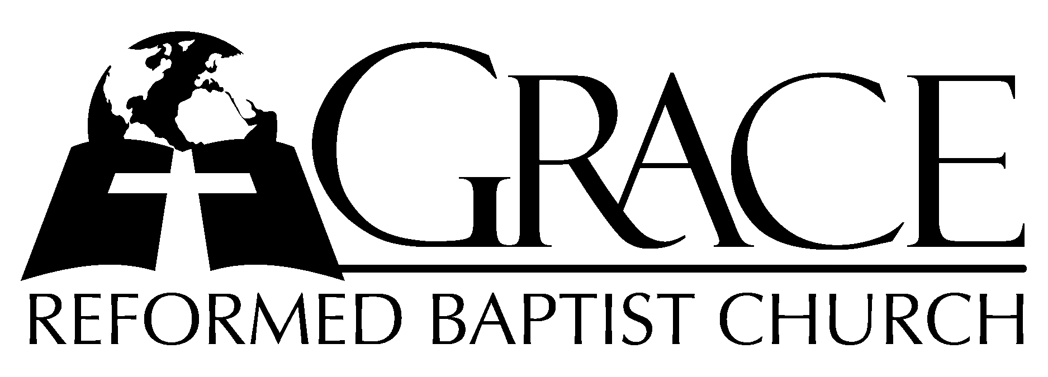
PO Box 221, 939 South Third Street
Mebane, North Carolina 27302
(919) 563-9249

Website: WWW.GRBC.NET

The Lord’s Day Services
Sunday School……….………9:30
Morning Worship……….…10:55
Evening Worship.…………..5:30

Wednesday Evening Prayer Service
7:15

We warmly welcome our Visitors today and request that you sign
our Guest Register located in the Foyer. We hope to greet you
in a more personal way following the services.

The Lord’s Day
June 22, 2008

Call to Worship Pastor Gary Hendrix

Hymn of Praise # 12 “Exalt the Lord”

Scripture Reading Hebrews 5

Pastoral Prayer

Offertory Hymn # 190 “Glory be to
Jesus”

Hymn of Preparation “Ancient Words”

1. Holy Words, long preserved for our walk in this world,
They resound with God’s own heart. O let the ancient words impart.
Words of life, words of hope, give us strength, help us cope.
In this world where’er we roam, ancient words will guide us home.
Ancient words, ever true, changing me and changing you;
We have come with open hearts, O, let the ancient words impart.

2. Holy words of our faith handed down to this age,
Came to us through sacrifice. O, heed the faithful words of Christ.
Holy words long preserved for our walk in this world,
They resound with God’s own heart. O, let the ancient words impart.
Ancient words, ever true, changing me and changing you;
We have come with open hearts, O, let the ancient words impart.
Ancient words, ever true, changing me and changing you;
We have come with open hearts, O, let the ancient words impart.
( a cappella)
We have come with open hearts, O, let the ancient words impart.

Words and Music: Lynn Deshazo, 2001 Integrity’s Hosanna! Music
Used by Permission CCLI # 1899094

Sermon Pastor Jeff Smith

◊◊◊◊◊◊◊◊◊◊◊◊◊◊◊◊◊◊◊◊◊◊◊◊◊◊◊◊◊

Evening Worship

Call to Worship Pastor Andy Dunkerton

Hymn of Praise # 537 “What Shall I
Render to my God?”

Scripture Reading Amos 9

Pastoral Prayer

Offertory Hymn “Beautiful Savior”
1. All my days I will sing this song of gladness,
Give my praise to the Fountain of delights;
For in my helplessness You heard my cry.
And waves of mercy poured down on my life.
Beautiful Savior, Wonderful Counselor.
Clothed in majesty, Lord of history, You’re the Way, the Truth, the Life.
Star of the Morning, glorious in holiness,
You’re the Risen One, heaven’s Champion, and You reign, You reign over all!
2. I will trust in the cross of my Redeemer;
I will sing of the blood that never fails,
Of sins forgiven, of conscience cleansed,
Of death defeated and life without end.
Beautiful Savior, Wonderful Counselor.
Clothed in majesty, Lord of history, You’re the Way, the Truth, the Life.
Star of the Morning, glorious in holiness,
You’re the Risen One, heaven’s Champion, and You reign, You reign over all!
3. I long to be where the praise is never ending;
Yearn to dwell where the glory never fades,
Where countless worshipers will share one song,
And cries of ‘Worthy’ will honor the Lamb!
Beautiful Savior, Wonderful Counselor.
Clothed in majesty, Lord of history, You’re the Way, the Truth, the Life.
Star of the Morning, glorious in holiness,
You’re the Risen One, heaven’s Champion, and You reign, You reign over all!

Words and Music: Stuart Townend 1998 Thankyou Music, Used by Permission CCLI 1899094

Hymn of Preparation # 439 “Jesus, Thy Blood
and Righteousness”
Sermon Pastor Jeff Smith

◊◊◊◊◊◊◊◊◊◊◊◊◊◊◊◊◊◊◊◊◊◊◊◊◊◊◊◊◊

