“The heavens are Yours,
the earth also is Yours; the world and
all its fullness. You have founded them.
The north and the south, You have
created them; Tabor and Hermon
rejoice in Your name.
You have a mighty arm; strong is Your hand, and high is Your right hand.
Righteousness and justice are
the foundation of Your throne;
mercy and truth go before Your face.
Blessed are the people who know
the joyful sound! They walk, O Lord,
in the light of Your countenance.”

Psalm 89: 11-15

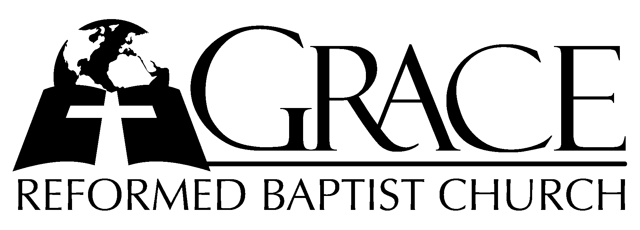
PO Box 221, 939 South Third Street
Mebane, North Carolina 27302
(919) 563-9249

Website: WWW.GRBC.NET

The Lord’s Day Services
Sunday School……….………9:30
Morning Worship……….…10:55
Evening Worship.…………..5:30

Wednesday Evening Prayer Service
7:15

We warmly welcome our Visitors today and request that you sign
our Guest Register located in the Foyer. We hope to greet you
in a more personal way following the services.

The Lord’s Day
July 5, 2008

Call to Worship Pastor Stu Johnston

Hymn of Praise # 616 “God of Our
Fathers”

Scripture Reading Hebrews 6:19 – 7:28

Pastoral Prayer

Offertory Hymn “See, What a Morning”

1. See, what a morning, gloriously bright, with the dawning of hope in Jerusalem;
Folded the grave clothes, tomb filled with light,
As the angels announce, “Christ is ri~sen!”
See God’s salvation~ plan, wrought in love, borne in pain~ paid in sacrifice,
Fulfilled in Christ the~ Man, for He lives; Christ is risen from the dead!

2. See, Mary weeping, “Where is He laid?” As in sorrow she turns from the empty tomb.
Hears a voice speaking, calling her name;
It’s the Master, the Lord, raised to life again!
The voice that spans the~ years, speaking life, stirring hope,~ bringing peace to us,
Will sound till He ap~pears, for He lives: Christ is risen from the dead!

3. One with the Father, Ancient of Days, through the Spirit Who clothes faith with certainty.
Honor and blessing, glory and praise to the King crowned with pow’r and authority.
And we are raised with~ Him; Death is dead, life has won,~ Christ has con~quered.
And we shall reign with~ Him, for He lives: Christ is risen from the dead!

(repeat chorus - a cappella)

And we are raised with~ Him; Death is dead, life has won,~ Christ has con~quered.
And we shall reign with~ Him, for He lives: Christ is risen form the dead!

Words and Music: Keith and Stuart Townend, 2002 ThankYou Music, Used by Permission CCLI # 1899094

Hymn of Preparation #253 “O Spirit of the
Living God”

Sermon Andy Hamilton

◊◊◊◊◊◊◊◊◊◊◊◊◊◊◊◊◊◊◊◊◊◊◊◊◊◊◊◊

Evening Worship

Call to Worship Pastor Andy Dunkerton
Hymn of Praise # 132 “Wondrous King,
All Glorious”

Scripture Reading Jonah 1

Pastoral Prayer

Offertory Hymn “There is a Higher
Throne”

1. There is a higher throne, than all this world has known,
Where faithful ones from ev’ry tongue, will one day come.
Before the Son we’ll stand, made faultless thro’ the Lamb;
Believing hearts find promised grace; Salvation comes.

Hear heaven’s voices sing; Their thund’rous anthem rings
Thro’ emerald courts and sapphire skies; their praises rise.
All glory, wisdom, pow’r, strength, thanks, and honor
Are to God, our King, Who reigns on high, forevermore!

2. And there we’ll find our home; Our life before the throne.
We’ll honor Him in perfect song where we belong.
He’ll wipe each tearstained eye as thirst and hunger die.
The Lamb becomes our Shepherd King, we’ll reign with Him.

Hear heaven’s voices sing; Their thund’rous anthem rings
Thro’ emerald courts and sapphire skies; their praises rise.
All glory, wisdom, pow’r, strength, thanks, and honor
Are to God, our King, Who reigns on high, forevermore!

Words and Music: Keith and Kristyn Getty
2002 ThankYou Music Used by Permission CCLI # 1899094

Hymn of Preparation # 593 “Jesus, I My Cross
Have Taken”

Sermon Andy Hamilton

◊◊◊◊◊◊◊◊◊◊◊◊◊◊◊◊◊◊◊◊◊◊◊◊◊◊◊◊◊

