“You are fairer than the sons of men;
Grace is poured upon Your lips;
Therefore God has blessed You forever.
Gird Your sword upon Your thigh,
O Mighty One, with Your glory and Your Majesty. And in Your majesty ride prosperously because
of truth, Humility, and righteousness;
and Your right hand shall teach you
awesome things. Your arrows are sharp
in the heart of the King’s enemies;
The peoples fall under You.
Your throne, O God, is forever and ever;
A scepter of righteousness is the scepter
of Your kingdom.”

Psalm 45: 2-6

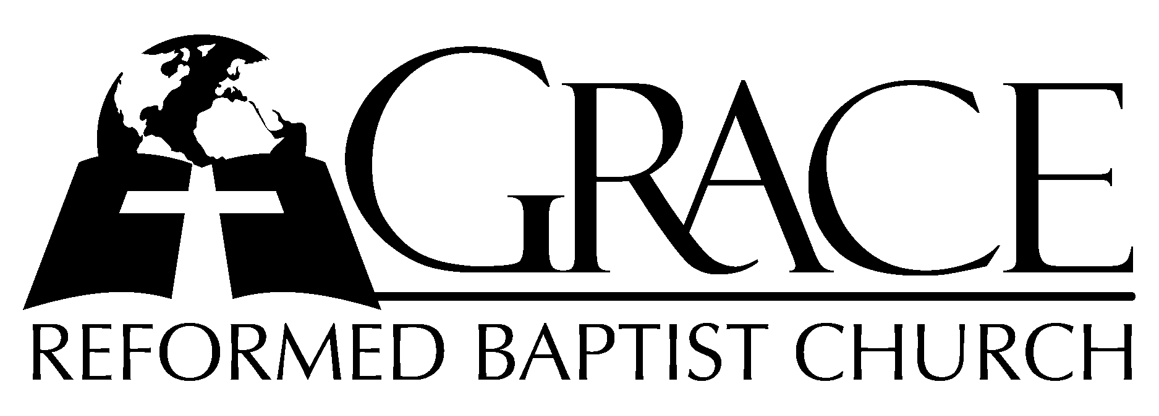
PO Box 221, 939 South Third Street
Mebane, North Carolina 27302
(919) 563-9249

Website: WWW.GRBC.NET

The Lord’s Day Services
Sunday School……….………9:30
Morning Worship……….…10:55
Evening Worship.…………..5:30

Wednesday Evening Prayer Service
7:15

We warmly welcome our Visitors today and request that you sign the
Guest Register located in the Foyer. We hope to greet you
in a more personal way following the services.

The Lord’s Day
July 13, 2008

Call to Worship Pastor Stu Johnston

Hymn of Praise # 133 “O For A Thousand
Tongues to Sing”

Scripture Reading Hebrews 8

Pastoral Prayer

Offertory Hymn “The Power of The Cross”

1. O, to see the dawn-- of the darkest day;-- Christ on the road to Calvary.
Tried by sinful men,-- torn and beaten, then-- nailed to a cross of wood.
This the pow’r-- of the cross:-- Christ became-- sin for us.--
Took to blame--, bore the wrath; We stand forgiven at the cross.

2. O, to see the pain-- written on Your face,-- bearing the awesome weight of sin.
Ev’ry bitter thought,-- ev’ry evil deed-- crowning Your blood-stained brow.
This the pow’r-- of the cross--: Christ became-- sin for us.--
Took to blame--, bore the wrath; We stand forgiven at the cross.

3. Now the daylight flees;-- now the ground beneath-- quakes as its Maker bows His head.
Curtain torn in two,-- dead are raised to life-- “Finished!” the vict’ry cry.
This the pow’r-- of the cross:-- Christ became-- sin for us.
Took to blame,-- bore the wrath; We stand forgiven at the cross.

4. O, to see my name-- written in the wounds,-- for through Your suff’ring I am free.
Death is crushed to death,-- life is mine to live,-- won through Your selfless love!
This the pow’r-- of the cross:-- Son of God-- slain for us.
What a love,-- what a cost! We stand forgiven at the cross.

Words and Music: Keith Getty & Stuart Townend
ThankYou Music Used by Permission CCLI # 1899094

Hymn of Preparation # 580 “It is Well With
My Soul”

Sermon Pastor Gary Hendrix

◊◊◊◊◊◊◊◊◊◊◊◊◊◊◊◊◊◊◊◊◊◊◊◊◊◊◊◊

Evening Worship

Call to Worship Pastor Andy Dunkerton
Hymn of Praise # 129 “Fairest Lord
Jesus”

Scripture Reading Jonah 2

Pastoral Prayer

Offertory/Preparatory “Beneath The Cross
Hymn of Jesus”

1. Be~neath the cross of Je~sus, I~ find a place to stand,
And~ wonder at such mer~cy that~ calls me as I am.
For~ hands that should discard me hold~ wounds which tell me come.
Be~neath the cross of Je~sus my unworthy soul is won.

2. Be~neath the cross of Je~sus, His~ fam’ly is my own.
Once~ strangers chasing selfish dreams now~ one through grace alone.
How~ could I now dishonor the~ ones that You have loved?
Be~neath the cross of Je~sus, see the children called by God.

3. Be~neath the cross of Je~sus, the~ path before the crown
We~ follow in His foot~steps where~ promised hope is found.
How~ great the joy before us to~ be His perfect bride.
Be~neath the cross of Je~sus we~ gladly live our lives.

Words and Music: Keith and Kristyn Getty
2005 ThankYou Music Used by Permission CCLI # 1899094

Sermon Jason Kay

◊◊◊◊◊◊◊◊◊◊◊◊◊◊◊◊◊◊◊◊◊◊◊◊◊◊◊◊◊
Communion Hymns

# 181 “O, Dearest Jesus”

“Alas, and Did My Savior Bleed”
(piano introduction)

Alas, and~ did my Savior bleed, and did my Sovereign~ die?
Would He devote that sacred head for such a worm as I?
Was it for~ crimes that I had done He groaned upon the tree?
Amazing pity, grace unknown, and love beyond degree.
My God, who would You shed Your blood, so pure and undefiled,
To make a sinful one like me Your chosen, precious child?

Well might the~ sun in darkness hide, and shut His glories in,
When Christ, the mighty Maker, died, for man, the creature’s, sin.
Thus might I~ hide my blushing face while His dear cross appears,
Dissolve my heart in thankfulness, and melt my eyes in tears.
My God, who would You shed Your blood, so pure and undefiled,
To make a sinful one like me Your chosen, precious child?

But drops of~ grief can ne’er repay the debt of love I owe.
Here, Lord, I give myself away; ’tis all that I can do.
My God, who would You shed Your blood, so pure and undefiled,
To make a sinful one like me Your chosen, precious child?
(piano ending)

Words: Isaac Watts Music: Bob Kauflin 1997 Sovereign Grace Music Used by Permission CCLI # 1899094

# 175 “Man of Sorrows”

