“But Christ came as High Priest of the good things
to come, with the greater and more perfect tabernacle not made with hands, that is,
not of this creation. Not with the blood of goats
and calves, but with His own blood He entered
the Most Holy Place once for all, having
obtained eternal redemption.
For if the blood of bulls and goats and the
ashes of a heifer, sprinkling the unclean,
sanctifies for the purifying of the flesh,
how much more shall the blood of Christ,
who through the eternal Spirit offered Himself without spot to God, cleanse your conscience
from dead works to serve the living God?
And for this reason He is the Mediator of the new covenant, by means of death, for the redemption
of the transgressions under the first
covenant, that those who are called may receive
the promise of the eternal inheritance.”

Hebrews 9: 11-15

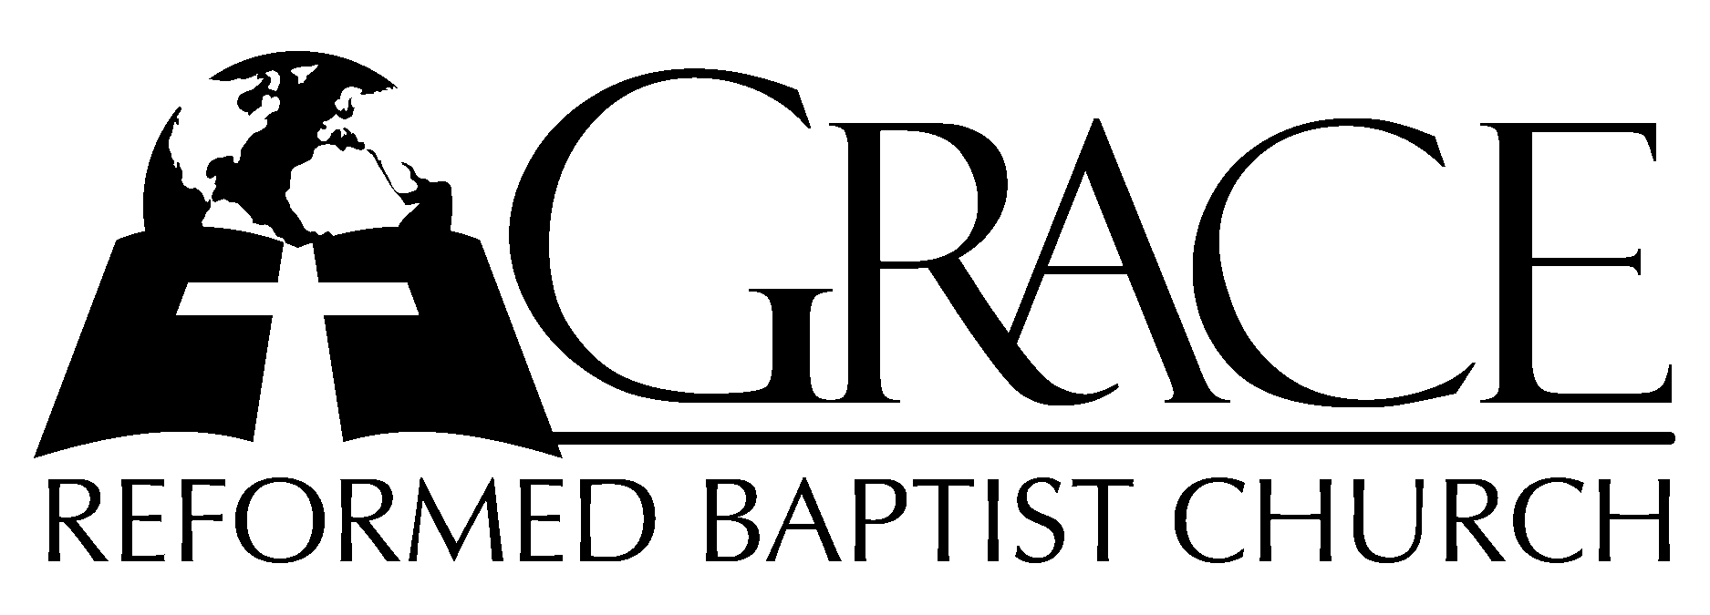
PO Box 221, 939 South Third Street
Mebane, North Carolina 27302
(919) 563-9249

Website: WWW.GRBC.NET

The Lord’s Day Services
Sunday School……….………9:30
Morning Worship……….…10:55
Evening Worship.…………..5:30

Wednesday Evening Prayer Service
7:15

We warmly welcome our Visitors today and request that you sign the
Guest Register located in the Foyer. We hope to greet you
in a more personal way following the services.

The Lord’s Day
July 20, 2008

Call to Worship Pastor Andy Dunkerton

Hymn of Praise # 70 “Praise, My Soul,
the King of Heaven”

Scripture Reading Hebrews 9: 1-15

Pastoral Prayer

Offertory Hymn “How Good It Is to Thank
the Lord”/
“Give Thanks”

1. How good it is to thank the Lord, and praise to Thee, Most High, accord,
To show Thy love with morning light, and tell Thy faithfulness each night;
Yea, good it is Thy praise to sing, and all our sweetest music bring.

2. O Lord, with joy my heart expands before the wonder of Thy hands;
Great works, Jehovah, Thou hast wrought, exceeding deep Thine ev’ry thought;
A foolish man knows not their worth, nor he whose mind is on the earth.

(piano introduction)

Give thanks with a grateful heart; Give thanks to the Holy One;
Give thanks because He’s given Jesus Christ, His Son.
Give thanks with a grateful heart; Give thanks to the Holy One;
Give thanks because He’s given Jesus Christ, His Son.
And now let the weak say, “I am strong;”
Let the poor say, “I am rich,” because of what the Lord has done for us.
And now let the weak say, “I am strong;”
Let the poor say, “I am rich,” because of what the Lord has done for us.

Give thanks!

How Good It Is to Thank the Lord, From PSALM 92
Give Thanks, Words and Music: Henry Smith, 1978 Integrity’s Hosanna! Music
Used by Permission CCLI # 1899094

Hymn of Preparation # 547 “My Jesus, I Love
Thee”

Sermon Pastor Gary Hendrix

◊◊◊◊◊◊◊◊◊◊◊◊◊◊◊◊◊◊◊◊◊◊◊◊◊◊◊◊

Evening Worship

Call to Worship Pastor Charles Fortner

Hymn of Praise # 453 “O the Deep, Deep
Love of Jesus!”
Scripture Reading Jonah 3

Pastoral Prayer

Offertory Hymn # 101 “My Song For Ever
Shall Record”

Hymn of Preparation “I Will Glory in My
Redeemer”

1. I will glory in my Redeemer whose priceless blood has ransomed me.
Mine was the sin that drove the bitter nails and hung Him on that judgment tree.
I will glory in my Redeemer who crushed the pow’r of sin and death;
My only Savior before the Holy Judge, the Lamb who is my righteousness,
The Lamb who is my righteousness.

2. I will glory in my Redeemer. My life He bought, my love He owns.
I have no longings for another, I’m satisfied in Him alone.
I will glory in my Redeemer, His faithfulness, my standing place,
Thought foes are mighty and rush upon me, my feet are firm held by His grace,
My feet are firm held by His grace.

3. I will glory in my Redeemer who carries me on eagle’s wings.
He crowns my life with lovingkindness, His triumph song I’ll ever sing.
I will glory in my Redeemer who waits for me at gates of gold,
And when He calls me it will be paradise, His face forever to behold.
His face forever to behold.

(a cappella)
I will glory in my Redeemer who waits for me at gates of gold,
And when He calls me it will be paradise, His face forever to behold.
His face forever to behold.

Words and Music: Steve and Vikki Cook, PDI Worship, 2001
Used by Permission CCLI # 1899094

Sermon Pastor Andy Dunkerton

◊◊◊◊◊◊◊◊◊◊◊◊◊◊◊◊◊◊◊◊◊◊◊◊◊◊◊◊◊

