See that you do not refuse Him who speaks. For if they did
not escape who refused Him who spoke on earth,
much more shall we not escape if we turn away from Him
who speaks from heaven, whose voice shook the earth;
but now He has promised, saying,
“Yet once more I shake not only the earth, but also heaven.”
Now this, “Yet once more”, indicates the removal of those
things that are being shaken, as of things that are made,
that the things which cannot be shaken may remain.
Therefore, since we are receiving a kingdom which cannot
be shaken, let us by grace, by which we may serve God
acceptably with reverence and godly fear.
For our God is a consuming fire.
Hebrews 12: 25-29

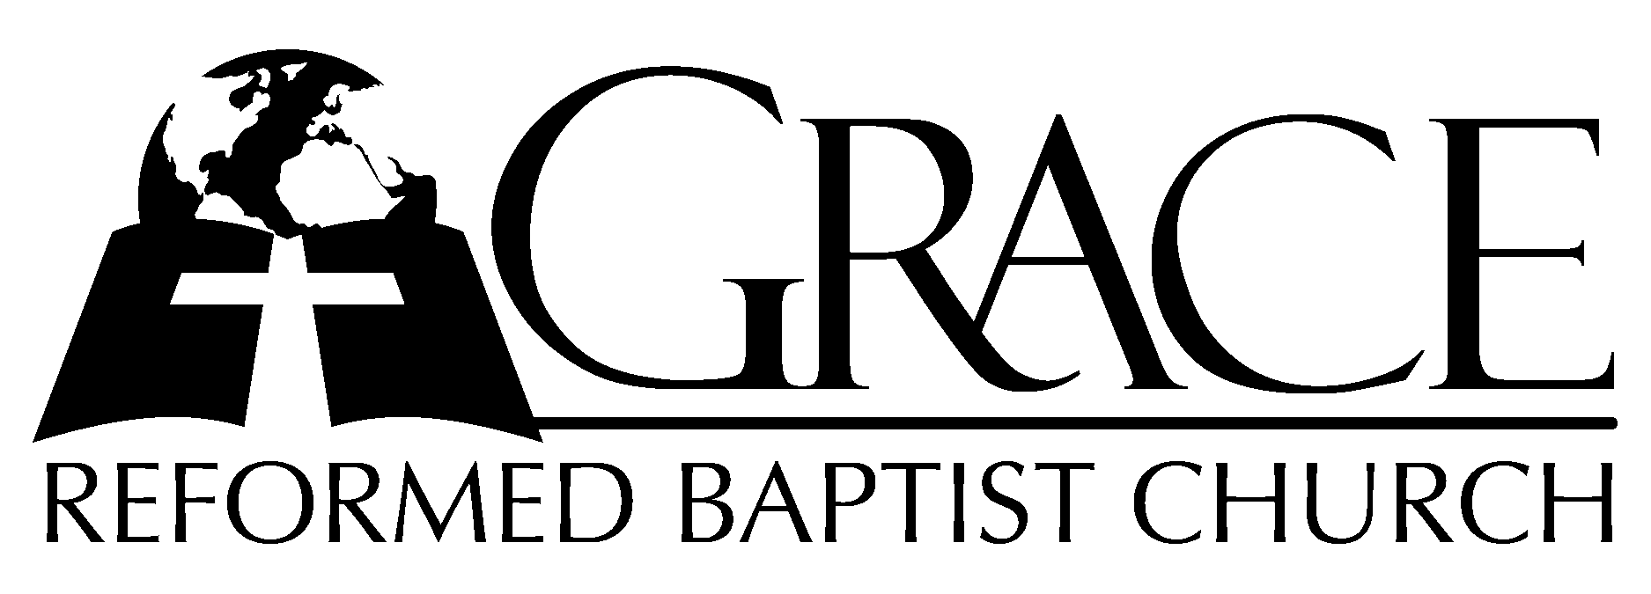

PO Box 221, 939 South Third Street
Mebane, North Carolina 27302
(919) 563-9249

Website: www.grbc.net

The Lord’s Day Services
Sunday School………………9:30
Morning Worship………….10:55
Evening Worship…….…….5:30

Wednesday Evening Prayer Service
7:15

We warmly welcome our Visitors today and request that you sign the Guest Register located
in the Foyer. We hope to greet you in a more personal way following the services.

The Lord’s Day
September 21, 2008
Call to Worship Pastor Stu Johnston

Hymn of Praise # 87 “Holy, Holy, Holy”

Scripture Reading Hebrews 12: 18-29

Pastoral Prayer

Offertory Hymn # 454 “My Faith Looks Up to Thee”
Hymn of Preparation “Speak, O Lord”

1. Speak, O Lord, as we come to You, to receive the food of Your Holy Word.
Take Your Truth, plant it deep in us: Shape and fashion us in Your likeness;
That the light of Christ might be seen today in our acts of love
and our deeds of faith.
Speak, O Lord, and fulfill in us all Your purposes for Your glory.

2. Teach us Lord, full obedience, holy reverence, true humility.
Test our thoughts and our attitudes; in the radiance of Your purity.
Cause our faith to rise, cause our eyes to see Your majestic love
and authority.
Words of pow’r that can never fail; let their truth prevail over unbelief.

3. Speak, O Lord, and renew our minds: Help us grasp the heights of Your
plans for us.
Truths unchanged from the dawn of time, that will echo down through eternity.
And by grace we’ll stand on Your promises; and by faith we’ll walk
as You walk with us.
Speak, O Lord, ´til Your church is built, and the earth is filled with Your glory.

Words and Music: Keith Getty and Stuart Townend, ©2005 Thankyou Music
Used by Permission CCLI # 1899094

Sermon Pastor Andy Dunkerton
***********************

Evening Worship
Call to Worship Pastor Andy Dunkerton

Opening Hymn # 310 “Here, O My Lord”
Scripture Reading Micah 5
Pastoral Prayer

Offertory Hymn “When All Thy Mercies”

1. When all Thy mercies, O~ my God, my rising soul~ surveys,
Transported with the view~, I’m lost~ in wonder, love~, and praise.
Unnumbered com~forts to~ my soul Thy tender~ care bestowed,
Before my infant heart conceived~ from Whom those com~forts flowed.

2. When worn with sickness, oft~ hast Thou with health renewed~my face;
And, when in sins and sor~rows sunk~, revived my soul~ with grace.
Ten thousand thou~sand pre~cious gifts my daily~ thanks employ;
Nor is the least a cheerful heart~ that tastes those gifts~ with joy.

3. Through ev’ry period of~ my life Thy goodness I’ll~ pursue;
And after death, in dis~tant worlds~, the glorious theme~ renew.
Through all eter~nity~ to Thee a joyful~ song I’ll raise;
For O, e-ter-ni-ty’s too short~ to utter all~ Thy praise. AMEN

Text: Joseph Addison, 1712 Tune: ST. MATTHEW, William Croft, 1678-1727

Hymn of Preparation “The Power of the Cross”

1. O, to see the dawn of the darkest day; Christ on the road to Calvary.
Tried by sinful men, torn and beaten, then nailed to a cross of wood.
This the pow’r of the cross: Christ became sin for us.
Took the blame, bore the wrath; we stand forgiven at the cross.

2. O, to see the pain written on Your face, bearing the awesome weight of sin.
Ev’ry bitter thought, ev’ry evil deed crowning Your blood-stained brow.
This the pow’r of the cross: Christ became sin for us.
Took the blame, bore the wrath; we stand forgiven at the cross.

3. Now the daylight flees; now the ground beneath quakes as its Maker bows His head.
Curtain torn in two, dead are raised to life, “Finished!” the vic’try cry.
This the pow’r of the cross: Christ became sin for us.
Took the blame, bore the wrath; we stand forgiven at the cross.

4. O, to see my name written in the wounds, for through Your suff’ring I am free.
Death is crushed to death, life is mine to live, won through Your selfless love!
This the pow’r of the cross: Christ became sin for us.
Took the blame, bore the wrath; we stand forgiven at the cross.

Words and Music: Keith Getty and Stuart Townend
©2006 Thankyou Music Used by Permission CCLI # 1899094

Sermon Pastor Stu Johnston
***********************

