“In the beginning was the Word,
and the Word was with God, and the Word
was God. All things were made through Him,
and without Him nothing was made that was made.
In Him was life, and the life was the light
of men. And the light shines in the darkness,
and the darkness did not comprehend it.”
“And the Word became flesh and dwelt among us, and we beheld His glory, the glory as of the only begotten of the Father, full of grace and truth.”
John 1: 1-5, 11-14



P.O. Box 221, 939 South Third Street
Mebane, North Carolina 27302
(919) 563-9249

Website: www.grbc.net

Our Weekly Services
Sunday School 9:30
Sunday Morning Worship 11:00
Sunday Evening Worship 5:30
Wednesday Prayer Meeting 7:15

We warmly welcome our visitors today.
Please complete a Visitor's Card and place it in the offering plate or in the box located in the foyer. We hope to greet you in a more personal way following the services.

The Lord's Day
December 14, 2014
Call to Worship Pastor Stu Johnston

Opening Hymn #129 “Fairest Lord Jesus”

Scripture Reading Hebrews 8

Pastoral Prayer

Offertory Hymn #544 “How Sweet the
Name of Jesus Sounds”

Song of Preparation “Loved with Everlasting
Love”
1. Loved with everlasting love, drawn by grace that love to know,
Spirit sent from Christ above, thou dost witness it is so.
O this full and precious peace from His presence all divine;
In a love that cannot cease, I am His and He is mine;
In a love that cannot cease, I am His and He is mine;

2. Heav’n above is deeper blue, earth around is sweeter green,
That which glows in ev’ry hue Christless eyes have never seen.
Birds in song His glories show, flow’rs with richer beauties shine
Since I know, as now I know, I am His and He is mine;
Since I know, as now I know, I am His and He is mine;

3. Taste the goodness of the Lord: welcomed home to His embrace,
All his love as blood outpoured seals the pardon of His grace.
Can I doubt His love for me, when I trace that love’s design?
By the cross of Calvary I am His and He is mine.
By the cross of Calvary I am His and He is mine.

4. His forever, only His who the Lord and me shall part?
Ah, with what a rest of bliss Christ can fill the loving heart.
Heav’n and earth may fade and flee, firstborn light in gloom decline,
But while God and I shall be, I am His and He is mine;
But while God and I shall be, I am His and He is mine.

Text: George W. Robinson, 1890, alt. Edmund Clowney, © 1986 Music: James Mountain, ca. 1890
Used by Permission CCLI # 1899094

Sermon Pastor Gary Hendrix

Evening Service
Call to Worship Pastor Andy Dunkerton

Opening Hymn #164 “Angels from the
Realms of Glory”

Scripture Reading Psalm 98: 1-9

Pastoral Prayer

Offertory/Preparatory Song “There is a Redeemer”

1. There is a Redeemer, Jesus, God’s own Son;
Precious Lamb of God, Messiah, Holy One.
Thank You, oh, my Father, for giving us Your Son,
And leaving Your Spirit ’til the work on earth is done.

2. Jesus, my Redeemer, name above all names;
Precious Lamb of God, Messiah, O for sinners slain.
Thank You, oh, my Father, for giving us Your Son,
And leaving Your Spirit ’til the work on earth is done.

3. When I stand in Glory, I will see His face,
There I’ll serve my King forever in that holy place.
Thank You, oh, my Father, for giving us Your Son,
And leaving Your Spirit ’til the work on earth is done. (repeat chorus)

Text and Music: Melody Green © 1982 Birdwing Music/Cherry Lane Music Used by Permission CCLI # 1899094

Sermon Pastor Charles Fortner



Following the evening service, the GRBC Chorale
will present

THE WORD BECAME FLESH.
All are invited to stay. A nursery will be provided.

GRBC Calendar & Announcements
Today
***The GRBC Chorale will practice today, 4:00 p.m.
in the Fellowship room.***

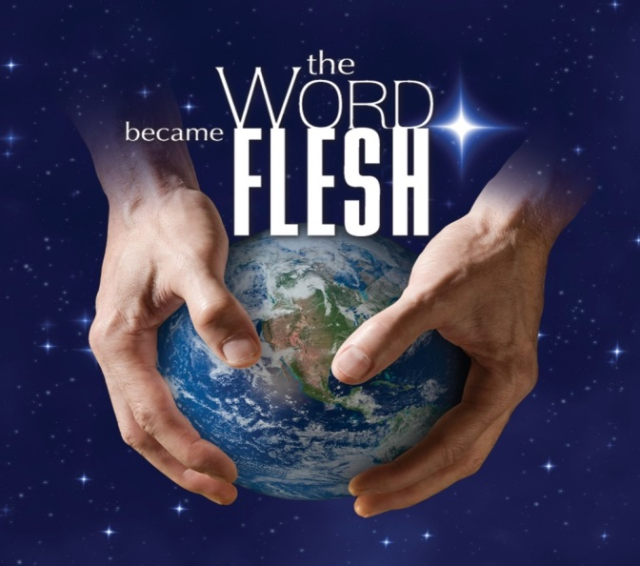

The Grace Reformed Baptist Church Chorale will present
THE WORD BECAME FLESH
tonight following the evening service.
***Programs will be provided and will contain several congregational songs. Please take what your family may need and share. The overhead screen
will not be used.***

***Sunday morning prayer each Lord’s Day, 9:00 a.m. in the College/Career classroom***
December
1) Prayer Meeting - 12/23, 7:15 p.m. (no meeting 12/24)
2) Hawfields’ Ministry, 12 -28, 3:00 p.m.
3) No Men’s ACTION meeting in December
4) No Ladies’ Missionary Society Meeting in December. The next meeting is scheduled for January 3.
5) The Ladies’ Bible Study will resume January 20.

